ARTICLE III. - OVERLAY DISTRICTS
DIVISION 1. - GENERALLY

Secs. 53-675—53-698. - Reserved.
DIVISION 2. - PLANNED UNIT DEVELOPMENT DISTRICT (PUD)
Subdivision I. - In General

Sec. 53-699. - Purpose and objectives.
(a) The purpose and intent of the planned unit development district is to provide a flexible, alternative procedure to encourage imaginative and innovative designs for the unified development of property in the city consistent with this chapter and accepted urban planning, with overall mixed-use regulations as set forth below and in accordance with the city's comprehensive plan. The planned unit development rules are designed to:
(1) Allow development which is harmonious with nearby areas;
(2) Enhance and preserve areas which are unique or have outstanding scenic, environmental, cultural or historic significance;
(3) Provide an alternative for more efficient use of land, resulting in smaller utility networks, safer streets, more open space, and lower construction and maintenance costs;
(4) Encourage harmonious and coordinated development, considering natural features, community facilities, circulation patterns and surrounding properties and neighborhoods;
(5) Facilitate the analysis of the effect of development upon the tax base, the local economy, population, public facilities and the environment;
(6) Provide and result in an enhanced residential and/or work environment for those persons living and/or working within the district; and
(7) Require the application of professional planning and design techniques to achieve overall coordinated mixed-use developments and avoid the negative effects of piecemeal, segregated, or unplanned development.
(b) Toward these ends, rezoning of land and development under this district will be permitted only in accordance with the intent and purpose of the city's comprehensive plan and this chapter, and to that end the planned unit development plan must be prepared and approved in accordance with the provisions of this chapter.
(Ord. No. 438, § 39(a), 11-24-2003)
Sec. 53-700. - Mixed use development.
The PUD district shall include and allow for compatible mixed uses such as compatible residential, commercial and/or industrial, within a single project within the boundaries of a an approved plan area, in order to provide the flexibility required for a well-designed and innovative development that will conserve, develop, protect and utilize to their best use the natural resources of the area in a manner that ensures the safe, orderly and healthy development and expansion of the city. In order to promote such development, the PUD may be comprised of a combination of all the other zoning districts provided for in this chapter. The outer boundary of the each such PUD zoning district shall be shown on a map. Said map will include a descriptive legend, the specific boundaries of the area proposed for use authorized for in any other zoning district, and percentage of the total area of such PUD which will comprise each such separate use, and all notations, references, and other information shown thereon, shall be adopted by ordinance.
(Ord. No. 438, § 39(b), 11-24-2003)
Sec. 53-701. - Residential clustering.
Upon approval by the city council, a PUD district subdivision or a section or phase of a PUD district subdivision of greater than three buildable acres may cluster living unit equivalents (LUEs) on buildable acres of subdivision so long as the total number of LUEs does not exceed the total number of allowable LUEs had each LUE been built on specified minimum lot square footage for appropriate zoning classification as shown in chart 1 in section 53-33(k). When clustering LUEs, the subdivision may be composed of the following:
(1) Forty percent or more of the LUEs must be built under the guidelines of R-1-1 zoning requirements;
(2) Thirty percent or less may be built under the guidelines of R-1-2 zoning requirements;
(3) Thirty percent or less may be built under the guidelines of R-1-A zoning requirements;
(4) Fifteen percent or less may be built under the guidelines of R-1-T zoning requirements so long as the total number of LUEs in the subdivision does not exceed the total number of LUEs allowed under R-1-1.
(Ord. No. 438, § 39(c), 11-24-2003)
Sec. 53-702. - Variances.
If, after review by the planning and zoning commission and on approval by the city council of a concept development plan, clustered residential developments may vary from established standards as set forth in chart 1 in section 53-33(k) if the following conditions are met:
(1) Create pedestrian access to retail establishments without using major roads.
(2) All homes have access to green space within one-eighth of mile from home.
(3) Subdivision must consist of three to four product types (i.e., R-1-1; R-1-2; R-1-A; R-1-T).
(4) Create pedestrian access to neighborhood schools.
(5) Plant five-inch diameter trees every 30 feet along streets.
(6) Have a minimum of three green space areas each having an area of not less than one acre within the interior of subdivision, not including floodplain or neighborhood association parks.
(7) Total density of development shall not exceed that which is allowed by designated zoning district.
(Ord. No. 438, § 39(c), 11-24-2003)
Sec. 53-703. - Flexible planning.
(a) When considering a planned unit development (PUD), the unique nature of each proposal for a PUD may require, under proper circumstances, the departure from the strict enforcement of certain present codes and ordinances, e.g., without limitation, the width and surfacing of streets and highways, lot size, parking standards, set backs, alleyways for public utilities, signage requirements, curbs, gutters, sidewalks and streetlights, public parks and playgrounds, drainage, school sites, storm drainage, water supply and distribution, sanitary sewers, sewage collection and treatment, single use districts, etc.
(b) Final approval of a PUD by the city council shall constitute authority and approval for such flexible planning to the extent that the PUD as approved, departs from existing codes and ordinances.
(c) The flexibility permitted for a PUD does not imply that any standard or requirement will be varied or decreased.
(Ord. No. 438, § 39(d), 11-24-2003)
Sec. 53-704. - Rules applicable.
The city council, after public hearing and proper notice to all parties affected and after recommendation from the planning and zoning commission, may attach a planned unit development district designation to any tract of land equal to or greater than three buildable acres. Under the planned development designation the following rules apply:
(1) The approval of any proposed PUD or combination of uses proposed therein shall be subject to the discretion of the city council, and no such approval will be inferred or implied.
(2) Permitted uses are those listed under the applicable zoning districts for the base zoning to be applied to the PUD (for example, the permitted uses in a PUD proposed to be developed as CBD-2, RS, W, CM districts). In addition, a planned unit development district may be established where the principal purpose is to serve as a transitional district, or as an extension of an existing district whereby the provision of off-street parking, screening walls, fences, open space and/or planting would create a protective transition between a lesser and more restrictive district. In approving a planned unit development, additional uses may be permitted, and specific permitted uses may be prohibited from the base district.
(3) Standards required by the base zoning apply in a planned unit development except that the following regulations and standards may be varied in the adoption of the planned unit development; provided that the plan is consistent with sound urban planning and good engineering practices.
a. Front, side and rear setbacks.
b. Maximum height.
c. Maximum lot coverage.
d. Floor area ratio.
e. Off-street parking requirements.
f. Special district requirements pertaining to the base zoning.
g. Number of dwelling units per buildable acre.
h. Accessory building regulations.
i. Sign standards.
(4) In approving a planned unit development, no standards may be modified unless such modification is expressly permitted by this chapter, and in no case may standards be modified when such modifications are prohibited by this chapter.
(5) In approving a planned unit development, the city council may require additional standards deemed necessary to create a reasonable transition to, and protection of, adjacent property and public areas, including but not limited to, light and air, orientation, type and manner of construction, setbacks, lighting, landscaping, management associations, open space, and screening.
(6) The planning and zoning commission and city council, in approving modifications to standards and regulations, shall be guided by the purpose intended by the base zoning and general intent of this chapter.
(Ord. No. 438, § 39(e), 11-24-2003)
Secs. 53-705—53-721. - Reserved.
Subdivision II. - Plans and Certain Other Requirements

Sec. 53-722. - Preliminary site plan.
A preliminary site plan of the entire property within the planned unit development will be considered by the planning and zoning commission prior to any recommendation to, or consideration by, the city council of this division.
(1) A preliminary site plan may be approved for a portion of a planned unit development district where the district is divided by a major thoroughfare, and the preliminary site plan includes all the property located on one side of the street.
(2) Approval of a preliminary site plan will determine the location and mix of proposed uses, proposed points of ingress and egress, parking spaces, building locations and height, lot coverage, yards and open spaces, landscaping, screening walls or fences, topography, and other development and protective requirements, considered necessary to create a reasonable transition to, and protection of, the adjacent property.
(3) The planning and zoning commission and/or city council may approve, conditionally approve, request modifications, or deny approval of the preliminary site plan based on evaluation of details with respect to:
a. The plan's compliance with all provisions of this chapter and other ordinances of the city.
b. The environmental impact of the development relating to the preservation of existing natural resources on the site and the impact on the natural resources of the surrounding properties and neighborhood.
c. The relationship of the development to adjacent uses in terms of harmonious use and design, setbacks, maintenance of property values, and negative impacts.
d. The provision of a safe and efficient vehicular and pedestrian circulation system.
e. The design and location of off-street parking and loading facilities to ensure that all such spaces are usable and are safely and conveniently arranged.
f. The sufficient width and suitable grade and location of streets designed to accommodate prospective traffic and to provide access for fire fighting and emergency equipment to buildings.
g. The coordination of streets so as to compose a convenient system consistent with the thoroughfare plan of the city.
h. The use of landscaping and screening to:
1. Provide adequate buffers to shield lights, noise, movement or activities from adjacent properties when necessary; and
2. Complement the design and location of buildings and be integrated into the overall site design.
i. The location, size and configuration of open space areas to ensure that such areas are suitable for intended recreation and conservation uses.
j. The adequacy of water, drainage, sewerage facilities, garbage disposal and other utilities necessary for essential services to residents and occupants.
(Ord. No. 438, § 39(e), 11-24-2003)
Sec. 53-723. - Final site plan.
Following approval of the preliminary site plan, or simultaneously if detailed information is available, a final site plan for any portion of the planned unit development may be approved. The preliminary site plan establishes the general development standards according to a base district. The final site plan providing all the detail required for development, subdivision, zoning and enforcement of the special conditions and regulations must be approved by ordinance prior to the zoning being in effect and construction being authorized.
(Ord. No. 438, § 39(f), 11-24-2003)
Sec. 53-724. - Amendments.
Consideration of amendments to a planned unit development will take into consideration the effect of the proposed development on the remainder of the property, adjacent properties and the neighboring communities. Amendments to the final site plan or any planned development conditions which are substantive shall require public hearings in the manner required for any other zoning change.
(Ord. No. 438, § 39(g), 11-24-2003)
Sec. 53-725. - Expiration.
If development equal to at least 25 percent of the cost of installing streets, utilities and drainage in the planned unit development, or, if the PUD is approved to be developed in sections or phases, if development equal to at least 50 percent of the cost of installing streets, utilities and drainage in the first section or phase of the PUD has not occurred, on a planned unit development tract or lot within two years after the date of approval, such approval shall expire; and may only be renewed after application is made therefor, notice is given and public hearings are held by the planning and zoning commission and city council to evaluate the appropriateness of the previously authorized planned development approval. Any such application for renewal or extension shall be considered in the same manner, and under the same rules, regulations and ordinances then in effect, as a new application for zoning.
(Ord. No. 438, § 39(h), 11-24-2003)
Sec. 53-726. - Chapter amendment.
Every planned unit development district approved under the provisions of this chapter is considered an amendment of this chapter as to the property involved, and to the master plan. All planned unit development districts will be referenced on the zoning district map, and a list of such planned unit development districts shall be maintained as an appendix to this chapter.
(Ord. No. 438, § 39(i), 11-24-2003)
Sec. 53-727. - Certificate of occupancy.
All planned unit development district conditions and special regulations must be complied with in the PUD, or in the separate section or phase, before a certificate of occupancy is issued for the use of land or any structure which is part of a planned unit development district, or, if applicable, the separate section or phase being developed.
(Ord. No. 438, § 39(j), 11-24-2003)
Secs. 53-728—53-752. - Reserved.
DIVISION 3. - HISTORIC DISTRICT, DISTRICT H
Subdivision I. - In General

Sec. 53-753. - Intent.
The city council here by declares that it is in the community's best interest to preserve the individuality and charm of the city by identifying and designating historical landmarks of architectural, cultural, and historical significance. The following historic landmark and district zoning ordinance has been adopted, pursuant to V.T.C.A., Local Government Code § 211.001 et seq.:
(1) Protect and enhance the landmarks and districts which represent distinctive elements of city's historic, architectural, and cultural heritage;
(2) Foster civic pride in the accomplishments of the past;
(3) Protect and enhance city's attractiveness to visitors and support and stimulate the economy;
(4) Ensure the harmonious, orderly, and efficient growth and development of the city;
(5) Promote economic prosperity and welfare of the community by encouraging the most appropriate use of such property within the city;
(6) Encourage stabilization, restoration, and improvements of such properties.
(Ord. No. 438, § 40(a), 11-24-2003)
Sec. 53-754. - Criteria for the designation of historic landmarks and districts.
A historic landmark or district may be designated if it:
(1) Possesses significance in history, architecture, archeology, or culture.
(2) Is associated with events that have made a significant contribution to the broad patterns of local, regional, state, or national history.
(3) Is associated with the lives of persons significant in our past.
(4) Embodies the distinctive characteristics of a type, period, or method of construction.
(5) Represents the work of a master designer, builder, or craftsman.
(6) Represents an established and familiar visual feature of the neighborhood or city.
(7) Is designated as a recorded state historic landmark or state archeological landmark, or is included on the National Register of Historic Places.
(Ord. No. 438, § 40(b), 11-24-2003)
Sec. 53-755. - Definitions.
The following words, terms and phrases, when used in this division, shall have the meanings ascribed to them in this section, except where the context clearly indicates a different meaning:
Alteration means a physical change in or to a building.
Appurtenant features means those features that define the design of a building or property. The term "appurtenant features" includes porches, railings, columns, shutters, steps, fences, attic vents, sidewalks, driveways, fences, garages, carports, outbuilding, gazebos, arbors, ponds, and pools.
Architectural control regulations means governing the appearance or architectural style of buildings or structures. Architectural control I is a form of aesthetic zoning. (PAS, Report No. 322, p. 4)
Building means a building, such as a house, barn, church, hotel, or similar construction so created to shelter any for of human activity. The term "building" also may be used to refer to a historically and functionally related unit, such as a courthouse and jail or a house and barn. (National Register Bulletin 24, p. 1)
Case law means the body of law developed through hearings and judgments of specific issues (cases) by courts of law.
Comprehensive historic preservation plan means a document that integrates the various preservation activities and gives them coherence and direction, as well as relates the community's preservation efforts to community development planning as a whole. (National Register Bulletin 24, p. 61)
Comprehensive plan means a document or series of documents prepared by a planning commission or department setting forth policies for the future of a community. Enabling statutes in many states require zoning to be in accordance with a comprehensive plan. (PAS, Report No. 322, pp. 10-11)
Contributing property means a property which is:
(1) Fifty years of age or older;
(2) Contributes to a district's historical significance through its association with historical persons or events, based on guidelines set forth; and
(3) Retains sufficient integrity, location, setting, design, construction, workmanship, and association to convey its significance.
Design review means the decision-making process conducted by an established review committee of a local government that is guided by the terms set in this division.
Design review guidelines means a set of guidelines adopted by the planning and zoning commission that details acceptable alterations of designated properties. They are usually generously illustrated and written in a manner that would be understood by most property owners.
District means a significant concentration, linkage, or continuity of sites, buildings, structures, or objects united historically or aesthetically by plan or physical development. (National Register Bulletin 24, p. 1)
Due process of law means a requirement that legal proceedings be carried out in accordance with established rules and principles. (PAS, Report No. 322, p. 14)
Enabling legislation means state legislation that grants certain authority to local governments so that they may direct the development of their communities. V.T.C.A., Local Government Code ch. 211, Municipal Zoning Authority is the legislation that enables municipalities in this state to zone and designate historic landmarks and districts as part of the comprehensive zoning plan.
Exterior features includes the architectural style, general design and general arrangement of the exterior of a building or other structure, including the kind and texture of the building material and the type and style of all windows, doors, light fixtures, signs, other appurtenant features and significant trees. For signs, the term exterior features means the style, material, size, and location of all signs. For the purposes of this chapter, a change in exterior color is not deemed to be a change in exterior features.
General law cities means incorporated municipalities with populations under 5,000. These cities must conform to the general laws of the state.
Historic property means a district, site, building, structure, significant in American history, architecture, engineering, archeology, or culture at the national, state or local level.
Historic resource means the same as a historic property. It includes architectural, historical, and archeological properties as well as landscape features.
Historical significance means a district, site, building, structure, or object of 50 years of age, significant in American history, architecture, engineering, archeology, or culture at the national, state or level which has been altered from its original design.
Home rule cities means incorporated municipalities with populations over 5,000. These cities must adopt a home rule Charter and are granted more independence in their local decision making.
Integrity means the authenticity of a property's historic identity, evidenced by survival of physical characteristic that existed during the property's historic or prehistoric period.
Intensive survey means a systematic detailed examination of an area designed to gather information about historic properties sufficient to evaluate them against predetermined criteria of significance.
Inventory means a list of historic properties that have been identified and evaluated as meeting specified criteria of significance.
Landmark means any individual building, structure or object that is significant for historical, architectural, or archeological reasons.
Object means as used to distinguish from buildings and structures those constructions that are primarily artistic in nature or are relatively small in scale and simply constructed. Although it may be, by nature or design, movable, an object is associated with a specific setting or environment, such as statuary in a designed landscape. (National Register Bulletin 24, p. 1)
Ordinary maintenance refers to activities relating to a property that would be considered ordinary or common for maintaining the property, such as the replacement of a porch floor with identical or in-kind materials. The term "ordinary maintenance" may also include other activities such as painting.
Overlay zones means a set of zoning requirements that are described in the chapter text, is mapped, and is imposed in addition to those of the underlying district. Development within the overlay zone must conform to the requirement of both zones or the more restrictive of the two. (PAS, Report No. 322, p. 24)
Police power means the authority of government to exercise controls to protect the public's health, safety, morals, and general welfare. (PAS, Report No. 322, p. 26)
Preservation means the act or process of applying measures to sustain the existing form, integrity, and material of a building or structure, and the existing form and vegetative cover of a site. The term "preservation" may include initial stabilization work, where necessary, as well as on going maintenance of the historic building materials.
Preservation planning means the planning for the continued identification and evaluation of historic properties and for their protection and enhancement. (National Register Bulletin 24, p. 61)
Rehabilitation means the act or process of returning a property to a state of utility through repair or alteration which makes possible an efficient contemporary use while preserving those portions or features of the property which are significant to its historical, architectural, and cultural values.
Restoration means the act or process of accurately recovering the form and details of a property and its setting as it appeared at a particular period of time by means of the removal of later work or by the replacement of missing earlier work.
Site means the location of a significant event, a prehistoric or historic occupation or activity, or a building or structure, whether standing, ruined, or vanished, where the location itself possesses historical, cultural, or archeological value regardless of the value of any existing structure. (National Register Bulletin 24, p. 1)
Special district means a district established to accommodate a narrow or special set of uses or for special purposes. The term can signify any district beyond the conventional residential, commercial, industrial, and agricultural districts. Examples include open space districts hotel/motel districts, or historic preservation districts. The establishment of special districts must have an appropriate police power basis (these should be spelled out in the preamble or statement of purpose). (PAS, Report No. 322, p. 32)
Statutory law means the body of law established through statutes initiated and adopted by elected officials participating in our legislative and executive branches of government.
Structure means as used to distinguish from buildings those functional constructions makes usually for purposes other than creating shelter. (National Register Bulletin 24, p. 1)
Taking means the appropriation by government of private land for which compensation must be paid. Under the U.S. Constitution, property cannot be condemned through eminent domain for public use or public purpose without just compensation. This is reasonably clear when government busy land directly. But the "taking issue" is far less clear when the imposition of police power controls. (PAS, No. 322, p. 34)
Zoning means a police power measure, enacted primarily by general purpose units of local government, in which the community is divided in to districts or zones within which permitted and special uses are established as are regulations governing lot size, building bulk, placement, and other development standards. (PAS, Report No. 322, p. 38)
(Ord. No. 438, § 40, 11-24-2003)
Sec. 53-756. - Penalties.
Failure to comply with any of the provisions of this division shall be deemed a violation and the violator shall be liable for a misdemeanor charge, and be subject to a fine of not less than $50.00 nor more than $100.00 for each day the violation continues. The penalty to possibly include:
(1) Pay back to the city any or all tax incentives received to date;
(2) Removal of the historical landmark designation or restore the property to the status that existed before violation.
(Ord. No. 438, § 40(q), 11-24-2003)
Secs. 53-757—53-780. - Reserved.
Subdivision II. - Historic Preservation Commission

Sec. 53-781. - Created.
There is hereby created a commission to be known as the Kyle Historic Preservation Commission. The historic preservation commission is to provide assistance to homeowners or business owners in restoring, preserving and enhancing their historic landmark or district.
(Ord. No. 438, § 40(c), 11-24-2003)
Sec. 53-782. - Membership.
(a) The historic preservation commission shall consist of seven members to be appointed, to the extent available among the residents of the community, by the city council as follows. These are recommended representatives:
(1) At least one shall be an architect, planner, or representative of a design profession.
(2) At least three shall be an owner and resident of a landmark or of a property in a historic district.
(3) At least one shall be a member of city council.
(4) At least one shall be a member of county historic commission.
(5) At least one shall be an historian.
In the event that the historic preservation commission decides more members are needed, the historic preservation commission may recommend such to the council who may appoint two additional qualified persons to the historic preservation commission.
(b) All historic preservation commission members, regardless of background, shall have a known and demonstrated interest, competence, or knowledge in historic preservation within the city.
(c) Historic preservation commission members shall serve for a term of two years, with the exception that two members shall have a one-year first term, and two members shall have a three-year first term.
(d) The chair and vice-chair of the historic preservation commission shall be elected by and from the members of the historic preservation commission.
(Ord. No. 438, § 40(c)(i)—(iv), 11-24-2003)
Sec. 53-783. - Powers and duties.
The historic preservation commission shall be empowered to:
(1) Make recommendations for employment of staff and professional consultants as necessary to carry out the duties of the historic preservation commission. This shall include a preservation officer.
(2) Prepare rules and procedures as necessary to carry out the business of the historic preservation commission, which shall be ratified by the city council.
(3) Adopt criteria for the designation of historic, architectural, and cultural landmarks and the delineation of historic districts, which shall be ratified by the city council.
(4) Conduct surveys and maintain an inventory of significant historic, architectural, and cultural landmarks and all properties located in historic districts within the city.
(5) Recommend the designation of resources as landmarks and historic districts.
(6) Create committees from among its membership and delegate to these committees' responsibilities to carry out the purposes of this division.
(7) Recommend conferral of recognition upon the owners of landmarks or properties within districts by means of certificates, plaques, or markers, which the city would retain ownership of said plaques or markers.
(8) Increase public awareness of the value of historic, cultural, and architectural preservation by developing and participating in public education programs.
(9) Make recommendations to the city council concerning the utilization of state, federal, or private funds to promote the preservation of landmarks and historic districts within the city.
(10) Approval or disapproval of applications for certificates of appropriateness pursuant to this division.
(11) Prepare and submit annually to the city council a report summarizing the work completed during the previous year.
(12) Prepare specific design guidelines for the review of landmarks and districts.
(13) Recommend the acquisition of a landmark structure by the city government where its preservation is essential to the purpose of this act and where private preservation is not feasible.
(14) Propose tax abatement programs for landmarks or districts.
(Ord. No. 438, § 40(c)(v), 11-24-2003)
Secs. 53-784—53-804. - Reserved.
Subdivision III. - Designation of Landmarks and Districts

Sec. 53-805. - Historic landmarks.
The following provisions pertaining to the designation of historic landmarks constitutes part of the comprehensive zoning plan of the city:
(1) Property owners of historic landmarks may apply for a historic landmark designation with the historic preservation commission. The historic preservation commission will hold a public hearing to see if the property meets the requirement of a historical property.
(2) Upon recommendation of the historic preservation commission, the proposed historic district application shall be submitted to the planning and zoning commission within 30 days from the date of submittal of designation request. The planning and zoning commission shall give notice and conduct its hearing on the proposed designation within 45 days of receipt of such recommendation from the historic preservation commission. Such hearing shall be in the same manner and according to the same procedures as specifically provided in article IX of this chapter. The planning and zoning commission shall make its recommendation to the city council within 45 days subsequent to the hearing on the proposed designation.
(3) The city council shall schedule a hearing on the planning and zoning commission's recommendation to be held within 45 days of receipt of the recommendation of the planning and zoning commission. The city council shall give notice, follow the publication procedure, hold the hearing, and make its determination in the same manner as provided in this chapter.
(4) Upon designation of a building, object, site, and/or structure as a historic landmark or district, the city council shall cause the designation to be recorded in the official public records of real property of the county, the tax records of the city, and the county appraisal district as well as the official zoning maps of the city. All zoning maps should indicate the designated landmarks with an appropriate mark.
(5) Permitted uses. Nothing contained in this division or in the designation of property as being a historic landmark shall affect the present legal use of property. Use classifications as to all property which may be included in a historical district or historic landmark shall continue to be governed by the general zoning provisions of this chapter and the procedures herein established. In no case, however, shall any use be permitted which requires the demolition, razing, remodeling, or alteration, of any buildings or structures approved as a historic landmark so as to adversely affect the character of the district or historic landmark, except upon compliance with the terms of this division. For purposes of clarity in the zoning designation of property, all zoning maps shall reflect property as historic landmarks by the including of the word historic as a prefix to its use designation as specified in accordance with the general zoning provisions of this chapter. No provision of this division shall be construed as prohibiting a property owner from continuing to use property for a nonconforming use.
(6) An applicant for a certificate of appropriateness dissatisfied with the action by the historic preservation commission relating to the issuance or denial of a certificate of appropriateness shall have the right to appeal to the city council within 30 days after receipt of notification of such action. The city council shall give notice, follow publication procedure, hold hearings, and make its decision in the same manner as provided in this chapter.
(Ord. No. 438, § 40(d), 11-24-2003)
Sec. 53-806. - Historic districts.
The following provisions pertaining to the designation of a historic district constitute a part of the comprehensive zoning plan of the city:
(1) Property owners may apply to the historic preservation commission for consideration in establishing a historic district designation of their real property, if they so desire. If 100 percent of property owners within the proposed historic district agree to the designation, the nomination will be forwarded to the historic preservation commission. At a historic preservation commissions public hearing, owners, interested parties, and technical experts may present testimony or documentary evidence, which will become part of a record regarding the historic, architectural, or cultural importance of the proposed historic district properties.
(2) Then the historic preservation commission may recommend the designation of a district if it:
a. Contains properties and an environmental setting which meet one or more of the criteria for designation of a landmark; and
b. Constitutes a distinct section of the city.
(3) Upon recommendation of the historic preservation commission, the proposed historic district shall be submitted to the planning and zoning commission within 30 days from the date of submittal of designation request. The planning and zoning commission shall give notice and conduct its hearing on the proposed designation within 45 days of receipt of such recommendation from the historic preservation commission. Such hearing shall be in the same manner and according to the same procedures as specifically provided in article IX of this chapter. The planning and zoning commission shall make its recommendation to the city council within 45 days subsequent to the hearing on the proposed designation.
(4) The city council shall schedule a hearing on the planning and zoning commission's recommendation to be held within 45 days of receipt of the recommendation of the planning and zoning commission. The city council shall give notice, follow the publication procedure, hold hearings, and make its determination in the same manner as provided in this chapter.
(5) Upon designation of a historic district the city council shall cause the designated boundaries to be recorded in the official public records of real property of the county, the tax records of the city and the county appraisal district as well as the official zoning maps of the city. All zoning maps should indicate the designated historic district by an appropriate mark.
(6) Any owner of a vacant lot within a historical district, interested in building a house or commercial business shall be required to build with historical architectural design. The plans must be submitted to the historic preservation commission for approval.
(7) Any property owner of a home or building within a historic district that does not have historical landmark status and wishes to move or demolish said property must receive approval from the historic preservation commission. Any house or building built on the newly vacant property must be of historical architectural design, with plans needing to be submitted to the historic preservation commission for approval before building permit will be issued.
(Ord. No. 438, § 40(e), 11-24-2003)
Secs. 53-807—53-835. - Reserved.
Subdivision IV. - Certificate of Appropriateness for Alteration or New Construction Affecting Landmark

Sec. 53-836. - Required.
(a) Definitions. The following words, terms and phrases, when used in this section, shall have the meanings ascribed to them in this subsection, except where the context clearly indicates a different meaning:
Exterior architectural feature includes, but is not limited to, architectural style and general arrangement of such portion of the exterior of a structure as is designed to be visible from adjacent public streets to include exterior lighting standards, fencing, color and secondary buildings.
(b) Application. No person shall alter, change, construct, reconstruct, expand, restore, remove or demolish any exterior architectural feature of a designated historic landmark or property within a historic district, or allow the results of such action to be maintained unless application is made in compliance with this division for a certificate of appropriateness and such a certificate is granted. See sections 53-838 through 53-840.
(c) Issuance. A certificate of appropriateness shall be obtained prior to the issuance of any building permit, although the certificate of appropriateness reviews and building permit and other required permit review processes may be conducted simultaneously. A certificate of appropriateness may also be required for work not otherwise requiring a building permit. The certificate of appropriateness shall be required in addition to, and not in lieu of, any building permit.
(Ord. No. 438, § 40(f), 11-24-2003)
Sec. 53-837. - Criteria for approval of a certificate of appropriateness.
In considering an application for a certificate of appropriateness, the historic preservation commission shall be guided by any adopted design guidelines, and where applicable, the following from the Secretary of Interior's Standards for the Rehabilitation of Historic Buildings. Any adopted design guidelines and the Secretary Interior's standards shall be made available to the property owners of historic landmarks or within historic districts.
(1) Every reasonable effort shall be made to adopt the property in a manner, which requires minimal alteration of the building, structure, object, or site and its environment.
(2) The distinguishing original qualities or character of a building, structure, object, or site and its environment shall not be destroyed. The removal or alteration of any historic material or distinctive architectural features should be avoided when possible.
(3) All buildings, structures, objects and sites shall be recognized as products of their own time. Alterations that have no historical basis and which seek to create an earlier appearance shall be discouraged.
(4) Changes, which may have taken place in the course of time, are evidence of the history and development of a building, structure, object, or site and its environment. These changes may have acquired significance in their own right, and this significance shall be recognized and respected.
(5) Distinctive stylistic features or examples of skilled craftsmanship, which characterize a building, structure, or object, or site, shall be kept where possible.
(6) Deteriorated architectural features shall be repaired rather than replaced, wherever possible. In the event replacement is necessary, the new material should reflect the material being replaced in composition, design, color, texture, and other visual qualities. Repair or replacement of missing architectural features should be based on accurate duplications of features, substantiated by historical, physical, or pictorial evidence rather than on conjectural designs or the availability of different architectural elements from other buildings or structures.
(7) The surface cleaning of structures shall be undertaken with the gentlest means possible. Sandblasting and other cleaning methods that will damage the historic building materials shall not be undertaken.
(8) Every reasonable effort shall be made to protect and preserve archeological resources affected by, or adjacent to, any project.
(9) Contemporary design for alterations and additions to existing properties shall not be discouraged when such alterations and additions do not destroy significant historical, architectural, or cultural material, and such design is compatible with the size, scale, color, material, and character of the property, neighborhood, or environment.
(10) Wherever possible, new additions or alterations to building, structures, objects, or sites shall be done in such a manner that if such additions or alterations were to be removed in the future, the essential form and integrity of the building, structure, object, or site would be unimpaired.
(Ord. No. 438, § 40(g), 11-24-2003)
Sec. 53-838. - Certification of appropriateness application procedure.
(a) Prior to the commencement of any work requiring certificate of appropriateness the owner shall file an application for such a certificate with the historic preservation commission. The application shall contain:
(1) Name, address, telephone number of applicant, detailed description of proposed work.
(2) Location and photograph of the property and adjacent properties.
(3) Elevation drawings of the proposed changes, if available.
(4) Samples of materials to be used.
(5) If the proposal includes signs or lettering, a scale drawing showing the type of lettering to be used, all dimensions and colors, a description of materials to be used, method of illumination (if any), and a plan showing the sign's location on the property.
(6) Any other information, which the historic preservation commission may deem necessary in order to visualize the proposed work.
(b) No building permits shall be issued for such proposed work until, a certificate of appropriateness has first been issued by the historic preservation commission.
(c) The historic preservation commission shall review the application at a regularly scheduled meeting within 45 days from the date the application is determined to be administratively complete, at which time an opportunity will be provided for the applicant to be heard. The historic preservation commission shall approve, deny, or approve with modifications the permit within 45 days after the review meeting. In the event the historic preservation commission does not act within 60 days of the receipt of the application, a permit may be granted.
(d) All decisions of the historic preservation commission shall be in writing. The historic preservation commission's decision shall state its findings pertaining to the approval, denial, or modification of the application. A copy shall be sent to the applicant. Additional copies shall be filed as part of the public record on that property and dispersed to appropriate city departments, e.g., building inspection.
(Ord. No. 438, § 40(h), 11-24-2003)
Sec. 53-839. - Certificate of appropriateness required for demolition.
A permit for the demolition of a historic landmark or property within a historic district, including secondary buildings shall not be granted by the building official without the review of a completed application for a certificate of appropriateness by the historic preservation commission, as provided for in sections 53-836 through 53-838.
(Ord. No. 438, § 40(i), 11-24-2003)
Sec. 53-840. - Construction and repair standards—New construction.
(a) New construction standards. New construction within a historic district shall be visually compatible with other buildings to which they are visually related generally in terms of the following factors; provided, however, these guidelines shall apply only to those exterior portions of buildings and sites visible from adjacent public streets:
(1) Height. The height of a proposed building shall be visually compatible with adjacent buildings.
(2) Proportion of building's front facade. The relationship of the width of a building to the height of the front elevation shall be visually compatible to the other buildings to which it is visually related.
(3) Proportion of openings within the facility. The relationship of the width of the windows in a building shall be visually compatible with the other buildings to which it is visually related.
(4) Rhythm of solids to avoids in front facades. The relationship of solids to voids in the front facade of a building shall be visually compatible with the other guidelines to which it is visually related.
(5) Rhythm of spacing of buildings on streets. The relationship of building to the open space between it and adjoining buildings shall be visually compatible to the other buildings to which it is visually related.
(6) Rhythm of entrance and/or porch projection. The relationship of entrances and porch projections to sidewalks of a building shall be visually compatible to the other buildings to which it is visually related.
(7) Relationship of materials and texture. The relationship of the materials, and texture of the exterior of a building, including its windows and doors, shall be visually compatible with the predominant materials used in the other buildings to which it is visually related.
(8) Roof shapes. The roof shape of a building shall be visually compatible with the other buildings to which it is visually related.
(9) Walls of continuity. Appurtenances of a building, including walls, fences and building exteriors shall, if necessary, form cohesive walls of enclosure along a street, to ensure visual compatibility of the building to the other buildings to which it is visually related.
(10) Scale of building. The size of a building, the mass of a building in relation to open spaces, the windows, door openings, porches and balconies shall be visually compatible with the other buildings to which it is visually related.
(b) Additional guidelines. The historic preservation commission may use as general guidelines, in addition to the specific guidelines contained in subsection (a) of this section, the current Standards for Historic Preservation Projects issued by the United States Secretary of the Interior.
(Ord. No. 438, § 40(j), 11-24-2003)
Sec. 53-841. - Same—New construction on existing buildings.
(a) New construction added to existing buildings shall be visually compatible with the existing building to which they are attached and visually related generally in terms of the factors in section 53-841(a); provided, however, these guidelines shall apply only to those exterior portions of the new construction of the existing buildings visible from adjacent public streets as provided in section 53-841(a).
(b) The historic preservation commission may use as general guidelines, in addition to the specific guidelines contained in subsection (a) of this section, the current Standards for Historic Preservation Projects issued by the United States Secretary of the Interior.
(Ord. No. 438, § 40(k), 11-24-2003)
Sec. 53-842. - Same—Existing buildings.
(a) Repairs to existing buildings or appurtenances within a local historic district or landmark must be visually compatible with other buildings to which they are visually related generally in terms of the following factors: provided, however, these guidelines shall apply only to those exterior portions and sites visible from adjacent public streets as provided in section 53-841(a).
(b) The historic preservation commission may use as general guidelines, in addition to the specific guidelines contained in section 53-841(a), the current Standards for Historic Preservation Projects issued by the United States Secretary of the Interior.
(Ord. No. 438, § 40(l), 11-24-2003)
Sec. 53-843. - Economic hardship application procedure.
(a) After receiving written notification from the historic preservation commission of the denial of a certificate of appropriateness, an applicant may commence the hardship process.
(b) When a claim of economic hardship is made due to the effect of this chapter, the owner must prove that:
(1) The property is incapable of earning a reasonable return, regardless whether that return represents the most profitable return possible;
(2) The property cannot be adapted for any other use, whether by the current owner or by a purchaser, which would result in a reasonable return;
(3) Efforts to find a purchaser interested in acquiring the property and preserving it have failed; and
(4) The sole source of income is derived from social security or other government assisted programs.
(c) The applicant shall consult in good faith with the historic preservation commission, local preservation groups and interested parties in a diligent effort to seek an alternative that will result in preservation of the property. Such efforts must be shown to the historic preservation commission.
(d) The historic preservation commission shall hold a public hearing on the application, within 45 days from the date the application is received by the building official. Following the hearing, the historic preservation commission has 30 days after receipt of notification of such action. The city council shall give notice, follow publication procedure, hold hearings, and make its decision in the same manner as provided in article IX of this chapter.
(e) All decisions of the historic preservation commission shall be in writing. A copy shall be sent to the applicant by registered mail and a copy filed with the city clerk's office for public inspection. The historic preservation commission's decision shall state the reasons for granting or denying the hardship application.
(f) An applicant for a certificate of appropriateness dissatisfied with the action of the historic preservation commission relating to the issuance or denial of a certificate of appropriateness shall have the right to appeal to the city council within 30 days after receipt of notification of such action. The city council shall give notice, follow publication procedure, hold hearing, and make its decision in the same manner as provided in article IX of this chapter.
(Ord. No. 438, § 40(m), 11-24-2003)
Sec. 53-844. - Enforcement.
All work performed pursuant to a certificate of appropriateness issued under this chapter shall conform to any requirements included therein. It shall be the duty of the building official or his designated representative to inspect periodically any such work to ensure compliance. In the event work is not being performed in accordance with the certificate of appropriateness, or upon notification of such fact by the historic preservation commission and verification by the building official, the building official shall issue a stop work order and all work shall immediately cease. No further work shall be undertaken on the project as long as a stop work is in effect.
(Ord. No. 438, § 40(n), 11-24-2003)
Sec. 53-845. - Ordinary maintenance.
Nothing in this division shall be construed to prevent the ordinary maintenance and repair of any exterior architectural feature of a historic landmark or property within a historic district, which does not involve a change in design, color, material, or outward appearance. In-kind replacement or repair is included in this definition of ordinary maintenance.
(Ord. No. 438, § 40(o), 11-24-2003)
Sec. 53-846. - Demolition by neglect.
No owner or person with an interest in real property designated as a landmark or included within a historic district shall permit the property to fall into a serious state of disrepair so as to result in the deterioration of any exterior architectural feature which would, in the judgment of the historic preservation commission, produce a detrimental effect upon the character of the historic district as a whole or the life and character of the property itself. Examples of such deterioration include:
(1) Deterioration of exterior walls or other vertical supports.
(2) Deterioration of roofs or other horizontal members.
(3) Deterioration of exterior chimneys.
(4) Deterioration or crumbling of exterior stucco or mortar.
(5) Ineffective waterproofing of exterior walls, roof, or foundations, including broken windows or doors.
(6) Deterioration of any feature so as to create a hazardous condition, which could lead to the claim that demolition, is necessary for the public safety.
(Ord. No. 438, § 40(p), 11-24-2003)
Secs. 53-847—53-870. - Reserved.
Subdivision V. - Incentives for Landmarks

Sec. 53-871. - Historic landmarks.
(a) Purpose. The purpose of this subdivision is to encourage historic preservation by providing incentives for the stabilization, rehabilitation and renovation of properties designated as historic landmarks.
(b) Incentives. A property designated as a historical landmark or contributing property within a historic district, is eligible for an exemption of 50 percent of assessed value of a structure or archeological site if the structure or archeological site is designated. This as recorded in V.T.C.A., Tax Code § 11.24 and V.T.C.A., Government Code ch. 442, or archeological landmark under V.T.C.A., Natural Resources Code ch. 191.
(c) Exemption. The exemption shall relate only to the assessed value of the qualifying structure. The exemption will be assessed by the county appraisal district on a yearly basis. Property owners must file for historical property tax abatement no later than May 1 of each year. Refer to V.T.C.A., Tax Code § 11.43(b).
(d) Marker. The city will place a historic landmark on the designated property. All costs of said marker shall be borne by the city, with the city retaining ownership.
(Ord. No. 438, § 40(r), 11-24-2003)
Secs. 53-872—53-890. - Reserved.
DIVISION 4. - CONDITIONAL USE OVERLAY DISTRICTS

Sec. 53-891. - Purpose.
(a) The purpose of this division is to establish four conditional use overlay districts to maintain a high character and quality of community development, to promote compatible uses and standards, to preserve and enhance property values, to promote economic growth, to provide for orderly development, to provide for proper movement of traffic, and to secure the general safety of citizens by regulating the exterior architectural characteristics of structures and the characteristics of the property as a whole throughout each of the conditional use overlay districts as defined in section 53-892.
(b) The conditional use overlay districts will assist the community to recognize and preserve the distinctive architectural character of this community, which has been greatly influenced by the architecture of an earlier period in this community's history. This purpose shall be served by the regulation of exterior design, use of materials, the finish grade line, ingress and egress, and landscaping and orientation of all structures hereinafter altered, constructed, reconstructed, reacted, enlarged, remodeled, removed, or demolished in the conditional use overlay districts defined in section 53-892.
(c) It is the further intent of this division that, in order to coordinate and expedite the permits, review and time required for compliance with this division and all other applicable city, state, and federal ordinances, codes, laws, rules, and regulations, the applicant for a conditional use permit under this division may combine such application with the application for site plan approval so that both applications may be considered and acted upon on substantially the same schedule.
(Ord. No. 438, § 66(a), 11-24-2003; Ord. No. 742 , § 2(Exh. A), 9-3-2013)
Sec. 53-892. - Districts and boundaries.
(a) Established. Seven conditional use overlay districts are established as follows:
(1) The 1-35 overlay district. The Interstate Highway 35 corridor conditional use overlay district (the 1-35 overlay district) extends from the northernmost city limit boundary at 1-35 to the southernmost city limit boundary at 1-35, and includes all real property within 1,500 feet of the outer most edge of the highway right-of-way of 1-35;
(2) The Old Highway 81 overlay district. The Old Highway 81 corridor conditional use overlay district (the Old Highway 81 overlay district) extends from the intersection of Burleson Street and Old Highway 81 on the north to the intersection of Opal Lane and Old Highway 81 on the south, and includes all real property within 200 feet from the outer most edge of the highway right-of-way of Old Highway 81;
(3) The Center Street overlay district. The Center Street conditional use overlay district (the Center Street overlay district), Center Street is also known as Farm-to-Market Road No. 150, extends from the intersection of Center Street and 1-35 on the east to the intersection of Center Street and Rebel Drive on the west, and includes all real property within 200 feet from the centerline of Center Street; and all real property within all central business district-1 (CBD-1) and central business district-2 (CBD-2) zoning districts; and
(4) The Rebel Drive overlay district. The Rebel Drive conditional use overlay district (the Rebel Drive overlay district), Rebel Drive is also known as Farm-to-Market Road No. 150, extends from the intersection of Rebel Drive and Center Street on the south to the northernmost city limit boundary at Rebel Drive on the north, and includes all real property within 400 feet of the outer most edge of the street right-of-way of Rebel Drive.
(5) The FM 1626 conditional use overlay district (FM 1626 overlay district). The FM 1626 overlay district extends from the intersection of FM 1626 and IH 35 on the south and east to the city limit boundary to the north and west, and includes all real property within 500 feet of the outer most edge of the street right-of-way of FM 150 East.
(6) The FM 150 East conditional use overlay district (FM 150 East overlay district). The FM 150 East overlay district extends from the intersection of FM 150 East and IH 35 on the west to the city limit boundary on the east, and includes all real property within 400 feet of the outer most edge of the street right-of-way of FM 150 East.
(7) The Goforth Road conditional use overlay district (Goforth Road overlay district). Goforth Road is also known as County Road 157. The Goforth Road overlay district extends from the intersection of Goforth Road and IH 35 on the west to the city limit boundary on the north and east, and includes all real property within 400 feet of the outer most edge of the street right-of-way of Goforth Road.
(b) Map. The boundaries of the conditional use overlay districts are additionally set forth on the city map which is attached hereto and made part hereof. The I-35 overlay district, the Old Highway 81 overlay district, Center Street overlay district, the Rebel Drive overlay district, the FM 1626 overlay district, the FM 150 East overlay district and the Goforth Road overlay district are hereinafter collectively sometimes referred to as the "overlay districts."
(Ord. No. 438, § 66(b), 11-24-2003; Ord. No. 438-29, § 3, 3-1-2005; Ord. No. 438-37, § 2, 9-20-2005; Ord. No. 742 , § 2(Exh. A), 9-3-2013)
Sec. 53-893. - Conditional use permit required.
(a) A conditional use permit shall be required prior to the construction or erection of any new structure for a commercial, retail, or business use within one of the overlay districts. A conditional use permit shall also be required:
(1) Prior to any existing structure within one of the overlay districts being altered, reconstructed, enlarged, or remodeled for a commercial, retail, or business use, which altering or remodeling would increase or decrease the total gross building area by 50 percent or more; and
(2) If such work requires any additional curb cut, or the reconstruction, enlargement, remodeling, or alteration of the exterior design, material, material, finish grade line, landscaping, or orientation of the structure.
(b) The conditional use permit shall be in addition to and not in lieu of the required site plan and the appropriate underlying zoning required for the proposed use.
(Ord. No. 438, § 66(c), 11-24-2003; Ord. No. 742 , § 2(Exh. A), 9-3-2013)
Sec. 53-894. - Jurisdiction and procedure.
The planning and zoning commission shall receive, consider and act upon all applications for a conditional use permit.
(Ord. No. 438, § 66(d), 11-24-2003; Ord. No. 742 , § 2(Exh. A), 9-3-2013)
Sec. 53-895. - Application and fees.
(a) The fee for a conditional use permit shall be as provided in appendix A of this Code, per acre or part thereof. Such fee shall be in addition to any other applicable fees or charges.
(b) Applications for conditional use permits in one of the overlay districts shall be accompanied by a site plan and building elevations drawn to scale showing at a minimum:
(1) The lot dimensions, size, shape, and dimensions of the proposed and/or existing structures;
(2) The location and orientation of the structures on the lot and the actual or proposed building setback lines; and
(3) All points of ingress and egress.
(c) Applications for structures to be constructed or remodeled, which remodeling would increase or decrease the total gross building area by 50 percent or more, shall be accompanied by appropriate, relevant colored elevations showing at a minimum:
(1) The design;
(2) Use of materials;
(3) Finish grade line;
(4) Landscaping;
(5) Orientation of the buildings; and
(6) Any significant architectural features.
In addition, the planning and zoning commission may require the submission of colored perspectives or architectural renderings in applications where the planning and zoning commission finds it useful.
(Ord. No. 438, § 66(e), 11-24-2003; Ord. No. 742 , § 2(Exh. A), 9-3-2013)
Sec. 53-896. - Standards for review.
(a) The planning and zoning commission shall determine whether the application and project is consistent and compliant with the terms and intent of this division, this chapter, chapter 32, article II, pertaining to the site development plan, and all other codes and ordinances of the city. The planning and zoning commission will determine if the proposed use, occupancy and structure will promote, preserve, and enhance, and will not damage or detract from the distinctive character of the community; will preserve and protect property values and taxable values; will not be detrimental or inconsistent with neighboring uses and occupancies; will not be detrimental to the general interests of the citizens; and will not be detrimental to the public health, safety and welfare. In conducting its review, the planning and zoning commission shall make examination of and give consideration to the traffic flow, development density, neighboring historical designs, neighboring uses, and elements of the application, including, but not limited to:
(1) Height, which shall conform to the requirements of this chapter;
(2) Building mass, which shall include the relationship of the building width to its height and depth, and its relationship to the visual perception;
(3) Exterior detail and relationships, which shall include all projecting and receding elements of the exterior, including, but not limited to, porches and overhangs and the horizontal or vertical expression which is conveyed by these elements;
(4) Roof shape, which shall include type, form, and materials;
(5) Materials, texture, and color, which shall include a consideration of material compatibility among various elements of the structure;
(6) Compatibility of design and materials, which shall include the appropriateness of the use of exterior design details;
(7) Landscape design and plantings, which shall include lighting and the use of landscape details to highlight architectural features or screen or soften undesirable views;
(8) Vehicular and pedestrian access, which shall include location, width, and type of surface for all points of ingress and egress;
(9) Signage, which shall include, in addition to the requirements chapter 29, pertaining to signs, the appropriateness of signage to the building in relation location, historical significance of the structure and neighboring structures, traffic visibility; obstruction of views from neighboring property;
(10) Exterior lighting, which shall included location, type, and/or design of lighting and/or lighting fixtures to be used.
(b) The planning and zoning commission may request from the applicant such additional information, sketches, and data as it shall reasonably require. It may call upon experts and specialists for testimony and opinion regarding matters under examination. It may recommend to the applicant changes in the plans it considers desirable and may accept a voluntary amendment to the application to include or reflect such changes. The planning and zoning commission shall keep a record of its proceedings and shall attach to the application copies of information, sketches, and data needed to clearly describe any amendment to the application.
(c) If the conditional use permit is granted by the planning and zoning commission, the applicant shall be required to obtain a building permit and/or a development permit, if required, provided all other requirements for a building permit and/or a development permit are met. The building permit and/or a development proposal as approved shall be valid from one year from the date of approval. The planning and zoning commission may grant an extension of the one-year limitation if sufficient documentation can be provided to warrant such an extension.
(Ord. No. 438, § 66(f), 11-24-2003; Ord. No. 742 , § 2(Exh. A), 9-3-2013)
Sec. 53-897. - Repair or maintenance exception.
This division shall not be construed to prevent any ordinary repair or maintenance of an exterior architectural feature or any ordinary planting or landscaping.
(Ord. No. 438, § 66(g), 11-24-2003; Ord. No. 742 , § 2(Exh. A), 9-3-2013)
Sec. 53-898. - Reserved.
Editor's note— Ord. No. 742 , § 2(Exh. A), adopted Sept. 3, 2013, repealed § 53-898, which pertained to scheduling and action and derived from Ord. No. 438, § 66(h), adopted Nov. 24, 2003.
Sec. 53-899. - I-35 overlay district development standards.
(a) Purpose. The I-35 overlay development standards are intended to be concise and user-friendly. The development review process is intended to be predictable and flexible, and to facilitate the timely approval of projects that conform to the general development principles outlined in the comprehensive master plan for I-35.
The requirements outlined in this document are intended to implement the vision, goals, policies and objectives outlined in the comprehensive master plan and to ensure new development incorporates the following:
• Development that does not turn its back to I-35 and other major arterials and in cases when it has to that the back it presents is as attractive as possible.
• Streets and sidewalks that form a connected network, providing a variety of pedestrian and vehicular routes to any single destination in and out of the development.
• Building facades that create visual interest through horizontal and vertical articulation with windows, multiple entrances facing streets and sidewalks, and minimizing blank walls.
(b) Background. In 2010 the City of Kyle adopted a comprehensive master plan that contains a variety of elements which shape the requirements outlined in this document. The urban design plan (UDP) is a component of the comprehensive master plan, which provides direct guidance regarding development within the public and private realm.
The UDP complements land use and zoning regulations by providing a more specific depiction of community, project and building attributes by establishing three different design conditions (urban, transitional, and rural). It is strongly recommended that property owners and developers review the urban design plan in conjunction with this document.
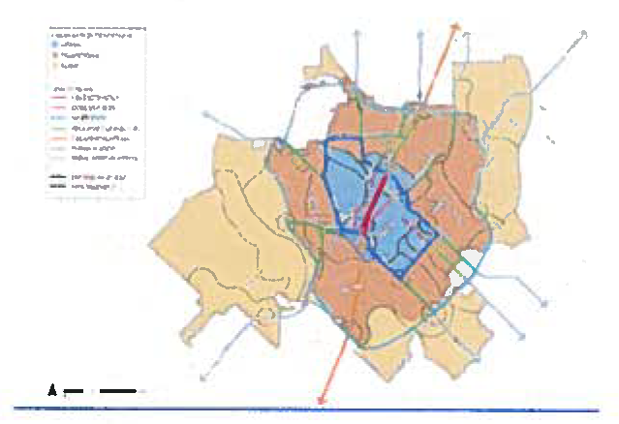
(c) Applicability.
(1) Location: These standards apply to all new non-residential development within the I-35 overlay district.
(2) Exemptions: These standards do not apply to the following:
• Change in use of an existing structure or expansion of an existing use that is lawfully permitted by the underlying zoning district.
• Use or development for which only a single-family residential building permit or certificate of occupancy is required.
• Rehabilitation of an existing building or structure that does not change the use or enlarge the building or structure.
(3) Relationship to other regulatory documents: The I-35 overlay district standards supplement the base zoning district classification. Whenever there is a conflict between the I-35 overlay district requirements and other sections of the City of Kyle Zoning Ordinance or other applicable regulations, the more restrictive requirement shall prevail.
(4) Variances: Any variances to the standards within this document shall be reviewed by the planning and zoning commission and appeals of the commission's decision shall be reviewed by the city council.
(5) Review and approval: The review of the following standards shall take place at the time of site development and building permit review.
(d) Uses. The permitted uses of the property shall be determined by the use regulations set forth in the base zoning district for the property except as follows:
(1) All motor vehicle and trailer sales, displays, rentals or leasing are prohibited from operating outdoors in the I-35 overlay district. This includes, but is not limited to, the sale, rental and leasing of cars, trucks, vans, motorcycles, water craft, recreational vehicles, all-terrain vehicles, OHV vehicles, buses, trailers, farm and lawn equipment, construction equipment, demolition equipment, commercial vehicles, limousines, and all other similar vehicles not listed. This description of outdoor vehicle sales applies to this entire section, including the "Exceptions" subsection.
(2) Exceptions. Motor vehicle sales, rentals, and leasing as described in this section are permitted within a covered, enclosed building, following city council approval of a conditional use permit. In all cases, all sales inventory and sales display models must be stored and presented for sale/lease/rental within a covered, enclosed building.
Land uses in operation at the time of adoption of this provision must operate in accordance with section 53-1140, nonconforming uses, Code of Ordinances, City of Kyle.
(e) Site standards.
Intent: The purpose of the site standards outlined within this document are to create development patterns that welcome motorists, pedestrians, and cyclists while establishing development standards that visually and cognitively establish a separation from the ordinary interstate landscape. Development within the I-35 overlay district should have a "front door" feel in the way they address or face the roadway. The layout of parking areas and buildings should promote safe and efficient pedestrian travel.
The following standards are intended to:
• Enhance and protect Kyle's character through clear development design goals and policies and minimum design standards.
• Protect and promote Kyle's long-term vitality through design standards that encourage high quality development, while discouraging less attractive and less enduring alternatives.
(1) Sidewalks. A minimum of a five-foot sidewalk is required along all public streets. Street trees on an average of every 40 feet shall be planted between the street and the sidewalk within a tree planting zone of no-less than seven feet wide (trees may be clustered without a reduction in the overall number of trees). Sidewalks and trees are to be installed within the public right-of-way. Sidewalks and street trees may be installed within private property if not feasible to construct within the right-of-way due to limited width, location of utilities, or other public agencies.
(2) Screening. Loading areas must be fully screened from view of public ROWs and residential districts (a minimum of a 14-foot screening wall must be provided for all loading areas). Wing walls, landscape screens, changes in building orientation, and/or other architectural elements must be used to buffer loading docks and mechanical equipment. Waste and recycling disposal areas must be screened from public streets, pedestrian gathering areas, and primary entrances with walls and/or landscaping.
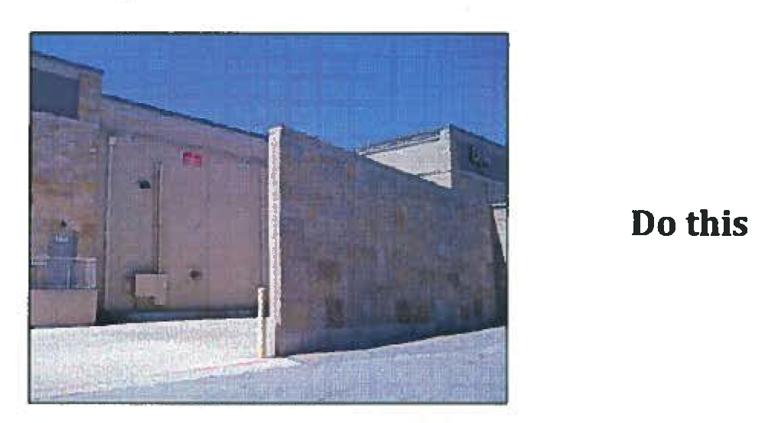
Wing wall used to screen loading dock.
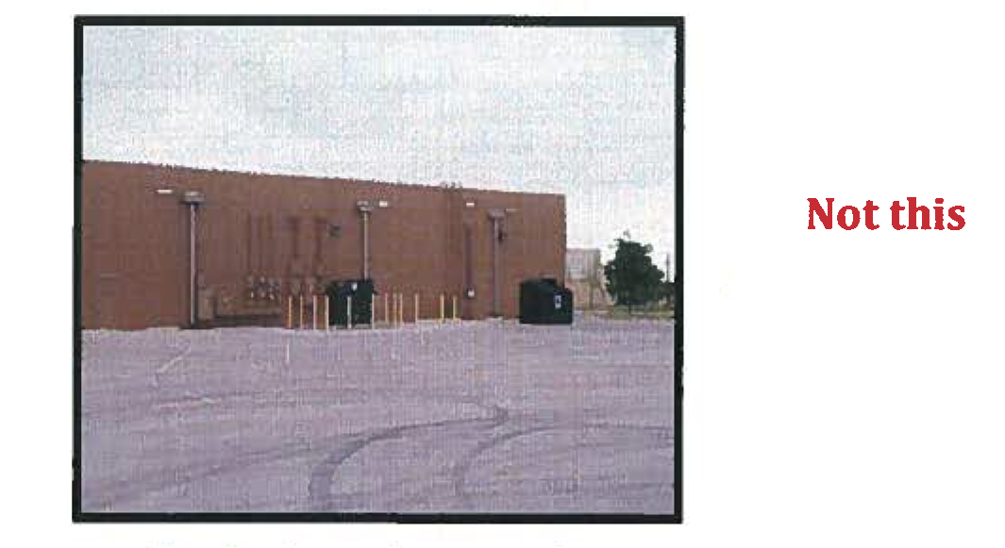
Example of unscreened utility and waste
disposal areas.
(3) Utilities. Utility boxes greater than two feet tall cannot be placed in the clear vision area, or interfere with use of streets, alleys, sidewalks, and bicycle paths. When utility equipment is required by the electric company to be placed in clear vision of streets, alleys, or sidewalks written notice of the requirement from the electric company must be submitted with the site plan along with a landscaping plan for the screening of the utility equipment. Utility boxes must be a uniform earth tone color or if mounted to a building shall match the wall color upon which the box is located.
(4) Utility equipment screening. Utility equipment located adjacent to a public street, viewable from a public street or circulation path or in an area frequently seen by the general public must be screened with a wing wall architecturally integrated into the host structure or evergreen landscaping.
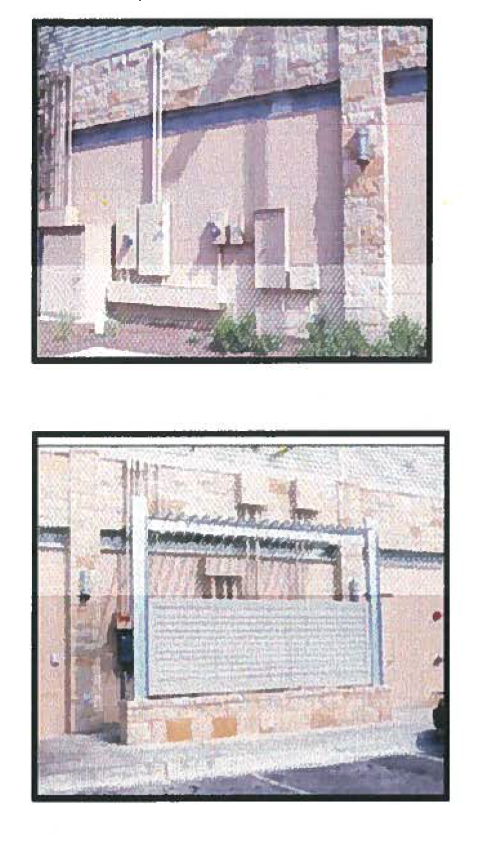
(f) Siting and orientation.
(1) Blank walls. Blank walls adjacent to a public street, sidewalks, trails, or interior pathways are prohibited. Design methods to eliminate blank walls can include:
• Transparent windows or doors.
• Display windows.
• Decorative accent lighting.
• Landscape planting bed at least five feet wide or a raised planter bed at least two feet high and three feet wide in front of the wall. Such planting areas shall include planting materials that are sufficient to obscure or screen at least 30 percent of the wall's surface within three years.
• Installing a vertical trellis in front of the wall with climbing vines or plant materials sufficient to obscure or screen at least 30 percent of the wall's surface within three years. For large areas, trellises should be used in conjunction with other blank wall treatments.
• A repeating pattern of wall recesses and projects, such as bays, offsets, reveals or projecting ribs, that has a relief of at least eight inches.
• A repeating pattern of pilasters projecting from the facade wall by a minimum of eight inches or architectural or decorative columns.
• Architectural details such as arches, friezes, tile work, murals, or moldings.
• Changes in plan with a depth of at least 24 inches, either diagonally, horizontally, or vertically, at intervals of not less than 20 feet and not more than 100 feet. * When not in conflict with the minimum articulation requirements of section j—building requirements.
• Enhanced exterior light features such as wall sconces, decorative light coves with concealed light sources, decorative lighting, ground-mounted accent lighting, or decorative pedestal lights.
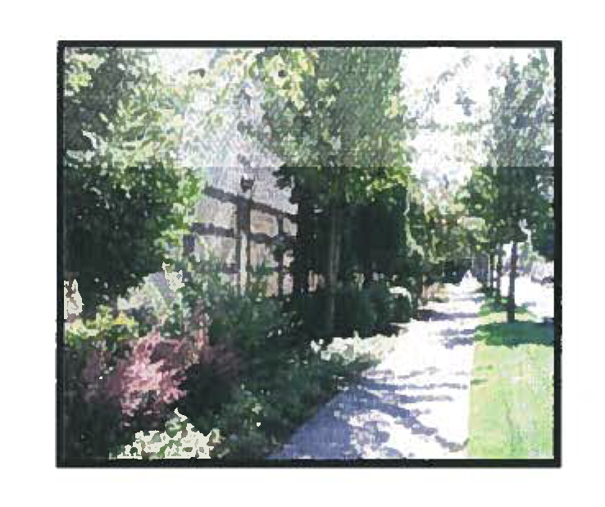
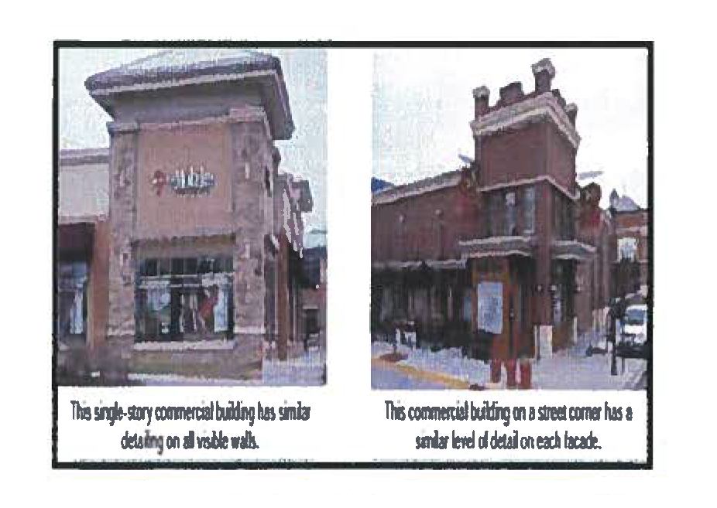
(2) Orientation to streets. The primary facade and pedestrian entrance of a building must be oriented towards the public right-of-way or courtyard. If a building cannot have its primary entrance facing a public right-of-way, then the requirements for the facade facing the public right-of-way shall include the following:
• Excluding window glazing, employ the same design character and colors as the building facade with the primary entrance; or
• Utilize architectural treatments, detail and scale elements such as canopies, that are consistent with the primary building facade.
• Enclose dumpsters, recycle bins and compactors with screening walls that match materials, style and colors of the adjacent building.
• Locate dumpsters and service areas on the side of the buildings.
• Screen service areas, including storage, meter banks, HVAC equipment, generators and similar equipment with screening walls and landscaping.
(3) Orientation to walkways. One main building entrance must open directly onto a connecting walkway with pedestrian frontage.
(4) Circulation. Circulation patterns must be as simple as possible. All likely pedestrian routes must be considered in the design phase of a development to prevent shortcuts through parking and landscape areas. An internal pedestrian walkway, ADA accessible, at least six feet wide must be provided from the perimeter public sidewalk to the primary public entrance.
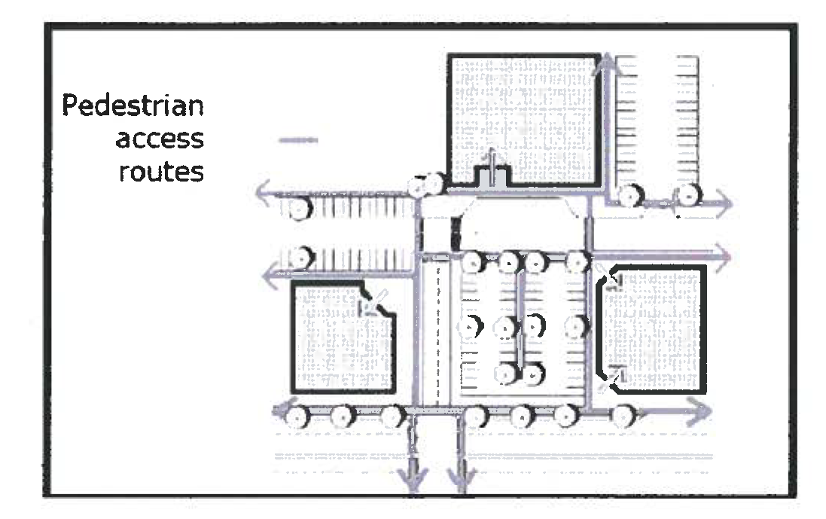
Example of an integrated pedestrian circulation system. Note the connection from the street, between buildings through parking lots and adjacent sites.
(5) Conflict points. Internal pedestrian walkways must be distinguished from driving surfaces by textured pavement or painted pavement and lighting.
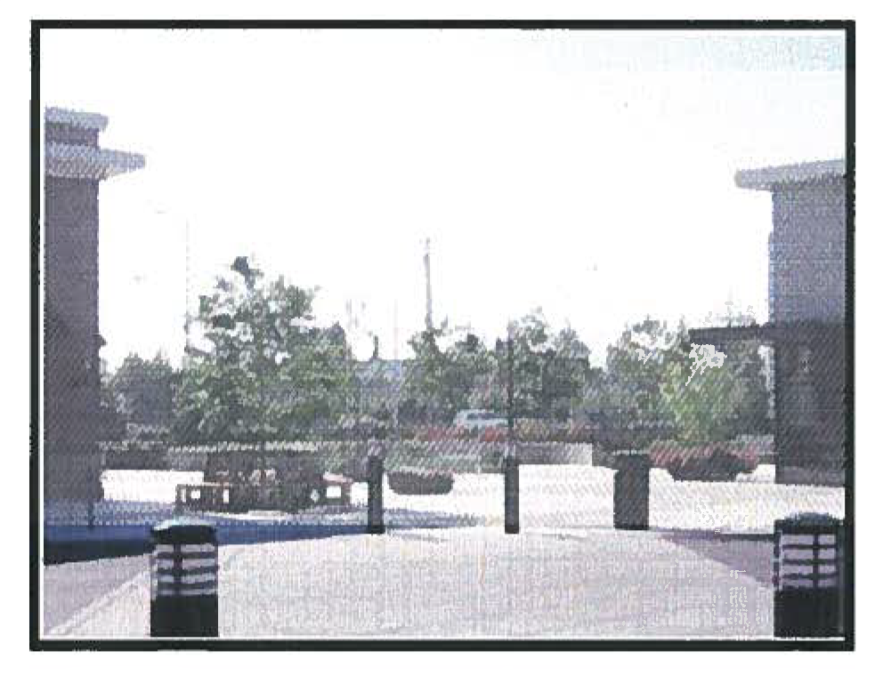
An example of a walkway with bollards that include light fixtures to clearly identify the pedestrian access.
(g) Water bodies and detention/retention areas.
Shape. Detention and water quality ponds shall utilize earthen berms and be designed with a curvilinear contoured shape. Any structural stabilization shall be limited to the use of native stone (except for outlet structure) and shall be limited to not more than 30 percent of the perimeter of the pond and shall be seamlessly integrated with landscape.
Natural and manmade water bodies at least 20,000 square feet in size placed next to a public right-of-way must be integrated into the overall design of a project in one of the following ways:
• Provide a walkway, with native trees on average 25-foot centers.
• Provide a public access area with covered structure and seating and appropriate pedestrian access.
• Provide a plaza or courtyard with shaded benches and/or picnic tables next to the water body.
If a dentition pond or water quality pond is not visible from or adjacent to a public or private street, sidewalk/trail, commercial or residential used or zoned property, circulation path, parking lot, or courtyard than shape and stabilization requirements shall not apply.

(h) Parking lots.
(1) Large parking lots must be visually and functionally segmented into smaller lots with no more than 250 parking spaces per parking area. For every parking area a minimum of a 15-foot landscape median/divider shall be installed to help break up "rooms" of large parking fields. These medians shall contain pedestrian walkways to offer safe, marked routes between parking spaces and building entries.
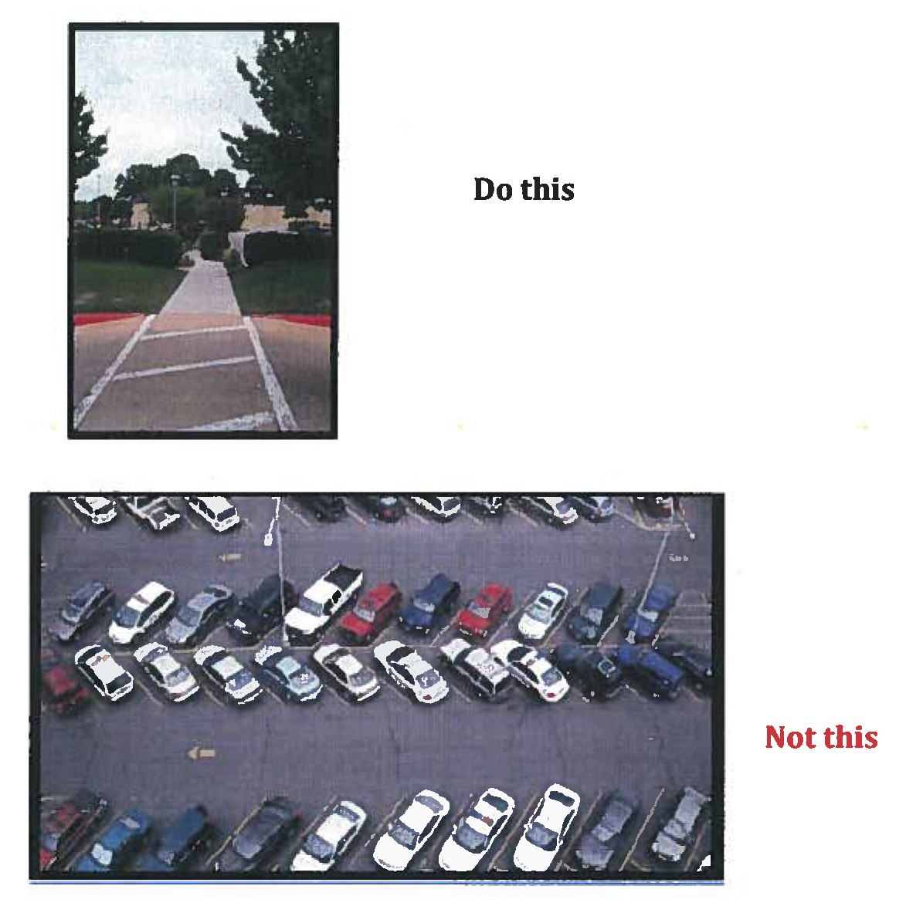
(i) Outdoor display/storage.
(1) Outdoor display of merchandise is permitted when such display is of merchandise from a permanent business located in a permanent legal structure on site and such display is limited to not more than 30 percent of the gross floor area of the building which houses the business displaying such merchandise.
(2) Display is not permitted within required setbacks. Except for items that would normally be utilized and stored outside, outdoor display shall occur only during the business hours of the applicable business establishment.
(3) Outdoor storage and container storage are permitted as an accessory use as follows:
a. Such storage does not exceed 20 percent of the gross floor area of the primary building that houses the business storing such materials,
b. Such storage or container is located no closer to a street frontage than the primary building that houses the business storing such materials,
c. Such storage or container is screened from view from adjacent properties,
d. Such storage or container is not permitted within required setbacks.
(j) Building requirements.
(1) Materials. Buildings constructed shall have a minimum of 90 percent masonry walls as defined below. The City of Kyle would like to encourage and support the use of red brick and white limestone, as used on Kyle City Hall. Retail buildings utilizing red brick and white limestone on 90 percent or more of new buildings shall be allowed a ten percent reduction in glazing requirements and shall be allowed an uninterrupted length of up to 40 feet rather than 30 feet. Non-retail buildings utilizing red brick and white limestone on 90 percent or more of new buildings shall be allowed a reduction of 50 percent of the required number of building front design features.
Masonry shall be defined to include the following:
• Brick.
• Natural stone.
• Concrete masonry units (decorative) * .
• Stucco/plaster/synthetic stucco to be used in detail applications only.
• Concrete sandblasted, textured and painted.
The ten percent of the exterior walls not included in masonry requirements may be covered with a variety of materials that could include but not limited to non-reflective corrugated steel panels, wood, prefinished metal panels, glass block, or other materials that are compatible with the overall design and use for the specific areas in which they are placed.
* Includes highly textured finish, such as split faced, intended, hammered, fluted, ribbed or similar architectural finish.
(2) Four-sided design. All walls must include materials and design characteristics consistent with those on the front of the building and/or same design character.
Exterior walls facing a driveway, public ROW, courtyard, sidewalk or circulation path or residential district or residential use cannot have a blank, uninterrupted length greater than 30 feet without including two or more of the below features. Buildings over 50,000 square feet shall not be allowed an uninterrupted length greater than 50 feet without including two or more of the below features:
• Change in plane;
• Change in texture;
• Masonry pattern;
• Windows; or
• Other equivalent element(s) that subdivide the wall into human scale proportions.
Side or rear walls which do not face a driveway, public ROW, sidewalk, circulation path, courtyard, residential district or residential use shall maintain the same materials with those on the front of the building but are not required to adhere to the uninterrupted length requirement outlined above.
(3) Roof. The continuous plane of a roof line cannot be more than 100 feet. All roof mounted mechanicals must be screened from public view.
(4) Building massing and form.
a. Retail. A single large dominant building mass must be avoided in new buildings. Buildings shall be constructed to one of the following two standards:
Option 1.
Thirty percent of the wall area below ten feet as measured from the finish floor level of the facade's entry shall consists of glazing (windows/doors).
Windows shall have a maximum exterior reflectivity of 20 percent.
Option 2.
A minimum of 25 percent of the front primary building facade shall consist of window or door openings. Window and door areas of the front facade may be reduced to 15 percent of area of facade if one additional architectural feature is added beyond the requirement.
All building fronts shall have at least five different design features to break the wall plane, buildings under 100,000 square feet in size shall have at least five different design features, and buildings over 100,000 square feet shall have at least six different design features.
The following are examples of the types of design features that shall be utilized: horizontal off-sets, recesses or projections, porches, breezeways, porte-cocheres, courtyards, awnings, canopies, alcoves, recessed entries, ornamental cornices, display or other ornamental windows, vertical "elevation" off-sets, decorative accent lighting, peaked roof forms, arches, outdoor patios, architectural details such as tile work or moldings integrated into the facade, a clustered landscape zoned with integrated planters or wing walls, accent materials, varied roof heights, premium roofing materials such as tile or standing seam metal.
All retail anchor stores, at least 25 percent of the stores in a shopping center, and freestanding, single-use buildings, must have a clearly defined, highly visible customer entrance with four or more of the following elements:
• Arcades;
• Arches;
• Canopies or porticos;
• Details such as tile work and moldings integrated into the building structure and design;
• Display windows;
• Integral planters or wing walls that include landscaped areas and/or places for sitting;
• Outdoor patios;
• Overhangs;
• Peaked roof forms;
• Raised corniced parapets over the door;
• Recesses and/or projections.
b. Non-retail/office buildings. All building fronts shall have at least five different design features to break the wall plane, buildings under 100,000 square feet in size shall have at least five different design features, and buildings over 100,000 square feet shall have at least six different design features. The following are examples of the types of design features that shall be utilized:
Horizontal off-sets, recesses or projections, porches, breezeways, porte-cocheres, decorative accent lighting, courtyards, architectural lighting, change in materials, awnings, canopies, alcoves, recessed entries, ornamental cornices, display or other ornamental windows, vertical "elevation" off-sets, peaked roof forms, arches, outdoor patios, architectural details such as tile work or moldings integrated into the facade, integrated planters or wing walls, accent materials, varied roof heights, premium roofing materials such as tile or standing seam metal, or similar design features approved by the director of planning and appealable to the planning and zoning commission.
Warehouse, mini-warehouse and overhead (commercial service) doors shall not be oriented so as to face a street(s) or residential property or shall be screened from view from the street(s) or residential property unless approved by the director of planning, appealable to the planning and zoning commission, determines that there is no other feasible.
(k) Walkway width and design. Sidewalks and walkways along the facades of mixed-use and retail buildings 100 feet or more in length (measured along the facades) that are not located adjacent to a street must be at least 12 feet wide (eight feet of the sidewalk shall remain unobstructed) and include the following:
• Trees shall be placed at an average of 30 feet on-center and placed in grates (except where trees are placed in planting strips). Breaks in the tree coverage will be allowed near major building entries to enhance visibility. However, no less than one tree per 60 lineal feet of building facades must be provided.
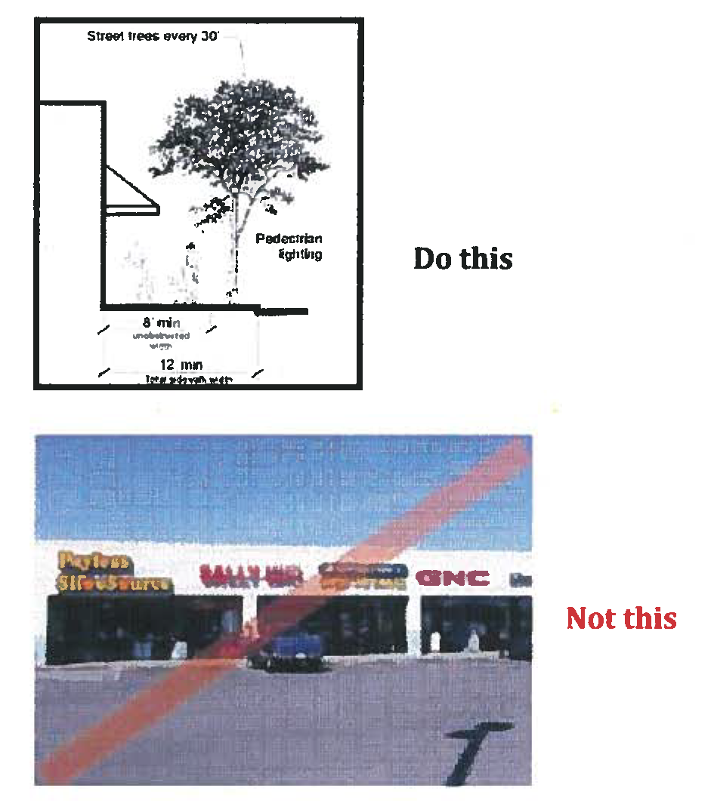
(l) Garage doors.
• Garage bay doors must be segmented, with windows covering at least 50 percent of the garage surface. Garage doors must be recessed at least two feet behind the building facade.
• Vehicle service areas and bays must be screened or sited so visibility from the public right-of-way is as low as possible. Bay doors cannot face a public street.
• Garage bay doors must be integrated into the overall design of the site with color, texture, and windows.
(m) Open space.
Intent: To provide a variety of accessible and inviting areas for outdoor dining, socializing and relaxing in commercial areas and to enhance the pedestrian environment.
All commercial developments, three acres or more in size, shall incorporate open space on-site. This could include a single public open space for larger developments or a variety of pedestrian-oriented spaces.
These are predominately hard-surfaced, plaza or courtyard type spaces. Pedestrian-oriented space shall have the following:
• Pedestrian-scaled lighting (no more than 15 feet in height) may be on-site or building-mounted lighting.
• Be sited in areas with significant pedestrian traffic to provide interest and security, such as adjacent to a building entry.
• Integrate landscaping features that add interest to the space.
• Pedestrian amenities, such as a water feature, drinking fountain, tables, and/or distinctive paving or artwork.
• Pedestrian-oriented building facades on some or all buildings facing the space.
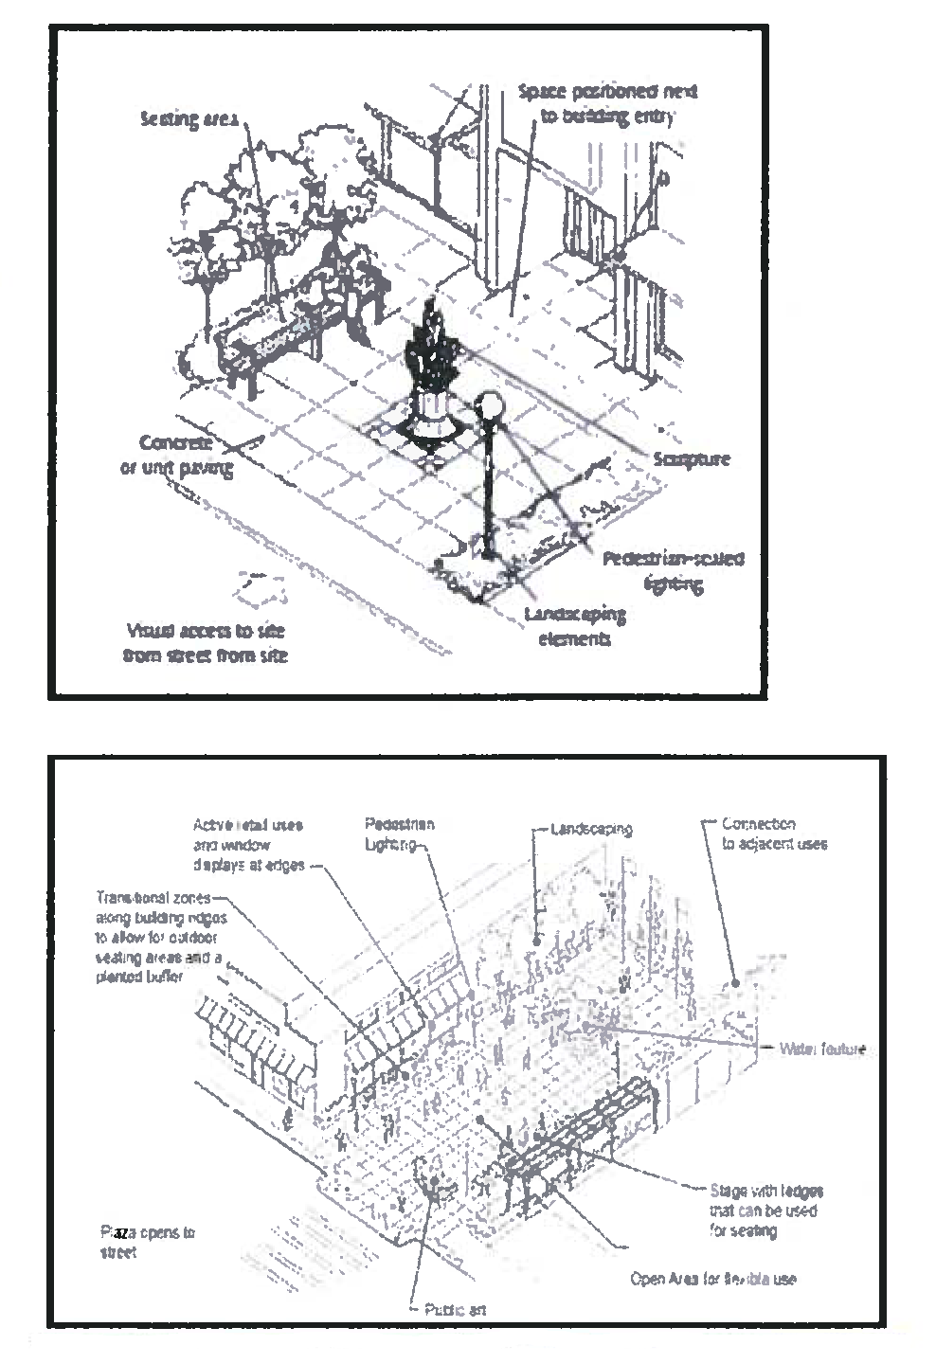
(Ord. No. 717, § 2(Exh. A), 12-18-2012; Ord. No. 940 , § 2(Exh. A), 4-4-2017)
Secs. 53-900—53-929. - Reserved.

