DIVISION 1. - GENERALLY

Sec. 53-33. - General requirements and limitations.
(a) Conformity to zoning district required. No building shall be erected and no existing buildings shall be moved, structurally altered, added to or enlarged, nor shall any land, building or premises be used, or designated for use for any purpose or in any manner other than provided for hereinafter in the district in which the building, land or premises is located; provided, however, that necessary structural repairs may be made where health and safety are endangered.
(b) Signs and billboards. No sign or billboard shall be erected, moved, altered, added to, enlarged, painted, or modified unless it shall conform to the provisions of this chapter and all applicable city ordinances governing the placement, location, permitting, construction and maintenance of signs. Except as otherwise expressly authorized by ordinance, all off-premises signs and billboards are expressly prohibited.
(c) Structures and buildings. No building, structure or accessory structure shall be erected, converted or enlarged, nor shall any such existing building or structure be structurally altered or rebuilt, nor shall any open space surrounding any building be encroached upon or reduced in any manner, unless the same shall be done and completed in a manner to comply with all applicable city codes and ordinances, and such work and structure shall:
(1) Conform to the building setback line, building site area, building location and land use regulations hereinafter designated for the district in which such building or open space is located.
(2) Not exceed the height limit herein established for the district in which such building is located, except as specifically authorized as follows:
a. The height limits prescribed herein shall not apply to television and radio towers, church spires, belfries, monuments, tanks, water and fire towers, stage towers, scenery lofts, cooling towers, ornamental towers and spires, chimneys, elevator bulkheads, smokestacks, necessary public or private utilities, conveyors, flagpoles, and necessary mechanical appurtenances. The height limits and other applicable regulations for television, radio and communications towers and antennas may be established by separate ordinance.
b. Public or semipublic service buildings, institutions or schools, where permitted, may be erected to a height not exceeding 60 feet and churches and other places of worship may be erected to a height not exceeding 75 feet when each of the required yards is increased by one foot for each two feet of additional building height above the height limits for the district in which the building is located.
(d) Accessory structures and uses. Accessory structures designed, constructed and located for a use permitted in the district, in compliance with this chapter and all other applicable city ordinances, are permitted in each zoning district.
(e) Conformity to construction plan requirements. No structure or building shall be erected, converted, enlarged, reconstructed or structurally altered unless construction plans meeting the requirements of this chapter have been approved by the city engineer and/or city building official.
(f) Conformity to parking and loading space requirements. No structure or building shall be erected, converted, enlarged, reconstructed, or structurally altered unless it shall conform to the off-street parking and loading requirements of this chapter.
(g) Conformity to landscaping and screening requirements. No building or structure shall be erected, converted, enlarged, reconstructed, or structurally altered unless it shall conform to the landscaping and screening requirements of the this chapter.
(h) Conformity to building setback requirements. No yard or other open space provided around any structure or building for the purpose of complying with provisions of this chapter shall be considered as providing a yard or open space for a building on any other lot.
(i) Outdoor lighting. All outdoor lighting shall be installed and maintained in compliance with all applicable city ordinances. Such lighting shall be located and maintained in a manner so as to not be directed onto any public street or adjacent property; provided that, such lighting may be directed directly down upon a public street as provided for streetlights.
(1) Multifamily, business and industrial. Outdoor lighting for multifamily, general retail, commercial, office and industrial property will be in accordance with the provisions of this chapter and city building codes. A lighting plan shall be included with the site plan submitted for a building permit.
(2) Residential. Outdoor lighting on residential property will be installed in accordance with applicable city ordinances. It will be located so as not to be directed directly upon adjoining property or create a nuisance for adjoining property owners. Lighting used for security purposes, which will be operated during night hours will be located as close as is practicable to main dwellings.
(j) Height and placement requirements. Except as otherwise specifically provided in this chapter, no building shall be erected or maintained within the required building setback line set forth herein, or which exceeds the height limits specified in chart 1 in subsection (k) of this section. The minimum street line width of all residential lots situated on a cul-de-sac shall be 35 feet, excluding width of side yard, drainage and/or public utility easements in which pipe will be laid as part of the initial development. The minimum street line width of all other lots situated on a cul-de-sac shall be 50 feet, excluding width of side lot line drainage and/or public utility easements in which pipe will be laid as part of the initial development.
(k) Common areas. If any part or portion of a development or property includes a common area or common open area, a home and/or property owners association shall be created and established in which all property owners shall be members. The articles and bylaws for the corporation and the declarations, conditions, covenants and restrictions for the proposed development shall provide for the assessment and collection of fees adequate and as necessary to maintain all such common areas in a good, clean and safe condition, and in compliance with all codes and ordinances of the city.
Chart 1
Land Use District | Front Setback (feet) | Side Setback (feet) | Corner Lot at Side Street or Alleyway Setback (feet) | Street Side Yard Setback (feet) | Rear Setback (feet) | Min. Lot Square Footage Area | Min. Lot Street Line Width (feet) | Height Limit (feet)
A | 40 | 25 | 40 | 25 | 25 | 43,500 | 150 | 45
UE | 25 | 25 | 25 | 25 | 25 | 22,500 | 100 | 45
R-1-1 | 35 ⁹ | 10 | 20 | 15 | 20 | 8,190 ¹ | 80 ¹ | 35
R-1-2 | 25 ⁹ | 7.5 | 15 | 10 | 15 | 6,825 ¹ | 65 ¹ | 35
R-1-3 | 20 ⁹ | 5 | 10 | 5 | 10 | 5,540 ¹ | 50 ¹ | 35
R-1-A | 25 | (2) | 10 | 15 | 15 | 4,550 ¹ | 35 | 35
R-1-T | (3) | (3) | 15 | 15 | (3) | 880 ³ | 22 | 35
R-1-C | (4) | (4) |  | 15 | (4) | 9,000 ⁴ | 80 | 45
R-2 | 25 ⁹ | 7 | 10 | 15 | 25 | 9,000 | 80 | 35
R-3-1 | 25 | 15 | 15 | 15 | 25 | (5) | 80 | 35 ⁶
R-3-2 | 25 | 20 | 15 | 15 | 25 | (5) | 80 | 45 ⁷
R-3-3 | 25 | 7 | 15 | 15 | 25 | (13) | 90 | 45 ⁷
M-1 | 25 | 7 | 15 | 15 | 25 | 8,190 | 80 | 35
M-2 | 25 | 7 | 25 | 25 | 25 | 8,190 | 80 | 35
CBD-1 | 25 ⁸ | (8) | 15 | 15 | (8) | (8) | (8) | 35 ⁸
CBD-2 | 0 | 0 | 0 | 0 | 0 | 2,500 | 25 | 45
RS | 25 | 10 | 15 | 15 | 15 | 6,000 | 50 | 45
HS | 50 | 50 | 50 | 50 | 50 | 10 acres | 200 | 100 ^{14/15}
W | 25 | 25 | 25 | 25 | 25 | 9,000 | 80 | 45
CM | 25 | 50 | 50 | 50 | 50 | 43,500 | 150 | 45
E | 25 | 25 | 15 | 15 | 15 | 6,000 | 50 | 45 ¹⁴
TU | 25 | 7 | 15 | 15 | 15 | (10) | (10) | (10)
B | 25 | 25 | 25 | 15 | 15 | (11) | (11) | (11)
PUD | (8) | (8) | (8) | 15 | (8) | 5 acres | (8) | (8)

Notes for chart—
(1) On approval by the city council:
a. In a section or phase of a subdivision up to 25 percent of R-1-1 lots may be less than 8,190 square feet in area but not less than 7,200 square feet, and up to 25 percent of the lots may be less than 80 feet in width but not less than 65 feet in width; and
b. Up to 25 percent of R-1-2 lots may be less than 6,825 square feet in area but not less than 5,825 square feet, and up to 25 percent of the lots may be less than 65 feet in width but not less than 55 feet in width; and
c. Up to 25 percent of R-1-3 lots may be less than 5,540 square feet in area, but not less than 4,740 square feet, and up to 25 percent of the lots may be less than 50 feet in width but not less than 45 feet in width; and
d. Up to 25 percent of R-1-T lots may be less than 880 square feet in area but not less than 800 square feet, and up to 25 percent of the lots may be less than 22 feet in width but not less than 20 ft in width; and
e. Up to 25 percent of R-1-A lots may be less than 4,550 square feet in area but not less than 4,000 square feet, and up to 25 percent of the lots may be less than 35 feet in width but not less than 30 ft in width.
If the city council approves any lots to be platted that have less area than the minimum area provided in the chart 1 in this section for any such zoning district, the percentage of such smaller lots actually platted and fully developed in any section or phase shall not at any time exceed the percentage of smaller lots approved by the city council for the entire subdivision or development. In no event shall more than 25 percent of the lots in any phase or section of a subdivision have less land area than the minimum lot area established in chart 1.
(2) Side yard setback for the R-1-A district is ten feet on one side, and a zero lot line is permitted on the other side. See definition for zero-lot-line lot.
(3) See division 5 of this article, pertaining to residential townhouse district R-1-T.
(4) See division 6 of this article, pertaining to residential condominium district R-1-C.
(5) Minimum lot area for property in the R-3-1 and R-3-2 district is 12,000 square feet, plus an additional 1,500 square feet for each dwelling unit in excess of four units; provided that the density limitations set forth for each such district shall apply.
(6) Not to exceed two stories.
(7) Not to exceed three stories.
(8) The conditions and limitations, setbacks and lot requirements set forth in chart 1 applicable to the district governing the proposed base use of the property shall apply within this district, i.e., if the proposed use of property within the district is a use provided for in the CBD-1 district the conditions and limitations applicable to the CBD-1 district shall apply to the property.
(9) On approval by the city council, up to 50 percent of the lots within a subdivision may have a front setback line up to 20 percent less than the district minimum, but in no case less than 16 feet; provided that no more than three consecutive and abutting lots shall have less than the district minimum front setback; and no more than 25 percent of the lots shall have a minimum front setback of ten percent less than the district minimum; and not more than 25 percent of the lots shall have a minimum front setback of 20 percent less than the district minimum. In no event shall a front-facing/front-loading attached garage have less than a 21-foot setback.
(10) The conditions, limitations, setbacks and lot requirements shall be determined by the planning commission as part of the site development approval process subsequent to review and recommendation by staff.
(11) The conditions, limitations, setbacks and lot size requirements shall comply fully with chapter 29, pertaining to signs.
(12) Minimum lot area for property in the R-3-3 district is 12,000 plus 1,500 square feet for each residential unit; minimum lot width shall be 90 feet.
(13) Height limitation applies to buildings; height for amusement rides shall be determined on a case-by-case basis.
(14) Not to exceed 100 feet for the main hospital building, and not to exceed 75 feet for any other building. No portion of any building within 100 feet of the property line of a single-family residential use shall exceed 35 feet in height.
(15) Permitted heights can exceed the maximum feet shown when and only when structured parking is included in the construction design of the building and occurs in the same phase of construction as the building and providing for a minimum of one-third of the number of the required parking spaces that are required by ordinance to separately serve the uses within the building.
(l) Impervious coverage. The maximum percentage of lot area which may hereafter be covered by improved surfaces and structures which do not allow for the penetration and/or percolation of stormwater into the soil beneath, such as, but not limited to, wood, stone, concrete, asphalt, roofing veneers, metal, swimming and decorative pools decking, brick, and hardened masonry pavers ^{[2]}, shall not exceed that set forth in chart 2 in this subsection.
Chart 2
District | Maximum Lot Coverage
R-1-1 | 50
R-1-2 | 60
R-1-A | 65
R-1-T | 80
R-1-C | 55
R-2 | 55
R-3-1 | 80
R-3-2 | 80
R-3-3 | 80
CBD-1 | 65 ⁽¹⁾
CBD-2 | 100
RS | 80
HS | 80
W | 75
CM | 75
E | 75
TU | As determined by the Planning Commission during the site review process

Note—All single-family detached land uses operated on lots in excess of 22,000 square feet are limited to an impervious surface ratio of 35 percent.
(1) Maximum lot coverage of 70 percent for the main building and for all buildings is permitted on lots where existing buildings were located prior to the date of the ordinance from which this chapter is derived. This only applies to buildings that existed on the date of the ordinance from which this chapter is derived, and that are within the area hereafter zoned CBD-1.
(m) Floor area ratio. Except as hereinafter provided, no building or structure may be erected, added to or altered to exceed the maximum floor area ratio standards in the various zoning districts as set forth in chart 3 in this subsection. In the zoning districts listed in the chart in this subsection, the maximum floor area ratio (FAR) for any building or structure shall be as follows:
Chart 3
District | Building Area, Maximum Floor Area  Ratio to Land Area
CBD-1 | 1.8:1
CBD-2 | 2.5:1
RS | 1.8:1
HS | 1.8:1
W | 1.5:1
CM | 1.2:1
E | 1.8:1
TU | 1.8:1

Structures used for off-street parking of vehicles shall not be included in calculating the building area to determine floor area ratio (FAR) standards.
(n) Parking. Automotive vehicles or trailers not bearing current license plates and state motor vehicle inspection stickers, excluding racing cars, antique cars, and cars belonging to members of armed forces who are on active duty, shall be parked or stored in any residential area only in completely enclosed buildings. No vehicle, trailer or major recreational equipment shall be parked or stored on any lot except that it shall be enclosed in a building or parked on a driveway or a concrete, paved or stone pad installed for such a purpose and subject to the following requirements:
(1) Parking regulations. Where any lot and/or structure is erected, reconstructed or converted for any of the business or commercial uses permitted in this chapter, designated on-street or off-street parking spaces shall be provided in a number not less than as provided in chart 4, set forth in this subsection.
(2) Handicap parking. Nonresidential handicap parking and handicap accessible routes shall be provided and constructed in compliance with the Texas Accessibility Standards (TAS).
(3) Maximum parking. The maximum number of parking spaces for a general retail, commercial, office or industrial use area shall not exceed 150 percent of the parking required pursuant to chart 4.
(4) Width of parking spaces. Except for all required handicap parking, not less than 50 percent of all parking spaces, for any given commercial use must be a minimum of nine feet in width, and all remaining parking spaces must not be less than 8½ feet in width.
(5) Reduction of parking. The total number of required motor vehicle parking spaces for a nonresidential use may be reduced by five percent for each of the activities listed in this subsection provided by the owners or operators, up to a maximum of ten percent reduction in the total number of motor vehicle spaces:
a. Participate in an area wide carpool/vanpool ride matching program for employees; designating at least ten percent of the employee motor vehicle parking spaces as carpool/vanpool parking and placing such spaces closer to the building than other employee parking;
b. Providing showers and lockers for employees who commute by bicycle;
c. Providing covered, secured bicycle parking racks or facilities;
d. Providing a transit facility that is approved by the local transit authority, and related amenities. Related amenities include, but are not limited to, a public plaza, pedestrian sitting areas, and additional landscaping.
(6) Development and maintenance standards for parking areas. Every parcel of land hereafter used as a public or private parking area, including commercial parking lots, shall be developed as follows:
a. Off-street parking areas for more than five vehicles shall be effectively screened by a sight-obscuring fence, hedge or planting, on each side which adjoins a residential use or property situated in a residential area.
b. Except for parking to serve residential uses, parking and loading areas adjacent to or within residential zones or adjacent to residential uses shall be designed to minimize disturbance of residents.
c. Access aisles shall be of sufficient width for vehicular turning and maneuvering.
(7) Council determination. Off-street and on-street parking, for all uses not within the categories listed in this subsection, shall be adequate to meet the anticipated needs and shall be determined by the city council using standards outlined for special exceptions and with a view towards providing adequate parking and carrying out the general scheme of the parking requirements herein set out.
(8) Special exception. The city council may grant a special exception to allow two or more uses to share parking spaces upon a showing that the particular uses in question will require parking at different times. Any spaces the council allows to be shared count toward the number of spaces each use must provide.
Chart 4 ⁽¹⁾
Use (See exhibit A for list of SIC codes) | Number of Parking Spaces ⁽¹⁾
CBD-1 | One space for every 200 square feet of floor space.
CBD-2 | If located on Center, Main or Front Streets, parking requirements will be decided on case-by-case basis. All others will provide one space for every 200 square feet of floor space.
R-1-1, R-1-2, R-1-A, R-1-T, R-1-C, R-2, R-3-1, R-3-2, R-3-3, M-1, M-2 and M-3 districts | Two spaces minimum for each living unit, and one-half space for each additional bedroom above two.
W and CM districts | One space per 1,000 feet of gross floor area and one space for every 1½ employees.
SIC codes: 72111000 (hotels); 72111001 (motels) | One space per bedroom and one space for each two employees.
SIC codes: 62149300 (emergency clinic); 62311000 (convalescent and nursing home); 62221000 (rehabilitation services); 62221001 (rehabilitation clinic); 62331100 (retirement homes) | One space for each two employees, and one space for each four patient beds.
Bars, cafes, restaurants, taverns, night clubs, and similar uses. RS SIC codes 72211006—72211017 (fast-food); 72211000—72211005 (restaurants); 72221200 (cafeteria); 72241001 (bar); 72241004 (brew pub) | One space for every four seats provided for customer services provided food is served. Bars and brew pubs which do not serve food shall have one space for three persons up to the maximum capacity allowed by fire codes for establishment.
RS district, E district unless SIC code stated additional requirements above. | One space for each 250 square feet of gross floor area.
HS district (hospital, extended care facility, intermediate care facility, longterm care facility). | Two for each bed, plus one for each two employees on the largest shift at full design capacity.
HS district (ambulance service) | Two for each ambulance vehicle.
HS district (medical educational institution) | One per each facility member, plus one for each three students.
HS district (clinic or doctor's office) | One per 200 square feet of gross floor area.

Note— ⁽¹⁾ The city council may, based on a site plan approved by council, waive all or part of these parking space requirements for buildings within the original town.
(o) Uses noncumulative. Uses within each district are restricted solely to those uses expressly permitted in each district, and are not cumulative unless so stated.
(p) Exceptions. Nothing in this section shall prohibit the approval of a comprehensive zero lot line residential development or other innovative housing development in compliance with the other terms and provisions of this chapter.
(q) Mandated exceptions. To the extent required by state or federal law, a personal care facility is an additional permitted use in any zoning district; provided that:
(1) Homes and residential units not designed and constructed in compliance with the ordinance and code requirements applicable to multiple-occupancy residential buildings and nursing homes, shall meet the following requirements:
a. The structure shall comply with provisions of the fire code, electrical code and building code that are applicable to nursing homes;
b. There shall be two parking spaces, plus one additional space for each three residents;
c. There shall be not less than 50 square feet of living space within a sleeping room for each occupant assigned to such room;
d. There shall be not less than 175 square feet of living area in the structure for each occupant/resident of the structure, and attendant on duty; and
e. The structure and operation shall comply with the standards established by the state department of human services as licensing standards for personal care facilities for a type B facility.
(2) The home must meet all applicable state licensing requirements;
(3) A personal care facility must have at least one paid staff member on duty 24-hours per day, and one supervisor for each six residents during waking hours;
(4) A personal care facility may not have more than 15 residents.
(Ord. No. 438, § 20, 11-24-2003; Ord. No. 438-35, §§ 1, 2, 8-2-2005; Ord. No. 526, §§ 2—6, 1-8-2008; Ord. No. 568, § 1, 5-5-2009; Ord. No. 663, §§ 1, 2, 7-19-2011; Ord. No. 915 , § 1(Exh. A), 10-18-2016; Ord. No. 928 , § 1(Exh. A), 1-17-2017)
Footnotes:
--- (2) ---
Pavers established on a suitable, engineered sub-base which is designed to capture and retain stormwater are not calculated in impervious surface ratios.

Sec. 53-34. - Establishment of zoning districts.
(a) The city is hereby divided into 24 zoning districts, one planned unit development district, and two overlay districts, the use, height and area regulations as set out herein shall be uniform in each district. The districts established shall be known as:
Abbreviated Designation | Zoning District Name | Designation
A | Agricultural district | District A
UE | Urban estate district | District UE
R-1-1 | Single-family residential 1 | District R-1-1
R-1-2 | Single-family residential 2 | District R-1-2
R-1-A | Single-family attached | District R-1-A
R-1-T | Residential townhouse | District R-1-T
R-1-C | Residential condominium | District R-1-C
R-2 | Residential two-family | District R-2
R-3-1 | Multifamily residential 1 | District R-3-1
R-3-2 | Multifamily residential 2 | District R-3-2
R-3-3 | Apartments residential 3 | District R-3-3
M-1 | Manufactured home | District M-1
M-2 | Manufactured home subdivision | District M-2
M-3 | Manufactured home park | District M-3
CBD-1 | Central business district 1 | District CBD-1
CBD-2 | Central business district 2 | District CDB-2
RS | Retail/service | District RS
W | Warehouse | District W
CM | Construction/manufacturing | District CM
E | Entertainment | District E
TU | Transportation/utilities | District TU
B | Billboards | District B
RV | Recreational vehicle park | District RV
HS | Hospital services | District HS
PUD | Planned unit development | District PUD
H | Historic district overlay | District H overlay
CU | Conditional use overlay | District CU overlay

(b) Zoning map. The location and boundaries of the districts herein established are shown upon the zoning map, which is hereby incorporated and made a part of this chapter; provided that such uses as listed but not shown on the zoning map are provided for future growth and use upon amendment of the comprehensive plan. It shall be the duty of the city building official to maintain the zoning map together with all notations, references, and other information shown thereon and all amendments thereto.
(c) District boundaries. Where uncertainty exists with respect to the boundaries of the established districts as shown on the zoning map, the following rules shall apply:
(1) Where district boundaries are indicated as approximately following the centerlines of streets or highways, street lines or highway right-of-way lines shall be construed to be said boundaries.
(2) Where district boundaries are so indicated that they approximately follow the lot lines, such lot lines shall be construed to be said boundaries.
(3) Where district boundaries are so indicated that they are approximately parallel to the centerlines or street lines of streets, or the centerlines of right-of-way lines of highways such district boundaries shall be construed as being parallel thereto and at such distance therefrom as indicated on the zoning map. If no distance is given, such dimension shall be determined by the use of the scale on said zoning map.
(4) In subdivided property, the district boundary lines on the zoning map shall be determined by use of the scale appearing on the map.
(5) If a district boundary line divides a property into two parts, the district boundary line shall be construed to be the property line nearest the district line as shown.
(6) Whenever any street, alley or other public way is vacated by the city council, the zoning district shall be automatically extended to the center of such vacation and all area included in the vacation shall then and henceforth be subject to all regulations of the districts as extended.
(7) Where the streets on the ground differ from the streets shown on the zoning map, those on the ground shall control.
(Ord. No. 438, § 21, 11-24-2003)
Sec. 53-35. - Zoning of annexed areas.
(a) Interim zoning district. All territory hereafter annexed to the city shall be automatically classified as agricultural district A, pending subsequent action by the planning and zoning commission and council for permanent zoning; provided that upon application, by either the city or the property owner of the land being annexed, for zoning other than agricultural, notice may be given and hearings held in compliance with V.T.C.A., Local Government Code ch. 211 and upon annexation, such property may be permanently zoned as determined by the city council after considering the planning and zoning commission's recommendation.
(b) Permits in interim zoned areas. In an area temporarily classified as agricultural district A, no permits for the construction of a building or use of land other than uses allowed in said district under this chapter shall be issued by the city building official.
(Ord. No. 438, § 22, 11-24-2003)
Sec. 53-36. - Agricultural district A.
The permitted uses in the agricultural district A allow farming, ranching, pasturage, detached single-family residences and related accessory structures, on a minimum one acre tract. Parks, playgrounds, greenbelts and other public recreational facilities, owned and/or operated by the municipality or other public agency are permitted.
(Ord. No. 438, § 23, 11-24-2003)
Sec. 53-37. - Urban estate district UE.
The urban estate district UE permits detached single-family residential dwellings with a minimum of 1,800 square feet of living area and related accessory uses on lots that are a minimum of one acre in size. Parks, playgrounds, greenbelts and other public recreational facilities, owned and/or operated by the municipality or other public agency are permitted.
(Ord. No. 438, § 24, 11-24-2003)
Secs. 53-38—53-62. - Reserved.
DIVISION 2. - SINGLE-FAMILY RESIDENTIAL 1 DISTRICT R-1-1

Sec. 53-63. - Purpose and permitted uses.
The R-1-1 single-family residential 1 district allows detached single-family residences with a minimum of 1,600 square feet of living area and permitted accessory structures on a minimum lot size of 8,190 square feet. There shall be no more than 3.9 houses per buildable acre.
(Ord. No. 438, § 25(a), 11-24-2003)
Sec. 53-64. - Additional permitted uses.
In addition to the uses permitted in division, the following uses are permitted in the R-1-1 single-family residential 1 district:
(1) Parks, playgrounds, community buildings and other public recreational facilities, owned and/or operated by the municipality or other public agency.
(2) Public buildings, including libraries, museums, police and fire stations.
(3) Real estate sales offices during the development of a residential subdivision but not to exceed two years. Display dwellings with sales offices, provided that if said display dwellings are not moved are converted to a permitted use within a period of one year, specific permission must be obtained from the city council for said display houses to remain.
(4) Schools, public, private and denominational.
(5) Temporary buildings for uses incidental to construction work on the premises, which buildings shall be removed upon the completion or abandonment of construction work.
(6) Water supply reservoirs, pumping plants and towers.
(7) Accessory structures and uses customarily incident to the uses in this division and located on the same lot therewith, not involving the conduct of any business or commercial enterprise.
(8) Churches.
(Ord. No. 438, § 25(b), 11-24-2003)
Sec. 53-65. - Conditions and limitations.
The following are the conditions and limitations in the R-1-1 single-family residential 1 district:
(1) The height and placement requirements shall be as provided in chart 1, section 53-33(k).
(2) Parking. The parking regulations and requirements shall be as provided in chart 4, section 53-33(n).
(3) Garages are required and must be one of the following designs:
a. Detached with a minimum setback of five feet from the front wall of the home facing front property line;
b. May be attached and must have a minimum setback of five feet from the front wall of the home facing front property line; or
c. May be attached and meet minimum front setback requirements, but must face side property line.
Each garage must be designed and constructed with a minimum of 480 square feet.
(4) All buildings and structures, garages, and/or accessory buildings constructed within this district must have all four sides composed of 100 percent brick, stone, hardiplank or other approved masonry product.
(Ord. No. 438, § 25(c), 11-24-2003)
Secs. 53-66—53-88. - Reserved.
DIVISION 3. - SINGLE-FAMILY RESIDENTIAL 2 DISTRICT R-1-2

Sec. 53-89. - Purpose and permitted uses.
The single-family residential 2 district permits detached single-family dwellings with a minimum of 1,200 square feet of living area, and related accessory structures, on a minimum lot size of 6,825 square feet. There shall be no more than 4.7 houses per buildable acre.
(Ord. No. 438, § 26(a), 11-24-2003)
Sec. 53-90. - Additional permitted uses.
The additional permitted uses for the single-family residential 2 district shall be as set forth in section 53-64.
(Ord. No. 438, § 26(b), 11-24-2003)
Sec. 53-91. - Conditions and limitations.
The conditions and limitations for district R-1-2 are as follows:
(1) Height and placement requirements. The height and placement requirements shall be as provided in chart 1, section 53-33(k).
(2) Parking. The parking regulations and requirements shall be as provided in chart 4, section 53-33(n).
(3) Garages are required and must be one of the following designs:
a. Detached with a minimum setback of five feet from the front wall of the home facing front property line;
b. May be attached and must have a minimum setback of five feet from the front wall of the home facing front property line; or
c. May be attached and meet minimum front setback requirements, but must face side property line.
Each garage must be designed and constructed with a minimum of 480 square feet.
(4) All buildings and structures, garages, and/or accessory buildings constructed within this district must have all four sides composed of 100 percent brick, stone, hardiplank or other approved masonry product.
(Ord. No. 438, § 26(c), 11-24-2003)
Secs. 53-92—53-100. - Reserved.
DIVISION 3A. - SINGLE-FAMILY RESIDENTIAL 3 DISTRICT R-1-3

Sec. 53-101. - Purpose and permitted uses.
The R-1-3 single-family residential 3 district allows detached single-family residences with a minimum of 1,000 square feet of living area and permitted accessory structures on a minimum lot size of 5,540 square feet. There shall be no more than 5.5 houses per buildable acre.
( Ord. No. 928 , § 1(Exh. A), 1-17-2017)
Sec. 53-102. - Additional permitted uses.
In addition to the uses permitted in division, the following uses are permitted in the R-1-3 single-family residential 3 district:
(1) Parks, playgrounds, community buildings and other public recreational facilities, owned and/or operated by the municipality or other public agency.
(2) Public buildings, including libraries, museums, police and fire stations.
(3) Real estate sales offices during the development of a residential subdivision but not to exceed two years. Display dwellings with sales offices, provided that if said display dwellings are not moved are converted to a permitted use within a period of one year, specific permission must be obtained from the city council for said display houses to remain.
(4) Schools, public, private and denominational.
(5) Temporary buildings for uses incidental to construction work on the premises, which buildings shall be removed upon the completion or abandonment of construction work.
(6) Water supply reservoirs, pumping plants and towers.
(7) Accessory structures and uses customarily incident to the uses in this division and located on the same lot therewith, not involving the conduct of any business or commercial enterprise.
(8) Churches.
( Ord. No. 928 , § 1(Exh. A), 1-17-2017)
Sec. 53-103. - Conditions and limitations.
The following are the conditions and limitations in the R-1-3 single-family residential 3 district:
(1) The height and placement requirements shall be as provided in chart 1, section 53-33(k).
(2) Parking. The parking regulations and requirements shall be as provided in chart 4, section 53-33(n).
(3) Garages are required and must be one of the following designs:
a. Detached with a minimum setback of five feet from the front wall of the home facing front property line;
b. May be attached and must have a minimum setback of five feet from the front wall of the home facing front property line; or
c. May be attached and meet minimum front setback requirements, but must face side property line.
Each garage must be designed and constructed with a minimum of 480 square feet.
(4) All buildings and structures, garages, and/or accessory buildings constructed within this district must have all four sides composed of 100 percent brick, stone, hardiplank or other approved masonry product.
( Ord. No. 928 , § 1(Exh. A), 1-17-2017)
Secs. 53-104—53-110. - Reserved.
DIVISION 4. - SINGLE-FAMILY ATTACHED DISTRICT R-1-A, GARDEN HOME^{[3]}

Footnotes:
--- (3) ---
Editor's note— Ord. No. 928 , § 1(Exh. A), adopted Jan. 17, 2017, amended the title of div. 4 from "Single-Family Attached/Detached District R-1-A, Garden Home" to read as herein set out.

Sec. 53-111. - Purpose and permitted uses.
The single-family attached district R-1-A, garden home allows attached single-family structures with a minimum of 1,000 square feet of living area per dwelling unit and permitted accessory structures on a minimum lot size of 4,800 square feet. There shall be no more than 6.8 houses per buildable acre. The single-family attached residences authorized in this zoning district include those generally referred to as garden homes, paired homes, patio homes and zero lot line homes. Additionally, single family detached structures are permitted in this district as a conditional use, as provided in V.T.C.A., Local Government Code ch. 211; provided that a conditional use permit may only be approved after a public hearing is held by the city council after having received a report and recommendation from the planning and zoning commission concerning the effect of the proposed use on the adjacent and neighboring properties and neighborhoods.
(Ord. No. 438, § 27(a), 11-24-2003; Ord. No. 438-35, § 3(a), 8-2-2005; Ord. No. 928 , § 1(Exh. A), 1-17-2017)
Sec. 53-112. - Additional permitted uses.
In addition to the uses permitted in this division, the following uses are permitted in the R-1-A district:
(1) Temporary buildings for uses incidental to construction work on the premises, to be removed upon the completion or abandonment of construction work.
(2) Accessory structures and uses customarily incident to the uses listed in this section and section 53-111 and located on the same lot therewith, not involving the conduct of any business or commercial enterprise.
(Ord. No. 438, § 27(b), 11-24-2003; Ord. No. 438-35, § 3(b), 8-2-2005)
Sec. 53-113. - Conditions and limitations.
The conditions and limitations for the R-1-A district are as follows:
(1) Height and placement requirements. The height and placement requirements shall be as provided in chart 1, section 53-33(k).
(2) Parking. The parking regulations and requirements shall be as provided in chart 4, section 53-33(n).
(3) Garages are required and must be one of the following designs:
a. Detached with a minimum setback of five feet from the front wall of the home facing front property line;
b. May be attached and must have a minimum setback of five feet from the front wall of the home facing front property line; or
c. May be attached and meet minimum front setback requirements, but must face side property line.
Each garage must be designed and constructed with a minimum of 480 square feet.
(4) All buildings and structures, garages, and/or accessory buildings constructed within this district must have all four sides composed of 100 percent brick, stone, hardiplank or other approved masonry product.
(Ord. No. 438, § 27(c), 11-24-2003; Ord. No. 438-35, § 3(c), 8-2-2005)
Secs. 53-114—53-139. - Reserved.
DIVISION 5. - RESIDENTIAL TOWNHOUSE DISTRICT R-1-T

Sec. 53-140. - Purpose and permitted uses.
The residential townhouse district R-1-T allows attached single-family structures containing four or more dwelling units with a minimum of 1,000 square feet of living area per unit and permitted accessory structures. The single-family residences authorized in this zoning district are those generally referred to as townhouses. There shall be no more than ten units per buildable acre of land within the associated boundary of the premises of the townhouse site.
(Ord. No. 438, § 28(a), 11-24-2003; Ord. No. 928 , § 1(Exh. A), 1-17-2017)
Sec. 53-141. - Additional permitted uses.
There are no additional permitted uses in the R-1-T residential townhouse district.
(Ord. No. 438, § 28(b), 11-24-2003)
Sec. 53-142. - Conditions and limitations.
The conditions and limitations district R-1-T is as follows:
(1) The declaration, conditions and covenants for the project shall provide for a home owners association and the assessment and collection of fees adequate and as necessary to maintain the property in compliance with all ordinances of the city.
(2) Height and placement requirements. The height and placement requirements shall be as provided in chart 1, section 53-33(k).
(3) Parking. The parking regulations and requirements shall be as provided in chart 4, section 53-33(n).
(Ord. No. 438, § 28(c), 11-24-2003)
Sec. 53-143. - Site development regulations.
The site development regulations as set forth in this section shall be exclusively applicable to residential townhouses, district R-1-T, and in addition to those in chart 1 in section 53-33(k):
(1) Density. Maximum dwelling units per buildable acre is ten units.
(2) Front yard. There shall be a front yard having a depth of not less than 15 feet extending from the property line of each individual lot to the nearest line of:
a. The curbline of any driveway or parking area;
b. Any wall of any structure; or
c. The boundary line of the property included within the townhouse development, whichever is closer.
(3) Side yard. No side yard shall be required for individual lots. There shall be a side yard setback of not less than 15 feet from the walls of any building, or accessory building, to the nearest boundary line of any property not included within the townhouse development.
(4) Rear yard minimum setback. There shall be a rear yard setback having a depth of not less than 15 feet from the rear most wall of the dwelling unit to the back property line, or, if a garage is at the rear of the property, 15 feet from the rear most wall of the dwelling to the nearest wall or roofline of the garage. No building or structure shall be located within 15 feet of the boundary line of any property not included within the townhouse development.
(5) Garages.
a. Garages are required within the boundaries of the development site and must be one of the following designs:
1. Detached with a minimum setback of five feet from the front wall of the home facing front property line;
2. May be attached and must not protrude forward of the front or side wall of the home facing the front or any side property line; or
3. May be attached and meet minimum front setback requirements, but must face side property line.
Each dwelling unit must have a garage, which must be designed and constructed with a minimum of 480 square feet per dwelling unit, and may be located on or reasonably adjacent to the development lot.
b. A minimum of two off-street parking spaces shall be provided for each living unit. All off-street parking and driveways shall be improved with all-weather asphalt, concrete, or paving stones, and in the case of open parking, curb and gutter.
c. No curbline of a driveway or parking area shall be less than five feet from the nearest boundary line of any property not within the townhouse development.
(6) Approved materials. All buildings and structures, garages, and/or accessory buildings constructed within this district must have all four sides composed of 100 percent brick, stone, hardiplank or other approved masonry product.
(Ord. No. 438, § 28(d)(i)—(vi), 11-24-2003; Ord. No. 928 , § 1(Exh. A), 1-17-2017)
Secs. 53-144—53-171. - Reserved.
DIVISION 6. - RESIDENTIAL CONDOMINIUM DISTRICT R-1-C

Sec. 53-172. - Purpose and permitted use.
The residential condominium district R-1-C allows the establishment of a residential housing in compliance with the Texas Uniform Condominium Act, V.T.C.A., Property Code ch. 82, with individual apartments or units having a minimum of 500 square feet living area, inclusive of separate sleeping, living and kitchen facilities.
(Ord. No. 438, § 29(a), 11-24-2003)
Sec. 53-173. - Conditions and limitations.
The conditions and limitations in the district R-1-C is as follows:
(1) All construction, plumbing, heating, cooling and electrical work shall comply with all applicable city ordinances. No land or property including an existing building or structure proposed to be converted to condominiums shall be zoned for such purpose prior to a complete inspection by the building official, conducted at the expense of the owners.
(2) The declaration, conditions and covenants for the proposed condominium shall provide for the assessment and collection of fees adequate and as necessary to maintain the property in compliance with all codes and ordinances of the city.
(3) A note shall be included on the preliminary and final plat stating that no certificate of occupancy may be issued for the proposed residential condominium project until the owner or owners of the property have complied with V.T.C.A., Property Code ch. 82, or any other statute enacted by the state concerning condominiums. The building official shall not issue a certificate of occupancy until the owner or owners of the property have complied with V.T.C.A., Property Code ch. 82, and any other state statute concerning condominiums.
(4) Height and placement requirements. The height and placement requirements shall be as provided in chart 1, section 53-33(k).
(5) Parking. The parking regulations and requirements shall be as provided in chart 4, section 53-33(n).
(Ord. No. 438, § 29(b), 11-24-2003)
Sec. 53-174. - Site development regulations.
The site development regulations set forth in this section shall be exclusively applicable to residential condominium, district R-1-C.
(1) Density. The maximum dwelling units per buildable acre or square footage for the R-1-C district are as follows:
a. Lot size of 9,000 square feet for two units.
b. Lot size of 10,000 square feet for four units.
c. A minimum of three units and for acreage tracts, 36 units per buildable acre.
(2) Front yard. There shall be a common area front yard having a depth of not less than 25 feet.
(3) Side yard. There shall be a common area side yard having a depth of not less than 15 feet.
(4) Rear yard. There shall be a common area rear yard having a depth of not less than 15 feet.
(5) Parking. The parking requirements for the R-1-C district is as follows:
a. Covered off-street parking is required and may be attached or detached and accessible from a public or private street.
b. Covered parking is required and may be attached or detached and placed to rear of the property. Attached covered parking must not face the front lot line.
c. Covered parking required within this district shall provide and accommodate for two parking spaces, as defined herein for each living unit. All covered parking and/or off-street parking and driveways shall be improved with all weather asphalt, concrete, or paving stones, and curb and gutter.
d. No curbline of a driveway or parking area shall be less than five feet from the nearest boundary line of any property not within the townhouse development.
(6) Approved materials. All buildings and structures, garages, and/or accessory buildings constructed within this district must have all four sides composed of 100 percent brick, stone, hardiplank or other approved masonry product.
(Ord. No. 438, § 29(c), (d), 11-24-2003)
Secs. 53-175—53-203. - Reserved.
DIVISION 7. - RESIDENTIAL TWO-FAMILY DISTRICT, R-2 DUPLEX

Sec. 53-204. - Purpose and permitted uses.
(a) The residential two-family district R-2 duplex allows single-family dwellings and duplex housing not to exceed six units per buildable acre.
(b) Two-family dwellings shall have a minimum living area on each side of 900 square feet.
(Ord. No. 438, § 30(a), 11-24-2003)
Sec. 53-205. - Additional permitted uses.
As set forth in section 53-64.
(Ord. No. 438, § 30(b), 11-24-2003)
Sec. 53-206. - Conditions and limitations.
The conditions and limitations of the R-2 district are as follows:
(1) Height and placement requirements. The height and placement requirements shall be as provided in chart 1, section 53-33(k).
(2) Parking. The parking regulations and requirements shall be as provided in chart 4, section 53-33(n).
(3) Garages or carports are required. A minimum of two off-street parking spaces shall be provided for each living unit. All off-street parking and driveways shall be improved with all-weather asphalt, concrete, or paving stones, and curb and gutter.
(4) Approved materials. All buildings and structures, garages, and/or accessory buildings constructed within this district must have all four sides composed of 100 percent brick, stone, hardiplank or other approved masonry product.
(Ord. No. 438, § 30(c), (d), 11-24-2003)
Secs. 53-207—53-237. - Reserved.
DIVISION 8. - MULTIFAMILY RESIDENTIAL 1, DISTRICT R-3-1

Sec. 53-238. - Purpose and permitted uses.
The multifamily residential district R-3-1 allows three-family and four-family dwellings each having a minimum living area of 850 square feet. The R-3-1 district permits typical garden apartment development with buildings not exceeding two stories, having at least five and not more than 12 units per buildable acre, and with apartments or units having a minimum living area of 850 square feet.
(Ord. No. 438, § 31(a), 11-24-2003)
Sec. 53-239. - Conditions and limitations.
The conditions and limitations on uses in the R-3-1 district are as follows:
(1) Density. More than one building or structure may be located upon a lot.
(2) Access. Any structure not facing a public street shall face upon a court yard having a minimum width of 45 feet between structures and any appurtenances thereto, which courtyard shall have direct access to a public street or a parking lot abutting a public street.
(3) Distance between buildings. No exterior walls of any two buildings, any one of which buildings contains an apartment or living unit and either one of which exterior walls includes a window or door, and which walls are parallel or within 45 degrees of being parallel, shall be closer together than a horizontal distance of 45 feet.
(4) Minimum distance requirements. All buildings and structures shall, except as provided in subsection (3) of this section, be separated by a minimum horizontal distance of eight feet.
(5) Parkland requirements. Unless otherwise satisfied pursuant to chapter 41, pertaining to subdivisions, one acre per 100 dwelling units, or five percent of the total site area, whichever is greater, shall be provided to satisfy parkland requirements; provided that the council may, at its discretion, require the payment of the established fee in lieu of land dedication for each such dwelling unit. Such recreational open space shall be located or arranged so as to function as a recreational area and be uniformly beneficial to all of the dwelling units in the project or development. Open space required to separate structures shall not be considered to be a part of the required recreational open space.
(6) Parking.
a. There shall be a minimum 15-foot setback from the rear most wall of any garage, and from the curbline of any parking area, to the nearest property line.
b. Garages and/or covered parking is required, and may be attached or detached.
c. A minimum of two off-street parking spaces shall be provided for each living unit. All off-street parking and driveways shall be improved with all weather asphalt, concrete, or paving stones, and curb and gutter.
(7) Traffic impact. The planning and zoning commission and the council may consider number of units proposed, the availability of mass transit and the impact the development may have on existing traffic patterns, with respect to any application for multifamily zoning.
(8) Height and placement requirements. The height and placement requirements shall be as provided in chart 1, section 53-33(k).
(9) Parking. The parking regulations and requirements shall be as provided in chart 4, section 53-33(n).
(10) Approved materials. All buildings and structures, garages, and/or accessory buildings constructed within this district must have all four sides composed of 100 percent brick, stone, hardiplank or other approved masonry product.
(Ord. No. 438, § 31(b), (d), 11-24-2003)
Sec. 53-240. - Site development regulations.
(a) The site development regulations in this section shall be applicable to apartment buildings and property zoned multifamily residential district R-3-1.
(b) The maximum dwelling units per buildable acre is 12 units.
(Ord. No. 438, § 31(c), 11-24-2003)
Secs. 53-241—53-260. - Reserved.
DIVISION 9. - MULTIFAMILY RESIDENTIAL 2, DISTRICT R-3-2

Sec. 53-261. - Purpose and permitted uses.
The multifamily residential district R-3-2 permits typical apartment development with buildings not exceeding three stories, nor more than 21 units per buildable acre, and with apartments or units having a minimum living area of 400 square feet; provided that not more than 25 percent of the units in any such apartment development or project shall have less than 500 square feet of living area.
(Ord. No. 438, § 32(a), 11-24-2003; Ord. No. 438-47, § 2(a), 7-5-2006)
Sec. 53-262. - Conditions and limitations.
See section 53-239(1) through (4).
(Ord. No. 438, § 32(b), 11-24-2003; Ord. No. 438-47, § 2(b), 7-5-2006)
Sec. 53-263. - Site development regulations.
The following site development regulations shall be applicable to apartment buildings and property zoned multifamily residential, district R-3-2:
(1) Density. The maximum dwelling units per building acre are 21 units.
(2) Height and placement requirements. The height and placement requirements shall be as provided in chart 1, section 53-33(k).
(3) Parking. The parking regulations and requirements shall be as provided in chart 4, section 53-33(n).
(4) Approved materials. All buildings and structures, garages, and/or accessory buildings constructed within this district must have all four sides composed of 100 percent brick, stone, hardiplank or other approved masonry product.
(Ord. No. 438, § 32(c), (d), 11-24-2003; Ord. No. 438-47, § 2(c), (d), 7-5-2006)
Secs. 53-264—53-291. - Reserved.
DIVISION 10. - APARTMENTS RESIDENTIAL 3, DISTRICT R-3-3

Sec. 53-292. - Purpose and permitted uses.
The multifamily residential district R-3-3 permits typical apartment development with buildings not exceeding three stories, nor more than 28 units per buildable acre, and with apartments or units having a minimum living area of 500 square feet; provided that not more than 25 percent of the units in any such apartment development or project shall have less than 750 square feet of living area.
(Ord. No. 438, § 33(a), 11-24-2003)
Sec. 53-293. - Conditions and limitations.
See section 53-239.
(Ord. No. 438, § 33(b), 11-24-2003)
Sec. 53-294. - Site development regulations.
The following site development regulations shall be applicable to apartment buildings and property zoned multifamily residential district R-3-3.
(1) Density. The maximum dwelling units per buildable acre are 28 units.
(2) Height and placement requirements. The height and placement requirements shall be as provided in chart 1, section 53-33(k);
(3) Parking. The parking regulations and requirements shall be as provided in chart 4, section 53-33(n).
(4) Approved materials. All buildings and structures, garages, and/or accessory buildings constructed within this district must have all four sides composed of 100 percent brick, stone, hardiplank or other approved masonry product.
(Ord. No. 438, § 33(c), (d)(iii), (d)(iv), (e), 11-24-2003)
Sec. 53-295. - Exceptions for low and moderate income.
(a) The city council may in appropriate circumstances and subject to the conditions provided in this section grant an exception for apartment projects planned for low and moderate income residents; provided that the proposed multifamily project has firm financing, contracts and agreements in place to ensure rent subsidy and rental assistance for 60 percent, or more, of the proposed units, and the site proposed for the project is buffered and separated from neighboring single-family residential property by such uses as:
(1) Parks, drainages with greenbelts;
(2) Railroad right-of-way or Interstate Hwy. 35;
(3) Schools or other large public facility campuses;
(4) A large shopping center;
(5) Commercial or industrial facility.
(b) Multifamily residential projects meeting the requirements of this section, in addition to meeting the other requirements of this district, may in the discretion of the city council have a:
(1) Maximum density not to exceed 28 dwelling units per buildable acre, with maximum lot coverage of all:
a. Main buildings not to exceed 50 percent; and
b. Main and accessory buildings combined not to exceed 60 percent.
(2) Minimum lot area shall be 12,000 square feet plus 1,000 square feet for each residential unit;
(3) Minimum lot width shall be 90 feet; and
(4) Maximum height of any building or structure shall three stories but not exceed 45 feet.
(Ord. No. 438, § 33(d)(i)—(ii), 11-24-2003)
Secs. 53-296—53-325. - Reserved.
DIVISION 11. - MANUFACTURED HOME DISTRICT M-1

Sec. 53-326. - Purpose and permitted uses.
(a) This is a zoning overlay district applicable only to specific geographic areas that, prior to the date of the ordinance from which this chapter is derived, were platted as individual lots and zoned or otherwise designated as eligible for mobile homes and manufactured homes as an additional permitted use.
(b) This district and use will continue in effect only for the purpose of complying with state law authorizing such manufactured homes to be replaced, so long as the use is not discontinued.
(c) No additional or new lots, tracts or parcels of land shall be hereafter zoned district M-1, except as required by state law or specifically provided otherwise in this section, no manufactured home shall be hereafter placed or installed on any lot, tract or parcel of land within the city unless such lot, tract or parcel of land:
(1) Was previously granted a conditional use permit and zoned district M-1 under a prior zoning ordinance of the city; or
(2) Is zoned district M-2 or district M-3.
(Ord. No. 438, § 34(a), 11-24-2003)
Sec. 53-327. - Conditions and limitations.
Manufactured homes located on lots, tracts or parcels of land previously granted a conditional use and zoned district M-1, for which the conditional use has not lapsed or expired, or been abandoned or cancelled, may be replaced on the lot, tract or parcel of land previously zoned M-1 only as permitted by state law; provided that any such manufactured home shall comply with the following conditions and limitations:
(1) Minimum living area. Manufactured homes in this district must have a minimum of 1,000 square feet of living area.
(2) Skirting. Manufactured homes must be skirted within 90 days from date installed.
(3) Tie-down. Manufactured homes must be tied down securely and in compliance with applicable regulations prior to occupancy.
(4) Height and placement requirements. The height and placement requirements shall be as provided in chart 1, section 53-33(k).
(5) Parking. The parking regulations and requirements shall be as provided in chart 4, section 53-33(n).
(Ord. No. 438, § 34(b), 11-24-2003)
Sec. 53-328. - Authorized in specified areas.
Only lots, tracts or parcels of land previously granted a conditional use permit and zoned M-1 shall be zoned M-1, and such conditional use and zoning shall terminate and expire on the earlier to occur of the expiration of the conditional use permit or the abandonment of the use. The use of a lot, tract or parcel for a manufactured home under district M-1 shall be deemed abandoned if:
(1) A manufactured home is not located on the lot, tract or parcel for a period of 90 consecutive days; or
(2) The manufactured home is removed from the property, and the lot, tract or parcel is sold, transferred or conveyed.
(Ord. No. 438, § 34(c), 11-24-2003)
Sec. 53-329. - Standards.
The installation, occupancy and maintenance of manufactured homes shall be subject to the following provisions:
(1) No outside horizontal dimension shall be less than 14 feet, except for original extensions or subsequent additions containing less than 50 percent of the total enclosed floor area.
(2) The exterior siding material, excluding skirting, shall be nonmetallic.
(3) The structures shall be of adequate quality and safe design, as certified by a label stating that the unit is constructed in conformance with the federal manufactured home construction and safety standards in effect on the date of manufacture, or other such applicable standards as required by state or federal law. Any such structure without such certification, but meeting all other requirements, may be accepted as safe and quality construction provided it meets the following criteria:
a. All electrical material, devices, appliances, and equipment are in sound and safe condition. Aluminum conductors are not acceptable.
b. All mechanical systems including space and water heating, are in sound and safe condition.
c. All plumbing, gas piping, and wastewater systems are in sound and safe condition.
d. The unit is in sound and safe structural condition. Uncompressed finish floorings greater than one-eighth inch in thickness beneath load-bearing walls that are fastened to the floor structure are not acceptable. Any such structure that shows signs of fire damage will not be acceptable.
e. The determination of the foregoing acceptance of any noncertified unit shall be made by the building official and/or the fire marshal.
(4) Manufactured homes shall be installed in accordance with the following criteria:
a. By a person licensed by the state in compliance with state law, or as hereinafter provided in this subsection. The frame shall be supported by, and tied to, a foundation system capable of safely supporting the loads imposed as determined from the character of the soil. The minimum acceptable foundation design shall be a series of eight-inch grout-filled concrete block piers spaced no more than eight feet on center and bearing on 12 inches by 12 inches solid concrete footings. A tie-down and anchoring system separate and apart from the foundation ties shall be provided as recommended by the manufacturer, if different from the foundation ties.
b. Axle and hitch assemblies shall be removed at the time of placement on the foundation.
c. Each manufactured home shall be totally skirted with metal, masonry, pressure-treated wood, or other nondegradable material which is compatible with the design and exterior materials of the primary structure.
d. Electrical power supply shall be from a meter installation on the mobile home, or from a permanent meter pedestal.
e. Driveways and off-street parking shall be provided in accordance with the requirements for single-family dwellings.
f. Garage and carport additions are permitted, provided they cover a paved parking area and are connected to a street by a paved drive, meet the minimum building setback requirements, and have roof and siding material compatible with the primary structure.
g. Patio and porch covers are permitted, provided they cover an improved patio, deck, or porch, and meet the minimum building setback requirements.
h. Living area additions are permitted, provided they meet the minimum building setback requirements, have roof and siding material that is compatible with the primary structure, and comply with the same structural standards as the primary structure.
i. All accessory structures and additions shall comply with all applicable city ordinances.
(Ord. No. 438, § 34(d), 11-24-2003)
Sec. 53-330. - Site development regulations.
The manufactured home shall not be placed or located on any lot, tract or parcel except as a replacement for a manufactured home previously located thereon pursuant to a conditional use permit for which the use has not lapsed, expired or been abandoned. Otherwise, provided the conditions and limitations as set forth in section 53-327 are satisfied, no additional site development regulations shall be applicable.
(Ord. No. 438, § 34(e), 11-24-2003)
Secs. 53-331—53-348. - Reserved.
DIVISION 12. - MANUFACTURED HOME SUBDIVISION DISTRICT M-2

Sec. 53-349. - Purpose and permitted uses.
Property and areas of the city zoned M-2 may be planned, used, approved, platted and occupied as a manufactured home subdivision with all lots sold and conveyed to individual lot owners. Land and areas of the city zoned M-2 and having an approved subdivision plat may be used for manufactured homes having a minimum of 1,200 square feet of living area.
(Ord. No. 438, § 35(a), 11-24-2003)
Sec. 53-350. - Additional permitted uses.
Additional permitted uses in the M-2 district are as follows:
(1) See section 53-64.
(2) Single-family detached dwellings.
(Ord. No. 438, § 35(b), 11-24-2003)
Sec. 53-351. - Conditions and limitations.
The conditions and limitations on uses in the M-2 district are as follows:
(1) Manufactured homes in this district must have a minimum of 1,200 square feet of living area.
(2) Manufactured homes must be skirted within 90 days from date installed.
(3) Manufactured homes must be tied down securely and in compliance with applicable regulations prior to occupancy.
(4) Height and placement requirements. The height and placement requirements shall be as provided in chart 1, section 53-33(k).
(5) Parking. The parking regulations and requirements shall be as provided in chart 4, section 53-33(n).
(6) All manufactured homes must be placed on lot with the longest length of the home facing the front lot line.
(7) Property zoned M-2 may not be used, operated, leased or rented as a manufactured home park.
(Ord. No. 438, § 35(c), 11-24-2003)
Sec. 53-352. - Authorized in specified areas.
No manufactured home may be located in any district other than an M-1, M-2 or M-3 district, and a manufactured home subdivision that permits the sale and conveyance of individual lots is permitted only in district M-2.
(Ord. No. 438, § 35(d), 11-24-2003)
Sec. 53-353. - Standards.
See section 53-329.
(Ord. No. 438, § 35(e), 11-24-2003)
Sec. 53-354. - Site development regulations.
The height and placement requirements shall be as provided in chart 1, section 53-33(k).
(Ord. No. 438, § 35(f), 11-24-2003)
Secs. 53-355—53-381. - Reserved.
DIVISION 13. - MANUFACTURED HOME PARK DISTRICT M-3

Sec. 53-382. - Purpose and permitted uses.
Property and areas of the city zoned M-3 may be planned, used, approved, platted and occupied as a manufactured home park with lots held under common ownership and rented or leased to individual tenant occupants. Land and areas of the city zoned M-3 and having an approved subdivision plat may be used for manufactured homes having a minimum of 1,200 square feet of living area.
(Ord. No. 438, § 36(a), 11-24-2003)
Sec. 53-383. - Additional permitted uses.
Additional permitted uses in the M-3 district are as follows:
(1) One manufactured home on each approved space or lot.
(2) Accessory buildings located on a lot for use by the owner or occupant of a structure that is located on such lot.
(3) Recreational, civic and/or commercial facilities designed for exclusive use of the occupants of the manufactured home park.
(4) Accessory buildings for use by the owner or manager of the mobile home park.
(5) One single-family dwelling unit on a 8,190 square foot, or larger, lot for use as the owner's or manager's residence.
(Ord. No. 438, § 36(b), 11-24-2003)
Sec. 53-384. - Conditions and limitations.
The conditions and limitations on uses in the M-3 district are as follows:
(1) Height and placement requirements. The height and placement requirements shall be as provided in chart 1, section 53-33(k).
(2) Parking. The parking regulations and requirements shall be as provided in chart 4, section 53-33(n).
(3) Design requirements. A development designed as a manufactured home park shall meet all requirements of the M-2 district, the manufactured home park ordinance of the city and all requirements of chapter 41, subdivision. The development shall include amenities and be designed for the explicit purpose of renting or leasing of sites and shall not be construed to permit the sale of such spaces or lots.
(4) Conversion. At no time may a manufactured home park be converted to a manufactured home subdivision without first complying with all requirements of the city subdivision ordinance then in effect, receiving approval by the city council, and being rezoned to M-2.
(5) Through traffic. No through traffic shall be permitted in a manufactured home park.
(6) Perimeter fence. A perimeter fence shall be required, unless otherwise approved by the planning and zoning commission.
(7) Placement. All manufactured homes must be placed on lot with the longest length of home facing the front lot line.
(Ord. No. 438, § 36(c), 11-24-2003)
Sec. 53-385. - Authorized in specified areas.
A manufactured home park for the rental or lease of lots is permitted only in district M-3.
(Ord. No. 438, § 36(d), 11-24-2003)
Sec. 53-386. - Standards.
See section 53-329; provided that the addition of garages, carports and additional living area is not permitted.
(Ord. No. 438, § 36(e), 11-24-2003)
Sec. 53-387. - Site development regulations.
The height and placement requirements shall be as provided in chart 1, section 53-33(k).
(Ord. No. 438, § 36(f), 11-24-2003)
Secs. 53-388—53-417. - Reserved.
DIVISION 14. - CENTRAL BUSINESS DISTRICT 1, DISTRICT CBD-1

Sec. 53-418. - Permitted uses.
(a) The CBD-1 central business district 1 principally addresses development in the original town and central area of the city, allowing a mix of uses including, office, restricted commercial, and residential uses excluding multifamily, which uses will generate a low volume of vehicular traffic and will encourage pedestrian traffic and include only the specifically listed uses in section 53-1230.
(b) The additional uses permitted in the CBD-1 central business district 1 shall be as provided in section 53-1230.
(Ord. No. 438, § 37(a), 11-24-2003)
Sec. 53-419. - Conditions and limitations.
The conditions and limitations on uses in the CBD-1 district are as follows:
(1) The use is conducted wholly within an enclosed building, except for delivery.
(2) Required yards and outdoor areas not to be used for display, sale vehicles, equipment, containers or waste material, save and except for screened dumpster collection areas.
(3) The use is not objectionable because of odor, excessive light, smoke, dust, noise, vibration or similar nuisance; and that, excluding that caused customer and employee vehicles, such odors, smoke, dust, noise or vibration be generally contained within the property. Garbage and refuse disposal and storage areas, delivery areas, and similar outside use areas that are necessary and incidental to the main use will be screened by approved fencing or landscaping.
(4) Signs (advertising) must be in compliance with all applicable ordinances.
(5) Establishments located on property that is within 300 feet of any property zoned for a residential use may not be open to the general public before 6:30 a.m. and must be closed to the general public by 10:00 p.m.
(6) Glare. No use or operation in an CBD-1 district may be located or conducted so as to produce intense glare or direct illumination across the bounding property line from a visible source of illumination nor may any such light be of such intensity as to create a nuisance or detract from the use and enjoyment of adjacent property.
(7) The rear yard of all projects constructed or developed within this district shall be screened in compliance with the screening requirements of section 53-994.
(Ord. No. 438, § 37(b), (f)—(h), 11-24-2003)
Sec. 53-420. - Site plan regulations.
An approved site plan shall be required within central business district 1. The site plan shall meet the requirements for site plans and construction plans as set forth in this chapter and in any other ordinances of the city. In addition to such other requirements, the site plan shall show and include sidewalks (pedestrian walkways) that must be constructed of brick, pavers, or concrete with an exposed broom finish, and connect to the adjacent property having a common frontage, driveways, setbacks, fencing and screening of all incidental and necessary outside uses.
(Ord. No. 438, § 37(c), 11-24-2003)
Sec. 53-421. - Building facade requirements.
All new buildings constructed within this district, and all existing buildings refurbished or reconstructed within the district, shall be constructed and maintained in the same or consistent architectural style as those buildings found within the district.
(Ord. No. 438, § 37(d), 11-24-2003)
Sec. 53-422. - Parking requirements.
All parking must be located to the rear of building within the district along Center Street. Corner lots along Center Street may apply for parking variance to allow parking on property facing the side street, if a variance is granted, parking must be set back from Center Street at a minimum of 25 feet. Additional parking requirements as provided in chart 4 in section 53-33(n).
(Ord. No. 438, § 37(e), 11-24-2003)
Secs. 53-423—53-442. - Reserved.
DIVISION 15. - CENTRAL BUSINESS DISTRICT 2, DISTRICT CBD-2

Sec. 53-443. - Permitted uses.
(a) The CBD-2 central business district 2 is less restrictive than CBD-1 and principally addresses development in the original town and central area of the city, allowing a mix of uses including, office, restricted commercial, restricted multi-family residential and residential uses. Each multi-family dwelling unit shall be required to have a minimum of five hundred (500) square feet of living area.
(b) The uses permitted in the CBD-2 central business district 2 shall be as provided in section 53-1230.
(Ord. No. 438, § 38(a), 11-24-2003; Ord. No. 668, § 2, 8-16-11)
Sec. 53-444. - Conditions and limitations.
The conditions and limitations on uses in the CBD-2 district are as follows:
(1) The use be conducted wholly within an enclosed building.
(2) Required yards and outdoor areas not be used for display, sale vehicles, equipment, containers or waste material, save and except for screened dumpster collection areas.
(3) The use is not objectionable because of odor, excessive light, smoke, dust, noise, vibration or similar nuisance; and that, excluding that caused customer and employee vehicles, such odors, smoke, dust, noise or vibration be generally contained within the property.
(4) Signs (advertising) must be in compliance with all applicable ordinances.
(5) The conditions and limitations and permitted uses applicable to the district governing the proposed use of the property shall apply within the central business district 2.
(6) Uses as determined by the planning and zoning commission and the council which are closely related and similar to those listed and that are not likely to create any more offensive noise, vibration, dust, heat, smoke, odor, glare, or other objectionable influences than the minimum amount normally resulting from listed uses permitted.
(Ord. No. 438, § 38(b), 11-24-2003)
Sec. 53-445. - Site plan regulations.
The site plan regulations applicable to the district governing the proposed use of the property shall apply within the central business district; provided that sidewalks (pedestrian walkways) must be constructed of brick, pavers, or concrete with an exposed broom finish, and connect to the adjacent property having a common frontage.
(Ord. No. 438, § 38(c), 11-24-2003)
Sec. 53-446. - Building facade requirements.
All new buildings constructed or existing buildings within this district for any use or occupancy listed in CBD-2 or CBD-1 shall be constructed or maintained in the same architectural style as those buildings found within district, and if the building is within the historical district the review and action by the historic preservation commission will be required.
(Ord. No. 438, § 38(d), 11-24-2003)
Sec. 53-447. - Parking requirements.
See the parking regulations and requirements and chart 4 in section 53-33(n).
(Ord. No. 438, § 38(e), 11-24-2003)
Sec. 53-448. - Glare.
No use or operation in CBD-2 district may be located or conducted so as to produce intense glare or direct illumination across the bounding property line from a visible source of illumination nor may any such light be of such intensity as to create a nuisance or detract from the use and enjoyment of adjacent property.
(Ord. No. 438, § 38(f), 11-24-2003)
Secs. 53-449—53-479. - Reserved.
DIVISION 16. - RETAIL AND SERVICES DISTRICT RS

Sec. 53-480. - Purpose and permitted uses.
This district allows general retail sales of consumable products and goods within buildings of products that are generally not hazardous and that are commonly purchased and used by consumers in their homes, including most in-store retail sales of goods and products that do not pose a fire or health hazard to neighboring areas, e.g., clothing, prescription drugs, furniture, toys, hardware, electronics, pet supply, variety, department, video rental and antique stores, art studio or gallery, hobby shops and florist shops., and the retail sale of goods and products (in the following listed use areas) to which value has been added on site, including sales of goods and services outside of the primary structure as customary with the uses specifically listed, and the following: Any use permitted in CBD-1 or CBD-2 and RS districts as provided in section 53-1230.
(Ord. No. 438, § 42(a), 11-24-2003)
Sec. 53-481. - Conditions and limitations.
The conditions and limitations on uses in the RS district are as follows:
(1) The use be conducted wholly within an enclosed building, except for delivery, catering, gasoline sales, nurseries and garden centers.
(2) Required yards and outdoor areas not be used for display, sale vehicles, equipment, containers or waste material, save and except for screened dumpster collection areas.
(3) All merchandise to be sold on the premises, except for delivery and catering.
(4) The use is not objectionable because of odor, excessive light, smoke, dust, noise, vibration or similar nuisance; and that, excluding that caused customer and employee vehicles, such odors, smoke, dust, noise or vibration be generally contained within the property.
(5) Establishments located on property that is within 300 feet of any property zoned for a residential use when the commercial use is first established may not to be open to the general public before 6:00 a.m. and must be closed to the general public by 10:00 p.m.
(6) Height and placement requirements. The height and placement requirements shall be as provided in chart 1, section 53-33(k).
(7) Lot coverage. The maximum percentage of lot area that can be covered is as provided in chart 2 in section 53-33(l).
(8) Floor area ratio. The maximum floor area ratio (FAR) for any building or structure is as provided in chart 3 in section 53-33(m).
(9) Parking. The parking regulations and requirements shall be as provided in chart 4, section 53-33(n).
(10) Signs (advertising) must be in compliance with all applicable ordinances.
(Ord. No. 438, § 42(b), 11-24-2003)
Sec. 53-482. - Site development regulations.
The site development regulations on uses in the RS district are as follows:
(1) Paved sidewalks, driveways and parking areas are required. The sidewalks, pedestrian walkways must be constructed of brick, pavers, or concrete with an exposed broom finish, and connect to the adjacent property having a common frontage.
(2) Screening of loading and storage facilities is required.
(Ord. No. 438, § 42(c), 11-24-2003)
Sec. 53-483. - Building facade requirements.
All new buildings constructed within the RS district shall comply with the following requirements:
(1) The exterior walls facing front and side streets shall be constructed of at least 100 percent stone, brick, masonry, stucco, masonry veneer, or similar granular product excluding doorways and windows;
(2) All roofs surfaces visible from the street shall be surfaced with metal, concrete, clay tile, or minimum of 25-year dimensional shingles;
(3) Any variation requests to subsection (1) or (2) of this section must present actual technical drawings, and/or architectural plans and models and be approved by the planning and zoning commission;
(4) It is recommended, but not required, that improvements to existing buildings in this district comply with subsections (1) or (2) of this section; and
(5) Glare. No use or operation in an RS district may be located or conducted so as to produce intense glare or direct illumination across the bounding property line from a visible source of illumination nor may any such light be of such intensity as to create a nuisance or detract from the use and enjoyment of adjacent property.
(Ord. No. 438, § 42(d), 11-24-2003)
Sec. 53-484. - Special screening requirements.
All construction or development of property within this district that abuts property with residential zoning and/or residential use must conform to the following special screening requirements:
(1) Solid, continuous fencing up to eight feet in height, but not less than six feet in height; and solid landscaping of at least four feet in width.
(2) Screening under this section shall be at least three feet in height, but no more than four feet in height in front yards, from the front setback line to the sidewalk.
(3) Landscaping under this section shall conform to the provisions of section 53-994(4) through (6).
(4) All screening required by this section shall be along all common property boundaries with residential zoning.
(5) All screening shall be constructed to maintain structural integrity against natural forces such as wind, rain, and temperature variations.
(6) The finished side of all fences built to comply with this section shall face away from the screened property.
(7) All screening and/or landscaping required by this section shall be in addition to all other landscaping, planting, screening, and/or setback requirements.
(8) Exceptions to the provisions of this section may be granted by the planning and zoning commission and city council to require a lesser amount of screening if the aesthetic, buffering and environmental intent of this chapter is met, and the reduction of the screened area results in the preservation of natural features having comparable value to the reduced landscape requirements.
(Ord. No. 438, § 42(e), 11-24-2003)
Secs. 53-485—53-506. - Reserved.
DIVISION 17. - BILLBOARD DISTRICT B

Sec. 53-507. - Purpose and permitted uses.
The billboard district B allows the following commercial land uses:
(1) As provided in section 53-1230.
(2) The uses as determined by the planning and zoning commission and the council which are closely related and similar to those listed in section 53-1230.
(Ord. No. 438, § 43(a), 11-24-2003)
Sec. 53-508. - Conditions and limitations.
The conditions and limitations on uses in the billboard district are as follows:
(1) The use is not objectionable because of odor, excessive light, smoke, dust, noise, vibration or similar nuisance; and that such odors, smoke, dust, noise or vibration at the property line does not exceed the permitted levels established by ordinance.
(2) Signs (advertising) must be in compliance with all applicable ordinances.
(Ord. No. 438, § 43(b), 11-24-2003)
Sec. 53-509. - Site development regulations.
The development of any use permitted in the billboard district shall conform with the site development regulations established for that district.
(Ord. No. 438, § 43(c), 11-24-2003)
Secs. 53-510—53-526. - Reserved.
DIVISION 18. - WAREHOUSE DISTRICT W

Sec. 53-527. - Purpose and permitted uses.
(a) The warehouse district W is designed to provide locations for outlets offering goods and services to a targeted segment of the general public as well as industrial users.
(b) The permitted uses include those that primarily serve other commercial and industrial enterprises and do not include any use listed in the construction and manufacturing district CM, in division 19 of this article. No building or land shall be used, and no building hereafter shall be erected, maintained, or structurally altered, except for one or more of the uses hereinafter enumerated.
(c) Any use permitted in district CBD-1, CBD-2, RS and this district as provided in section 53-1230.
(Ord. No. 438, § 44(a), 11-24-2003)
Sec. 53-528. - Conditions and limitations.
The conditions and limitations on uses in the W district are as follows:
(1) The use is conducted primarily within an enclosed building or screened area, except for the customary outdoor activities for the specific use listed.
(2) The use is not objectionable because of odor, excessive light, smoke, dust, noise, vibration or similar nuisance; and that such odor, smoke, dust, noise or vibration at the property line does not exceed the permitted levels established by ordinance.
(3) Signs (advertising) must be in compliance with all applicable ordinances.
(4) Establishments located on property that is within 300 feet of any property zoned for a residential use when the commercial use is first established may not to be open to the general public before 6:00 a.m. and must be closed to the general public by 10:00 p.m.
(5) Height and placement requirements. The height and placement requirements shall be as provided in chart 1, section 53-33(k).
(6) Lot coverage. The maximum percentage of lot area that can be covered is as provided in chart 2 in section 53-33(l).
(7) Floor area ratio. The maximum floor area ratio (FAR) for any building or structure is as provided in chart 3 in section 53-33(m).
(8) Parking. The parking regulations and requirements shall be as provided in chart 4, section 53-33(n).
(Ord. No. 438, § 44(b), 11-24-2003)
Sec. 53-529. - Site development regulations.
Paved sidewalks, driveways and parking areas are required.
(Ord. No. 438, § 44(c), 11-24-2003)
Sec. 53-530. - Performance standards for the W district.
All uses in the W warehouse district shall conform in operation, location and construction to the minimum performance standards specified as follows for noise, odorous matter, toxic and noxious matter, glare, smoke, particulate matter and other air contaminants, fire, explosive and hazardous matter, and vibration:
(1) Decibel limits. At no point at the boundary property line of any use in a W district may the sound pressure level of any operation or plant exceed the decibel limits specified in the octave band groups designated in the table in this subsection.
a. Maximum permissible daytime octave band/decibel limits at the bounding property line in a warehouse district are as follows:
1. Daytime. Daytime shall refer to the hours between sunrise and sunset on any given day.
2. Property line. The building official will interpret the bounding property line for noise enforcement as being at the nearest right-of-way or property line of any street, alley, stream or other permanently dedicated open space from the noise source when such open space exists between the property line of the noise source and adjacent property. When no such open space exists, the common line between two parcels of property shall be the bounding property line.
Octave band  (CPS) | Decibel band limit  (dB Re 0.0002 microbar)
37—75 | 82
75—150 | 76
150—300 | 68
300—600 | 60
600—1200 | 56
1200—2400 | 53
2400—4800 | 50
4800—9600 | 48
A-Scale | 62

Note. A-scale level is provided for monitoring purposes only and is not applicable to detailed sound analysis.
b. The following corrections will be made to the table of octave band/decibel limits in determining compliance with the noise level standards in a commercial/manufacturing district:
1. When noise is present at night, any time other than daytime, subtract seven decibels.
2. When noise contains strong, pure tone components or is impulsive, that is when meter changes at ten decibels or more per second, subtract seven decibels.
3. Add ten decibels when noise is present for not more than:
(i) One-half minute in any one-half-hour period;
(ii) One minute in any one-hour period;
(iii) Ten minutes in any two-hour period; or
(iv) Twenty minutes in any three-hour period.
c. Measurement of noise is made with a sound level meter or octave band analyzer meeting the standards prescribed by the American Standards Association.
(2) Smoke and particulate matter. No operation or use in a W district shall cause, create or allow the emission of air contaminants which violate state or federal environmental laws, as referenced herein, V.T.C.A., Health and Safety Code chs. 381 and 382, air pollution prevention and control, 42 USCA 67401 et seq. Open storage and open processing operations, including on-site transportation movements which are a source of wind or airborne dust or other particulate matter, are subject to the standards and regulations specified herein.
(3) Odorous matter. No use may be located or operated in a W district which involves the emission of odorous matter from a source of operation where the odorous matter exceeds the odor threshold at the bounding property line or any point beyond the tract on which such use or operation is located. The odor threshold as herein set forth is determined by observation by the building official. In any case where uncertainty may arise or where the operator or owner of an odor emitting use may disagree with the enforcing officer or where specific measurement of odor concentration is required the method and procedures as specified by American Society for Testing Materials, ASTM D1391-57, entitled Standard Method For Measurement of Odor in Atmospheres, will be used and a copy of ASTM D1391-57 is hereby incorporated by reference.
(4) Flammable and explosive material. No use involving the manufacture or storage of compounds or products which decompose by detonation is permitted in a warehouse district except that chlorate, nitrate, perchlorate, phosphorus and similar substances and compounds in small quantities for use by industries, school laboratories, druggists or wholesalers may be permitted when approved by the fire marshal of the city as not presenting a fire or explosion hazard. The storage and use of all flammable liquids and materials such as pyroxylin plastics, nitrocellulose films, solvents and petroleum products is permitted only when such storage or use conforms to the standards and regulations established by city ordinance.
(5) Toxious and noxious matter. No operation or use permitted in a warehouse district may emit a concentration across the bounding property line of the tract, on which such operation or use is located, of toxic or noxious matter which exceeds the concentration (exposure) considered as the threshold limit for an industrial worker, as such standards are set forth by the state department of health in Threshold Limit Values Occupational Health Regulation No. 3, as such regulations exist or may later be amended.
(6) Vibrations. No operation or use in a W district may at any time create earth-borne vibration which, when measured at the bounding property line of the source of operation, exceed the limit of displacement set forth in the following table in the frequency ranges specified:
Frequency  (cycles per second) | Displacement  (in inches)
0 to 10 | 0.0010
10 to 20 | 0.0008
20 to 30 | 0.0005
30 to 40 | 0.0004
40 to 50 | 0.0003

(7) Glare . No use or operation in a W district may be located or conducted so as to produce intense glare or direct illumination across the bounding property line from a visible source of illumination nor may any such light be of such intensity as to create a nuisance or detract from the use and enjoyment of adjacent property.
(Ord. No. 438, § 44(d), 11-24-2003)
Sec. 53-531. - Special screening requirements.
All construction or development of property within the warehouse district that abuts property with residential zoning and/or residential use must conform to the following special screening requirements:
(1) Solid, continuous fencing up to eight feet in height, but not less than six feet in height; and solid landscaping of at least four feet in width.
(2) Screening under this section shall be at least three feet in height, but no more than four feet in height in front yards, from the front setback line to the sidewalk.
(3) Landscaping under this section shall conform to the provisions of section 53-994(4) through (6).
(4) All screening required by this section shall be along all common property boundaries with residential zoning.
(5) All screening shall be constructed to maintain structural integrity against natural forces such as wind, rain, and temperature variations.
(6) The finished side of all fences built to comply with this section shall face away from the screened property.
(7) All screening and/or landscaping required by this section shall be in addition to all other landscaping, planting, screening, and/or setback requirements.
(8) Exceptions to the provisions of this section may be granted by the planning and zoning commission and city council to require a lesser amount of screening if the aesthetic, buffering and environmental intent of this chapter is met, and the reduction of the screened area results in the preservation of natural features having comparable value to the reduced landscape requirements.
(Ord. No. 438, § 44(e), 11-24-2003)
Secs. 53-532—53-555. - Reserved.
DIVISION 19. - CONSTRUCTION AND MANUFACTURING DISTRICT CM

Sec. 53-556. - Permitted uses.
(a) The construction and manufacturing district CM allows assembly, packaging, treatment, processing and manufacture of products that do not pose any materially potential hazard to persons and property outside the boundaries of the property, and the following specifically listed uses to the extent such uses are contained or included within property as to not pose a potential hazard outside of the property on which such use is conducted.
(b) The construction and manufacturing district CM allows any use permitted in the following districts as provided in section 53-1230:
(1) CBD-1;
(2) CBD-2;
(3) RS;
(4) W; and
(5) CM.
(Ord. No. 438, § 45(a), 11-24-2003)
Sec. 53-557. - Conditions and limitations.
The conditions and limitations on uses in the CM district are as follows:
(1) Height and placement requirements. The height and placement requirements shall be as provided in chart 1, section 53-33(k).
(2) Lot coverage. The maximum percentage of lot area that can be covered is as provided in chart 2 in section 53-33(l).
(3) Floor area ratio. The maximum floor area ratio (FAR) for any building or structure is as provided in chart 3 in section 53-33(m).
(4) Parking. The parking regulations and requirements shall be as provided in chart 4, section 53-33(n).
(5) Conditions and limitations. Development of any use permitted in the W and CM districts shall conform to the conditions and limitations established for that district.
(6) Quarry operations. Quarry operations may be permitted provided the applicable requirements of article VI, division 3 of this chapter are met, which standards shall be in lieu of section 53-559(1), (4) and (6), and if there is a conflict between article VI, division 3 of this chapter and other provisions of this division, article VI, division 3 of this chapter shall control.
(Ord. No. 438, § 45(b), 11-24-2003; Ord. No. 438-42, § 4, 7-5-2006)
Sec. 53-558. - Site development regulations.
Development of any use permitted in the W and CM districts shall conform to the site development regulations established for that district.
(Ord. No. 438, § 45(c), 11-24-2003)
Sec. 53-559. - Performance standards for the construction and manufacturing district.
All uses in the CM construction and manufacturing district shall conform in operation, location and construction to the minimum performance standards herein specified for noise, odorous matter, toxic and noxious matter, glare, smoke, particulate matter and other air contaminants, fire and explosive or hazardous matter, vibration, open storage and glare.
(1) Noise. At no point at the boundary property line of any use in a CM district may the sound pressure level of any operation or plant exceed the decibel limits specified in the octave band groups designated in the table in this subsection.
a. Maximum permissible daytime octave band/decibel limits at the bounding property line in a commercial manufacturing district are as follows:
1. Daytime. Daytime shall refer to the hours between sunrise and sunset on any given day.
2. Property line. The building official will interpret the bounding property line for noise enforcement as being at the nearest right-of-way or property line of any street, alley, stream or other permanently dedicated open space from the noise source when such open space exists between the property line of the noise source and adjacent property. When no such open space exists, the common line between two parcels of property shall be the bounding property line.
Octave band  (CPS) | Decibel band limit  (dB Re 0.0002 microbar)
37—75 | 86
75—150 | 76
150—300 | 70
300—600 | 65
600—1200 | 63
1200—2400 | 58
2400—4800 | 55
4800—9600 | 53
A-Scale | 65

Note—A scale level is provided for monitoring purposes only and is not applicable to detailed sound analysis.
b. The following corrections will be made to the table of octave band/decibel limits in determining compliance with the noise level standards in an CM district:
1. When noise is present at night, any time other than daytime, subtract seven decibels.
2. When noise contains strong, pure tone components or is impulsive, that is when meter changes at ten decibels or more per second, subtract seven decibels.
3. Add ten decibels when noise is present for not more than:
(i) One-half minute in any one-half-hour period;
(ii) One minute in any one-hour period;
(iii) Ten minutes in any two-hour period; or
(iv) Twenty minutes in any three-hour period.
c. Measurement of noise is made with a sound level meter or octave band analyzer meeting the standards prescribed by the American Standards Association.
(2) Smoke and particulate matter. No operation or use in an CM district shall cause, create or allow the emission of air contaminants which violate state or federal environmental law, as referenced herein, V.T.C.A., Health and Safety Code chs. 381 and 382; air pollution prevention and control, 42 USCA 7401 et seq. Open storage and open processing operations including on-site transportation on movements which are a source of wind or airborne dust or other particulate matter are subject to the standards and regulations specified herein.
(3) Odorous matter. No use may be located or operated in an CM district which involves the emission of odorous matter from a source of operation where the odorous matter exceeds a concentration at the bounding property line or any point the tract on which such use or operation is located which, when diluted with an equal volume of odor free air, exceeds the odor threshold (two odor units). The odor threshold as herein set forth is determined by observation by the superintendent of construction safety and services. In any case where uncertainty may arise or where the operator or owner of an odor emitting use may disagree with the enforcing officer or where specific measurement of odor concentration is required, the method and procedures as specified by American Society for Testing Materials, ASTM D1391-57, entitled Standard Method For Measurement of Odor In Atmospheres will be used and a copy of the ASTM D1391-57 is hereby incorporated by reference.
(4) Flammable and hazardous materials. No use involving the manufacture or storage of compounds or products which decompose by detonation is permitted in an CM district except that chlorate, nitrate, perchlorate, phosphorous and similar substances and compounds in small quantities for use by industry, school laboratories, druggists or wholesalers may be permitted when approved by the fire marshal of the city as not presenting a fire or explosion hazard. The storage and use of all flammable liquids and materials, such as pyroxylin plastics, nitrocellulose film, solvents and petroleum products is permitted only when such storage or use conforms to the standards and regulations of established by city ordinance.
(5) Toxic and noxious matter. No operation or use permitted in an CM district may emit a concentration across the bounding property line of the tract on which such operation or use violating sate or federal environmental laws, as referenced in this section, V.T.C.A., Health and Safety Code chs. 381 and 382; air pollution prevention and control, 42 USCA 7401 et seq. Open storage and open processing operations, including on-site transportation movements which are a source of wind or airborne dust or other particulate matter, are subject to the standards and regulations specified herein.
(6) Vibration s. No operation or use in an CM district may at any time create earth-borne vibration which, when measured at the bounding property line of the source of operation, exceed the limit of displacement set forth in the following table in the frequency ranges specified.
 | Displacement
(cycles per second) | (in inches)
0 to 10 | 0.0020
10 to 20 | 0.0016
20 to 30 | 0.0010
30 to 40 | 0.0006
40 to 50 | 0.0005

(7) Glare. No use or operation in an CM district may be located or conducted so as to produce intense glare or direct illumination across the bounding property line from a visible source of illumination nor may any such light be of such intensity as to create a nuisance or detract from the use and enjoyment of adjacent property.
(Ord. No. 438, § 45(d), 11-24-2003)
Sec. 53-560. - Special screening requirements.
All construction or development of property within this district that abuts property with residential zoning and/or residential use must conform to the following special screening requirements:
(1) Solid, continuous fencing up to eight feet in height, but not less than six feet in height; and solid landscaping of at least four feet in width.
(2) Screening under this section shall be at least three feet in height, but no more than four feet in height in front yards, from the front setback line to the sidewalk.
(3) Landscaping under this section shall conform to the provisions of section 53-994(4) through (6).
(4) All screening required by this section shall be along all common property boundaries with residential zoning.
(5) All screening shall be constructed to maintain structural integrity against natural forces such as wind, rain, and temperature variations.
(6) The finished side of all fences built to comply with this section shall face away from the screened property.
(7) All screening and/or landscaping required by this section shall be in addition to all other landscaping, planting, screening, and/or setback requirements.
(8) Exceptions to the provisions of this section may be granted by the planning and zoning commission and city council to require a lesser amount of screening if the aesthetic, buffering and environmental intent of this chapter is met, and the reduction of the screened area results in the preservation of natural features having comparable value to the reduced landscape requirements.
(Ord. No. 438, § 45(e), 11-24-2003)
Secs. 53-561—53-583. - Reserved.
DIVISION 20. - ENTERTAINMENT DISTRICT E

Sec. 53-584. - Purpose and permitted uses.
The entertainment district E allows general entertainment businesses from amusement parks to golf courses as provided in section 53-12300.
(Ord. No. 438, § 46(a), 11-24-2003)
Sec. 53-585. - Conditions and limitations.
The conditions and limitations on uses in the entertainment district are as follows:
(1) The use is conducted wholly within an enclosed building when applicable, other uses to be determined by city council.
(2) Required yards and outdoor areas not be used for display, sale vehicles, equipment, containers or waste material, save and except for screened dumpster collection areas.
(3) All merchandise be sold on the premises, except for delivery and catering.
(4) The use is not objectionable because of odor, excessive light, smoke, dust, noise, vibration or similar nuisance; and that, excluding that caused customer and employee vehicles, such odors, smoke, dust, noise or vibration be generally contained within the property.
(5) Establishments located on property that is within 300 feet of any property zoned for a residential use when the commercial use is first established may not to be open to the general public before 9:00 a.m. and must be closed to the general public by 11:00 p.m.
(6) Height and placement requirements. The height and placement requirements shall be as provided in chart 1, section 53-33(k).
(7) Lot coverage. The maximum percentage of lot area that can be covered is as provided in chart 2 in section 53-33(l).
(8) Floor area ratio. The maximum floor area ratio (FAR) for any building or structure is as provided in chart 3 in section 53-33(m).
(9) Parking. The parking regulations and requirements shall be as provided in chart 4, section 53-33(n).
(10) Signs (advertising) must be in compliance with all applicable ordinances.
(Ord. No. 438, § 46(b), 11-24-2003)
Sec. 53-586. - Site development regulations.
The site development regulations on uses in the entertainment district are as follows:
(1) Paved sidewalks, driveways and parking areas are required. The sidewalks, pedestrian walkways must be constructed of brick, pavers, or concrete with an exposed broom finish, and connect to the adjacent property having a common frontage.
(2) Screening of loading and storage facilities is required.
(3) All amusement parks, miniature golf, horse stables and racetracks shall be fenced with a minimum height of five feet.
(Ord. No. 438, § 46(c), 11-24-2003)
Sec. 53-587. - Building facade requirements.
All new buildings constructed within the entertainment district shall comply with the following requirements:
(1) The exterior walls facing front and side streets shall be constructed of at least 100 percent stone, brick, masonry, stucco, masonry veneer or similar granular product or wood siding, excluding doorways and windows;
(2) All roofs surfaces visible from the street shall be surfaced with metal, concrete, clay tile, or minimum of 25-year dimensional shingles;
(3) Any variation requests to subsection (1) or (2) of this section must present actual technical drawings, and/or architectural plans and models and be approved by the planning and zoning commission; and
(4) It is recommended, but not required, that improvements to existing buildings in the entertainment district comply with subsections (1) and (2) of this section.
(Ord. No. 438, § 46(d), 11-24-2003)
Sec. 53-588. - Special screening requirements.
All construction or development of property within the entertainment district that abuts property with residential zoning and/or residential use must conform to the following special screening requirements:
(1) Solid, continuous fencing up to eight feet in height, but not less than six feet in height; and solid landscaping of at least four feet in width.
(2) Screening under this section shall be at least three feet in height, but no more than four feet in height in front yards, from the front setback line to the sidewalk.
(3) Landscaping under this section shall conform to the provisions of section 53-994(4) through (6).
(4) All screening required by this section shall be along all common property boundaries with residential zoning.
(5) All screening shall be constructed to maintain structural integrity against natural forces such as wind, rain, and temperature variations.
(6) The finished side of all fences built to comply with this section shall face away from the screened property.
(7) All screening and/or landscaping required by this section shall be in addition to all other landscaping, planting, screening, and/or setback requirements.
(8) Exceptions to the provisions of this section may be granted by the planning and zoning commission and city council to require a lesser amount of screening if the aesthetic, buffering and environmental intent of this chapter is met, and the reduction of the screened area results in the preservation of natural features having comparable value to the reduced landscape requirements.
(Ord. No. 438, § 46(e), 11-24-2003)
Secs. 53-589—53-609. - Reserved.
DIVISION 21. - TRANSPORTATION AND UTILITIES DISTRICT TU

Sec. 53-610. - Purpose and permitted uses.
The transportation and utilities district allows airports, utilities and communication towers as provided in section 53-1230.
(Ord. No. 438, § 47(a), 11-24-2003)
Sec. 53-611. - Conditions and limitations.
The conditions and limitations on uses in the TU district are as follows:
(1) Property zoned TU is for a specific use only, which shall be stated when property owner request TU zoning.
(2) Required yards and outdoor areas are not to be used for display, sale vehicles, equipment, containers or waste material, save and except for screened dumpster collection areas.
(3) All merchandise is to be sold on the premises, except for delivery and catering.
(4) The use is not objectionable because of odor, excessive light, smoke, dust, noise, vibration or similar nuisance; and that, excluding that caused by customer and employee vehicles, such odors, smoke, dust, noise or vibration is to be generally contained within the property.
(5) Height and placement requirements. The height and placement requirements shall be as provided in chart 1, section 53-33(k).
(6) Lot coverage. The maximum percentage of lot area that can be covered is as provided in chart 2 in section 33-33(l).
(7) Floor area ratio. The maximum floor area ratio (FAR) for any building or structure is as provided in chart 3 in section 53-33(m).
(8) Parking. The parking regulations and requirements shall be as provided in chart 4, section 53-33(n).
(9) Signs (advertising) must be in compliance with all applicable ordinances.
(10) Any communications tower or antenna shall also be subject to the requirements set forth in the city ordinances regulating the locations, setback, placement, or standards for communications towers and antennas.
(Ord. No. 438, § 47(b), 11-24-2003)
Sec. 53-612. - Site development regulations.
The site development regulations on uses in the TU district are as follows:
(1) Paved sidewalks, driveways and parking areas are required. The sidewalks and pedestrian walkways must be constructed of brick, pavers, or concrete with an exposed broom finish, and connect to the adjacent property having a common frontage.
(2) Screening of loading and storage facilities is required.
(3) All airports shall comply with all Federal Aviation Administration rules and regulations.
(Ord. No. 438, § 47(c), 11-24-2003)
Sec. 53-613. - Building facade requirements.
All new buildings constructed within the TU district shall comply with the following requirements:
(1) The exterior walls facing front and side streets shall be constructed of at least 40 percent stone, brick, masonry, stucco, masonry veneer, or similar granular product excluding doorways and windows;
(2) All roofs surfaces visible from the street shall be surfaced with metal, concrete, clay tile, or minimum of 25-year dimensional shingles;
(3) Any variation requests to subsection (1) or (2) of this section must present actual technical drawings, and/or architectural plans and models and be approved by the planning and zoning commission; and
(4) It is recommended, but not required, that improvements to existing buildings in the TU district comply with subsections (1) and (2) of this section.
(Ord. No. 438, § 47(d), 11-24-2003)
Sec. 53-614. - Special screening requirements.
All construction or development of property within this district that abuts property with residential zoning and/or residential use must conform to the following special screening requirements:
(1) Solid, continuous fencing up to eight feet in height, but not less than six feet in height; and solid landscaping of at least four feet in width.
(2) Screening under this section shall be at least three feet in height, but no more than four feet in height in front yards, from the front setback line to the sidewalk.
(3) Landscaping under this section shall conform to the provisions of section 53-994(4) through (6).
(4) All screening required by this section shall be along all common property boundaries with residential zoning.
(5) All screening shall be constructed to maintain structural integrity against natural forces such as wind, rain, and temperature variations.
(6) The finished side of all fences built to comply with this section shall face away from the screened property.
(7) All screening and/or landscaping required by this section shall be in addition to all other landscaping, planting, screening, and/or setback requirements.
(8) Exceptions to the provisions of this section may be granted by the planning and zoning commission and council to require a lesser amount of screening if the aesthetic, buffering and environmental intent of this chapter is met, and the reduction of the screened area results in the preservation of natural features having comparable value to the reduced landscape requirements.
(Ord. No. 438, § 47(e), 11-24-2003)
Secs. 53-615—53-630. - Reserved.
DIVISION 22. - HOSPITAL SERVICES DISTRICT HS

Sec. 53-631. - Purpose and permitted uses.
The hospital services district HS is established to provide for the optimum development of hospital facilities and allied health services. The purpose of this district is to promote health, safety, welfare, comfort, and convenience for those within the HS district and to address land use compatibility with surrounding land uses. This may be accomplished through locating these uses with direct access to major arterial roadways and within a larger scale, regional development complex. The HS district allows for an acute care, general hospital, specialty surgical and diagnostic hospital, and a comprehensive variety of allied health services and support services. The following permitted uses found in this district are combined in order to promote health care in a positive and sustainable manner for the city:
(1) Ambulatory surgical center.
(2) Drug store.
(3) General or acute care hospital.
(4) Medical clinics.
(5) Medical offices.
(6) Medical research laboratory.
(7) Medical, surgical, and dental supply houses.
(8) Intermediate care facility.
(9) Longterm care facility.
(10) Specialty surgical and diagnostic hospital.
(11) Subacute hospital.
(12) Outpatient cardiac diagnostic and treatment facility.
(13) Outpatient diagnostic center and services.
(14) Outpatient surgery and treatment center.
(15) Pharmacy.
(16) Psychiatric and rehabilitation hospital.
(17) Secondary uses permitted with the permitted uses in this district as provided in section 53-633(6)b.
(18) Secondary uses permitted with hospitals in this district as provided in section 53-633(6)c.
(19) Temporary buildings for uses incidental to construction work on the premises.
(20) Utility services, general.
(21) Accessory uses as provided in section 53-632.
(Ord. No. 526, § 7(a), 1-8-2008)
Sec. 53-632. - Accessory uses.
Regulations on accessory uses in the HS district are as follows:
(1) General provisions.
a. The sum of all accessory uses in a principal building shall not exceed 25 percent of the total floor area of the principal building.
b. An accessory use is not allowed without a main building or primary use being in existence.
c. An accessory use may not be sold separately from the sale of the entire property, rented, or sublet.
d. A maximum of two accessory uses are allowed per lot, not including other accessory uses such as a pool or playscape.
(2) Development regulations.
a. Minimum building setbacks shall be the same as principal structure.
b. Accessory uses shall not be located in front of the principal building.
c. Height restrictions shall be in accordance with that of the principal structure.
d. Minimum of ten-foot setback from principal building.
e. An accessory use shall not be used as a dwelling unit unless it is specifically permitted for such purpose.
(Ord. No. 526, § 7(b), 1-8-2008)
Sec. 53-633. - Conditions and limitations.
Conditions and limitations on uses in the HS district are as follows:
(1) Height and placement requirements. The height and placement requirements shall be as provided in chart 1, section 53-33(k).
(2) Lot coverage. The maximum percentage of lot area that can be covered is as provided in chart 2 in section 53-33(l).
(3) Floor area ratio. The maximum floor area ratio (FAR) for any building or structure is as provided in chart 3 in section 53-33(m).
(4) Off-street parking regulations. The parking regulations and requirements shall be as provided in chart 4, section 53-33(n).
(5) Signs. Signs (advertising) must be in compliance with all applicable ordinances.
(6) Regulations specific to the HS district. Regulations that are specific to the HS district are as follows:
a. A permanent structure is required to contain the principal use with indoor facilities that include offices, restroom facilities, etc., to comply with all building code regulations.
b. The following secondary uses shall be permitted in the HS district:
1. Administrative offices incidental to a principal permitted uses.
2. Portable or temporary buildings when incidental to the construction of a permanent structure.
c. The following secondary uses shall be permitted only when they are directly associated with a hospital:
1. Ambulance services.
2. Doctor's, nurses, and allied health staff living quarters.
3. Facilities provided by the hospital for the benefit of employees, including cafeteria, incidental day care, employee training and meeting areas.
4. Facilities provided by the hospital for the direct benefit of its patients, relatives and other visitors to the patients, including cafeteria, gift shop.
5. Facilities provided for the safety, security and operation of the principal permitted use, including site security offices, firefighting facilities and maintenance facilities.
6. Heliport with Federal Aviation Administration regulatory compliance.
7. Inpatient physical medicine and rehabilitation facility.
8. Medical, nursing, and allied health schools and educational institutions, including associated bookstores and laboratories.
9. Walkup or drive-through bank teller facilities.
10. Wellness centers. There shall not be a limit on hours of operation.
(Ord. No. 526, § 7(c)—(h), 1-8-2008)
Sec. 53-634. - Site development regulations.
The site development regulations on uses in the HS district are as follows:
(1) Paved sidewalks, driveways and parking areas. Paved sidewalks, driveways and parking areas are required. The sidewalks, pedestrian walkways must be constructed of brick, pavers, or concrete with an exposed broom finish, and connect to the adjacent property having a common frontage.
(2) Screening of service zones. Screening of loading, service zones and storage facilities is required. Loading, service zones and storage facilities shall be buffered from view by walls that match the building materials and colors. Screen walls shall be a minimum of eight feet high. Berming used in conjunction with intensive landscaping, may be considered, to reduce the height of the screen wall.
(3) Building facade requirements. All new buildings constructed within the HS district shall comply with the following requirements:
a. Materials. The exterior walls facing front and side streets shall be constructed of at least 75 percent stone, brick, masonry, stucco, masonry veneer, or similar granular product or any combination of the materials in this subsection. Mirrored glass is not permitted;
b. Variations. Any variation requests to subsection (3)a. of this section must present actual technical drawings, and/or architectural plans and models and be approved by the planning and zoning commission.
c. Glare. No use or operation in an H district may be located or conducted so as to produce intense glare or direct illumination across the bounding property line from a visible source of illumination nor may any such light be of such intensity as to create a nuisance or detract from the use and enjoyment of adjacent property.
(4) Special screening requirements. All construction or development of property within this district that abuts property with residential zoning and/or residential use must conform to the following special screening requirements:
a. Solid, continuous fencing up to eight feet in height, but not less than six feet in height; and solid landscaping of at least four feet in width.
b. Screening under this section shall be at least three feet in height, but no more than four feet in height in front yards, from the front setback line to the sidewalk.
c. Landscaping under this section shall conform to the provisions of section 53-994(4) through (6).
d. All screening required by this section shall be along all common property boundaries with residential zoning.
e. All screening shall be constructed to maintain structural integrity against natural forces such as wind, rain, and temperature variations.
f. The finished side of all fences built to comply with this section shall face away from the screened property or be double sided/double faced.
g. All screening and/or landscaping required by this section shall be in addition to all other landscaping, planting, screening, and/or setback requirements.
h. Exceptions to the provisions of this section may be granted by the planning and zoning commission and council to require a lesser amount of screening if the aesthetic, buffering and environmental intent of this chapter is met, and the reduction of the screened area results in the preservation of natural features having comparable value to the reduced landscape requirements.
(Ord. No. 526, § 7(i), 1-8-2008)
Secs. 53-635—53-650. - Reserved.
DIVISION 23. - RECREATIONAL VEHICLE PARK DISTRICT RV

Sec. 53-651. - Definitions.
The following words, terms and phrases, when used in this division, shall have the meanings ascribed to them in this section, except where the context clearly indicates a different meaning:
Dependent recreational vehicle and dependent travel trailer means a recreational vehicle or travel trailer which does not have a flush toilet and a bath or shower.
Independent recreational vehicle and independent travel trailer means a recreational vehicle or travel trailer which has a flush toilet and a bath or shower.
Natural barrier and artificial barrier means any river, pond, canal, railroad, levee, embankment, fence or hedge.
Park means a recreational vehicle and/or travel trailer park; and does not include, permit or authorize mobile or manufactured homes.
Recreational vehicle and travel trailer means a vehicle or similar portable structure designed for recreational use and travel having no foundation other than wheels, jacks, blocks or skirting, having 600 square feet or less of enclosed area, and so designed or constructed as to permit occupancy for dwelling or sleeping purposes; provided, however, a mobile home or manufactured home is not a recreational vehicle or travel trailer, and, for purposes of determining the distances specified herein, the term "recreational vehicle and travel trailer" includes any portable, prefabricated, temporary room, commonly called a cabana, that is attached to such recreational vehicle.
Recreational vehicle lot and travel trailer lot means a plot of ground within a recreational vehicle and/or travel trailer park designed for the accommodation of one recreational vehicle or travel trailer.
Recreational vehicle park and travel trailer park means any plot of ground upon which one or more recreational vehicles or travel trailers are located, or are occupied for dwelling or sleeping purposes during travel, vacation, periods of temporary work such as construction, and other periods of time generally less than 12 months in duration, regardless of whether or not a charge is made for such accommodations.
(Ord. No. 438, § 41(c), 11-24-2003)
Sec. 53-652. - Purpose and permitted uses.
Property and areas of the city zoned RV may be planned, used, approved, platted and occupied as a recreational vehicle park with lots held under common ownership and rented or leased to individual occupants. Land in areas of the city zoned RV and having an approved plat may be used for dependent recreational vehicle, dependent travel trailers, independent recreational vehicles, independent travel trailers, recreational vehicles and travel trailers as defined in section 53-651.
(Ord. No. 438, § 41(a), 11-24-2003)
Sec. 53-653. - Additional permitted uses.
Additional permitted uses in the RV park district are as follows:
(1) Accessory buildings located on a lot for use by the owner or occupant of a structure that is located on such lot.
(2) Recreational, civic and/or commercial facilities designed for exclusive use of the occupants of the recreational vehicle park.
(3) Accessory buildings for use by the owner or manager of the park.
(4) One single-family dwelling unit on a 6,000 square foot or larger lot for use as the owner's or manager's residence.
(Ord. No. 438, § 41(b), 11-24-2003)
Sec. 53-654. - Conditions and limitations.
(a) Park license required. It is unlawful for any person to maintain or operate within the city, any recreational vehicle and/or travel trailer park unless such person first obtains a license therefor. A minimum of ten lots shall be required to qualify for RV zoning and no license shall be issued or renewed for a recreational vehicle and/or travel trailer park unless such park has at least ten lots.
(b) License application. Application for a recreational vehicle and/or travel trailer park license shall be filed with the city for review and approval by the city council. Applications shall be in writing, signed by the applicant, and shall contain the following:
(1) The name and address of the applicant;
(2) The location and legal description of the recreational vehicle and/or travel trailer park;
(3) A complete plan of the park showing compliance with this chapter;
(4) Plans and specifications of all buildings and other improvements constructed, or to be constructed, within the recreational vehicle and/or travel trailer park;
(5) Such further information as may be requested by the city council to enable it to determine if the recreational vehicle and/or travel trailer park will comply with the legal requirements.
(c) Inspection. The city shall investigate the application, and inspect the proposed plans and specifications. A report shall then be made to the city manager concerning such applicant, together with recommendations relating to the issuance of a license. If the recreational vehicle and/or travel trailer park will be in compliance with all provisions of this division, and, in the case of proposed parks, make such approval contingent upon the completion of the park according to the plans and specifications submitted with the application.
(d) Issuance. If the application satisfies the requirements of this division, the city manager shall issue the license.
(e) Transfer prohibited. A license issued pursuant to this chapter is not transferable.
(f) License fee. The annual license fee for each recreational vehicle and/or travel trailer park shall be as provided in appendix A of this Code per year for the first ten lots or spaces, plus an amount as provided in appendix A of this Code for additional lots or spaces over ten, or the fee established in the city administrative fees ordinance.
(g) License display and posting. The license certificate shall be conspicuously posted in the office of or on the premises of the recreational vehicle and/or travel trailer park at all times.
(h) License revocation. The city council may revoke any license issued under this division if any of the provisions of this division are violated. Before any such license may be revoked, the city must give ten days' notice to the holder of such license and hold a hearing thereon. If the license is revoked, the license may be reissued to the same licensee, if the reasons for such revocation have been duly corrected, or a license may be issued to another qualified applicant.
(i) Location of parks. The recreational vehicle and/or travel trailer park may be located only in conformity with the comprehensive zoning ordinance of the city, and, in addition to the requirements contained therein, unless the park is separated from neighboring properties by a natural or artificial barrier, each boundary of the park must have a solid barrier wall or fence of at least six feet in height; no lot or boundary line of any space or lot within the park shall be closer than 25 feet to such barrier wall or fence; and the 25-foot area shall be required to be maintained as a clear zone at all times. The provisions of this division do not apply to recreational vehicle and/or travel trailer parks already in existence and operation at the time of the passage of the ordinance from which this chapter is derived, and such existing operating parks are treated as a nonconforming use insofar as the requirements of this division are concerned.
(Ord. No. 438, § 41(d), 11-24-2003)
Sec. 53-655. - Site development regulations.
(a) Park plan requirements. The recreational vehicle and/or travel trailer park shall conform to the following requirements:
(1) The park shall be located on a well drained site, properly graded to ensure rapid drainage and freedom from stagnant pools of water, in compliance with the city's subdivision drainage requirements.
(2) Recreational vehicle and/or travel trailer lots shall be provided, consisting of a minimum of 2,500 square feet for each lot, which shall be at least 35 feet wide and clearly defined. Recreational vehicles or travel trailers shall be so harbored on each lot that there shall be at least a 25-foot clearance between recreational vehicles and travel trailers; provided, however, with respect to recreational vehicles or travel trailers parked end-to-end, the end-to-end clearance between the same may be less than 25 feet, but not less than ten feet. No recreational vehicle or travel trailer shall be located closer than ten feet from any building within the park or from any property line bounding the park.
(3) All recreational vehicle and/or travel trailer lots shall abut upon a driveway of not less than 36 feet in width which shall have unobstructed access to a public street, alley or highway. All driveways shall be hard surfaced, well-marked in the daytime, and lighted at night. The minimum quality of such driveway surfacing shall be a two-course hot top surface.
(4) Walkways not less than 44 inches wide shall be provided from the recreational vehicle and/or travel trailer lots to the service building.
(5) Separate restroom and shower facilities shall be provided within the park for men and women. Such restroom and shower facilities shall be designed, constructed and maintained in compliance with the city building codes and ordinances and centrally and conveniently located within the park. A minimum of two showers, lavatories and commodes shall be included in each restroom and shower facility building for each sex. One additional shower, lavatory and commode (hereinafter collectively "unit") shall be added to each such men's and women's facility for each additional increment of 15 pad sites or lots, or fraction thereof, in excess of 25 pad sites or lots within the park. For example, the minimum facilities shall be required for any park with 25 or less pad sites or lots; one additional unit shall be required for parks that have 26 to 40 pad sites or lots; two additional units will be required for parks having 41 to 60 pad sites or lots; and three additional units will be required for parks having 61 to 75 pad sites or lots.
(b) Utility connections. Water, sewer and electrical system must be provided to each lot or pad site in accordance with city specifications.
(c) Office building. Each recreational vehicle and/or travel trailer park shall be provided with a building to be known as the office in which shall be kept copies of all records pertaining to the management and supervision of the park, as well as all rules and regulations of the park; such records, rules and regulations to be available for inspection by law enforcement officers, public health officials and other officials whose duties necessitate acquisition of the information contained therein.
(d) Site drainage plan. The site plan shall include a site drainage plan showing the necessary drainage related facilities designed and provided for in compliance with this policy and the drainage criteria manuals, regulations and ordinances of the city (Drainage Criteria Manual). Such plans and design calculations for all drainage facilities shall be submitted to the city for acceptance prior to issuance of any utility or building permit. The design engineer shall certify that the plans and calculations for all drainage facilities are in compliance with the policies and criteria of the city.
(e) Stormwater requirements.
(1) Facility design requirements. Storm drainage facilities should be designed in compliance with the Drainage Criteria Manual.
(2) Drainage and storm sewers.
a. Adequate drainage shall be provided within the limits of the property. The protection of adjoining property from any increase in runoff is mandatory. The city may eliminate the detention requirement for properties adjacent to floodplains defined on the flood insurance rate map and when in the judgment of the city such elimination would not result in an increase in the peak flood flow.
b. Drainage and storm sewer plans shall be certified by a licensed professional engineer and approved by the city. Review and approval shall in no manner make the city liable for defects in such plans. Criteria established in the Drainage Criteria Manual and good engineering practices will be used for all calculations relative to rainfall runoff quantities, and the design of channels, culverts, storm sewers and detention facilities. The owners of the tracts upon which are located such easements, appurtenances and detention facilities shall maintain same and be responsible for their upkeep. Notice of such duty to maintain shall be shown on the plats.
c. Drainage and storm sewer plans. Construction plans for streets and utility installation required by the city shall include drainage and storm sewer plans prepared by a licensed professional engineer which shall be reviewed and approved by the city prior to such construction. The city shall make inspections as are deemed necessary to ensure proper installation. Neither the review nor approval of such plans nor the inspection of the completed work will create any liability on the part of the city.
(3) Plan approval. Plans for proposed drainage facilities shall be submitted to the city for acceptance prior to construction. Further, computations for all drainage related design shall be submitted with the plans for review. Data submitted shall include a drainage area map, a summary of methodology employed and resulting data, land use and runoff coefficient assumptions and other pertinent hydrologic and hydraulic data. Certification shall be submitted by the design engineer that the plans and computations are in compliance with the requirements of this policy and the Drainage Criteria Manual. Following construction, but prior to acceptance of improvements by the city, the design engineer shall furnish certification that based upon his periodic inspection of the work all improvements, including those covered by this chapter, have been constructed in compliance with the city's requirements.
(4) Applicable criteria. If the city has not adopted a Drainage Criteria Manual, the stormwater and drainage provisions of chapter 17, article II, pertaining to the flood hazard area regulations, chapter 41, pertaining to subdivisions, and good engineering practices shall govern; provided that if the city engineer and the applicant cannot agree on the applicable criteria the terms, provisions, conditions, and requirements of the City of Austin Drainage Criteria Manual shall be applicable.
(Ord. No. 438, § 41(e), 11-24-2003)
Sec. 53-656. - Additional requirements and regulations.
(a) Maintenance. Every person owning or operating a recreational vehicle and/or travel trailer park shall maintain such park, and any facilities, fixtures and permanent equipment in connection therewith, in a clean and sanitary condition and shall maintain such equipment in a state of good repair.
(b) Cooking and heating fuel. Bottled gas for cooking purposes shall not be used at individual recreational vehicles or travel trailer lots unless the containers are properly connected by copper or other suitable tubing. Bottled gas cylinders shall be securely fastened in place. Bottled gas shall be located in a recreational vehicle or travel trailer, and outside such vehicle, in compliance with state regulations. State and local regulations applicable to the handling of bottled gas and fuel oil must be followed.
(c) Park rules and regulations. It is the duty of the owner, agent, representative or manager to prescribe rules and regulations for the management of the park, to make adequate provisions for the enforcement of such rules and to subscribe to all subsequent rules and regulations which may be adopted for the management of such park. Copies of all such rules and regulations shall be furnished to the city. In addition thereto, it is the duty of the owner, agent, representative or manager to comply strictly with the following:
(1) Provide for regular inspection of the water and sanitary conveniences;
(2) Provide for the collection and removal of garbage and other waste material;
(3) Provide for the concealment or storage of unsightly material or vehicles of any kind;
(4) Not allow any recreational vehicle, travel trailer or other structure not in compliance with this chapter to be or remain in the park; and
(5) Not allow, suffer or permit any person to occupy any lot, plot or parcel for sleeping, eating and living purposes other than for interim or temporary periods of time that are less than 12 months in duration.
(Ord. No. 438, § 41(f), 11-24-2003)
Secs. 53-657—53-660. - Reserved.
DIVISION 24. - NEIGHBORHOOD COMMERCIAL DISTRICT NC

Sec. 53-661. - Purpose.
The neighborhood commercial district [NC] is to provide for various types of small scale, limited impact commercial, retail, personal services, and office uses located in close proximity to their primary customers. The uses of the neighborhood commercial district shall be designed in a way so as to be operated completely compatible to and harmonious with the character of surrounding residential areas.
(Ord. No. 700, § 2(Exh. A), 7-17-2012)
Sec. 53-662. - Building placement.
Front  Setback**  (min. feet) | Side  Setback  (min. feet) | Side Setback  to Residential  District  (min. feet) | Corner Lot -  Side Setback | Rear  Setback*  (min. feet) | Lot Width  (min. feet) | Max.  Height
20' | 5' | 10' | 15' | 20' | 50' | 2 stories

* When the rear or side lot line abuts a single-family residential zoned lot or a lot used for a single-family residence the rear/side setback shall consist of the following transitional yards:
• A ten-foot wide planting area consisting of two non-deciduous trees and eight evergreen shrubs per 50 linear feet of lot width.
• Eight-foot privacy fence.
** In already developed areas where adjacent lots have front yard setbacks less than 20 feet, an administrative special exception maybe granted to allow for a setback consistent with the median setback along a block face.
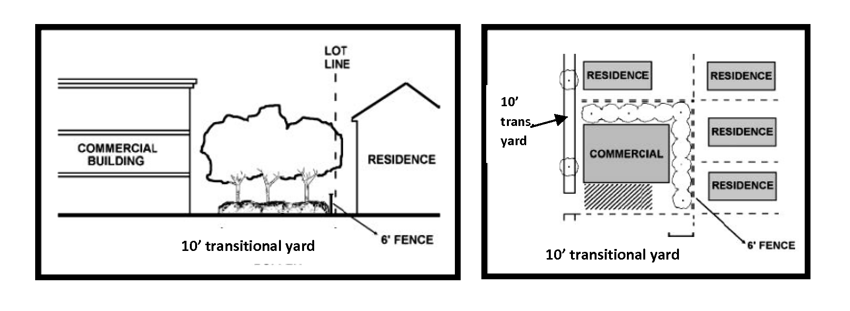
(Ord. No. 700, § 2(Exh. A), 7-17-2012)
Sec. 53-663. - Design.
• Primary entrances shall face the public street.
• The exterior walls shall be constructed of 100 percent stone, brick, masonry, stucco, masonry veneer, or similar granular product excluding doorways and windows. All walls must include materials and design characteristics consistent with those on the front.
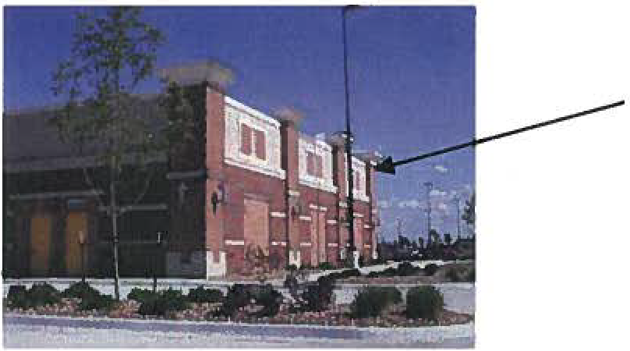 | Sides of building use the same material as the front. While the front elevation of buildings will inherently have more visual interest, the side and rear elevations should generally incorporate the same design standards that apply to the front elevation.
The image to the right shows a blank building wall easily visible from the street. This building design DOES NOT meet the requirement for four-sided design. | 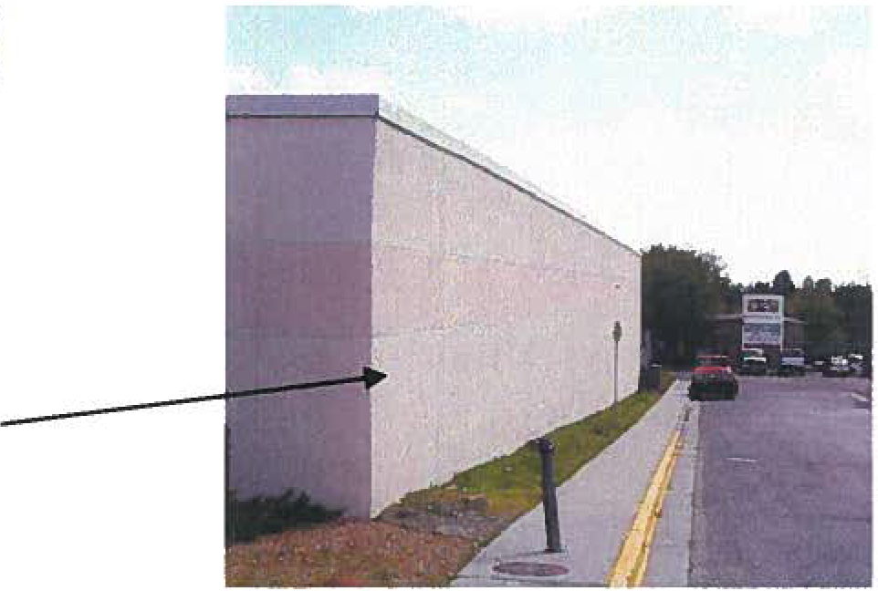

• Windows or doors of clear or lightly tinted glass (no high glare glass)shall comprise at least 50 percent of the frontage length measured between three feet and ten feet above grade for retail buildings and shall comprise at least 30 percent of the frontage length for non-retail based buildings. Windows shall be distributed in a more or less even manner.
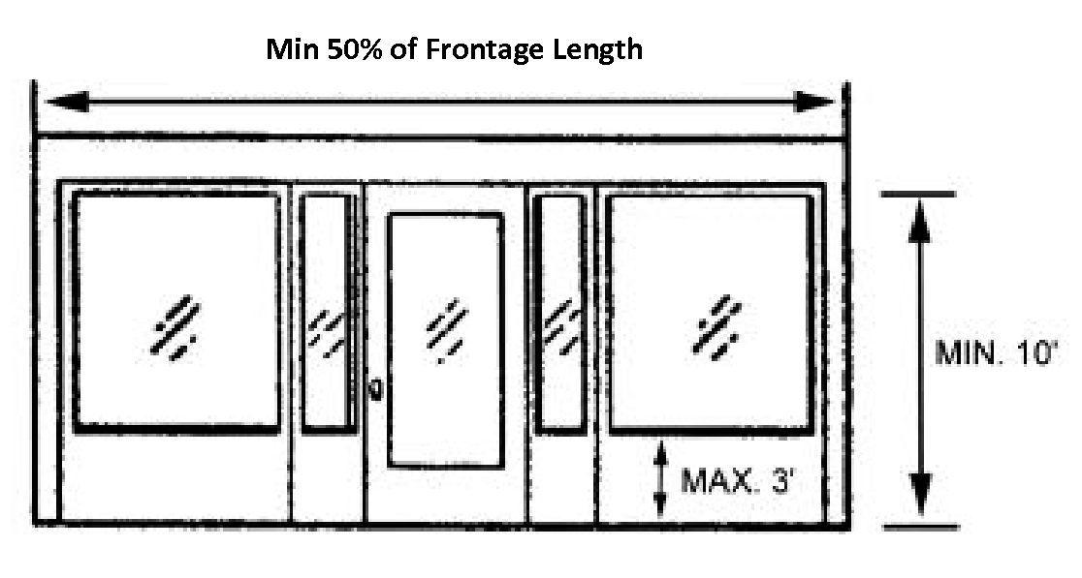
• For new non-residential development all buildings shall incorporate at least four of the following buildings elements:
• Awnings;
• Pillars;
• Canopies;
• Alcoves;
• Recessed entries;
• Ornamental cornices (other than colored stripes or bands alone);
• Pillar posts.
• Exterior walls cannot have a blank uninterrupted length greater than 30 feet, without including two or more features:
• Change in plane;
• Change in texture or masonry pattern;
• Windows;
• Other equivalent that subdivide the wall into a human scale.
(Ord. No. 700, § 2(Exh. A), 7-17-2012)
Sec. 53-664. - Site standards.
The site development regulations for uses in the NC district are as follows:
Landscaping.
• Street trees shall be planted a minimum of 30 feet on center. A minimum of 25 percent of the lot area shall be devoted to landscaping (all landscaping shall consist of drought tolerant plants). Fifty percent of the required landscaping shall be located in front of the primary building.
Sidewalks.
• Sidewalks, driveways and parking areas are required. The sidewalks and pedestrian walkways must be constructed of brick, pavers, or concrete with an exposed broom finish, and connect to the adjacent property having a common frontage.
Screening.
• Screening of loading, trash, recycling and storage facilities is required. All trash and recycling receptacles shall be stored behind the host building. The materials used for screening must be compatible with the materials used on the host building.
Parking.
• All on-site parking shall be setback at least ten feet from the front building line (corner lots shall adhere to this requirement on both street frontages). Curb cuts for parking areas shall not exceed 25 feet in width.
Detention Facilities.
• Detention and water quality ponds shall utilize earthen berms and be designed with a curvilinear contoured shape. Any structural stabilization shall be limited to the use of native stone (except for outlet structure) and shall be limited to not more than 30 percent of the perimeter of the pond and shall be seamlessly integrated with landscape.
Lighting.
• Site lighting shall be shielded so that light sources are not visible from the public right-of-way or from adjacent residential zoned or used property. Lighting pole standards shall not exceed a height of 12 feet.
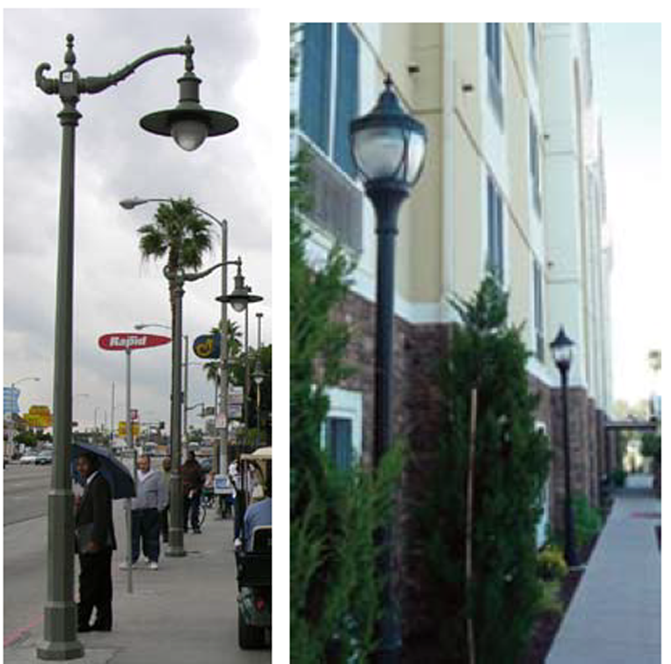 | 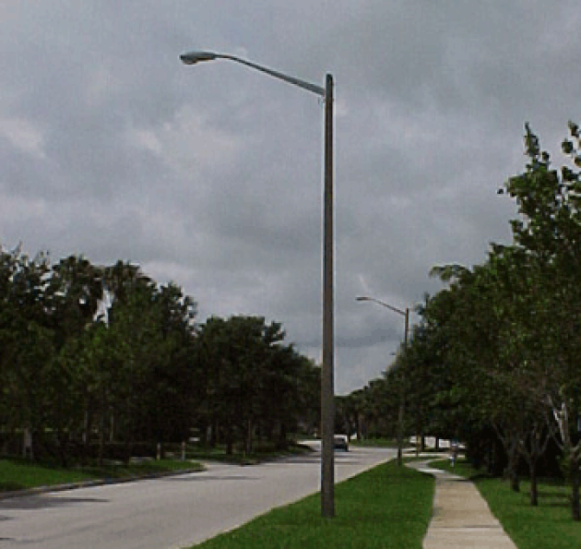
Use pedestrian-oriented lighting. | Not automobile-oriented lighting.

Fencing.
• Any fencing in front, or to the side of on corner lots, shall not exceed a height of three feet and any solid fencing material shall not exceed a height of two feet. No chain link, sheet metal, plastic, vinyl, barbed wire or horizontal metal pipe larger than two inches in diameter shall be used. If adjacent to a single-family zoned property or a property used as a single-family residence, a six-foot privacy fence shall be required.
(Ord. No. 700, § 2(Exh. A), 7-17-2012)
Sec. 53-665. - Use.
The neighborhood commercial zoning district shall allow professional offices and small businesses serving neighborhood community needs. The following uses shall be permitted:
• Second floor multi-family shall be permitted by right regardless of base zoning;
• Bed and breakfast up to five rooms;
• Retail;
• Restaurant w/o drive-thru;
• Religious assembly;
• Art gallery;
• Dance studios;
• Child care center (outdoor playground allowed);
• Fire/police station;
• Professional office;
• Barber/beauty shop;
• Convenience/grocery store w/o fuel sales;
• Nursing/retirement homes;
• Veterinarian - without outdoor boarding;
• Health and fitness center;
• Financial institution w/o drive-thru banking.
(Ord. No. 700, § 2(Exh. A), 7-17-2012)
Sec. 53-666. - Special standards.
Parcels shall not be aggregated to a size of one acre or greater.
Size of building: First floors are limited to a maximum of 10,000 square feet.
Permanent outdoor storage shall not be allowed. Outdoor dining shall be allowed. Limited outdoor display shall be allowed with no more than ten percent of the lot area to be used for merchandise (merchandise shall not be left outside overnight). Outdoor displays shall not be allowed in any required off-street parking spaces.
Establishments located on property that are within 300 feet of any property zoned or used for a residential use may not be open to the general public before 6:00 a.m. and must be closed to the general public by 10:00 p.m. Businesses may utilize extended hours on Friday and Saturday if the following conditions exist:
• If a property is located 150 feet or more from a single-family zoned or used property the business shall be allowed a closing time of midnight, on Friday and Saturday, by right.
• Any property closer than 150 feet from a single-family residentially zoned or used property may apply for a conditional use permit to allow for extended business hours that would allow for a closing time of midnight, on Friday and Saturday.
(Ord. No. 700, § 2(Exh. A), 7-17-2012)
DIVISION 25. - COMMUNITY COMMERCIAL DISTRICT CC

Sec. 53-667. - Purpose.
The purpose of the community commercial district [CC] is to provide for slightly more intense commercial uses than allowed in the neighborhood commercial zoning district. The district is established to provide areas for quality retail establishments and service facilities. This district should generally consist of retail nodes located along or at the intersection of major collectors or thoroughfares to accommodate higher traffic volumes.
(Ord. No. 700, § 2(Exh. A), 7-17-2012)
Sec. 53-668. - Applicability.
Any building constructed or reconstructed within a community commercial zoned property shall adhere to the following requirements.
(Ord. No. 700, § 2(Exh. A), 7-17-2012)
Sec. 53-669. - Building placement.
Front  Setback**  (min. feet) | Side  Setback  (min. feet) | Side Setback  to Residential  District  (min. feet) | Corner Lot -  Side Setback | Rear  Setback*  (min. feet) | Lot Width  (min. feet) | Max.  Height
25' | 10' | 15' | 15' | 25' | 80' | 3 stories

* When the rear or side lot line abuts a single family residential zoned lot or property used for a single family residence the rear/side setback shall consist of the following transitional yards:
• A 15-foot wide planting area consisting of one shade tree, two non-deciduous trees, and eight evergreen shrubs per 50 linear feet of lot width.
• Eight-foot privacy fence.
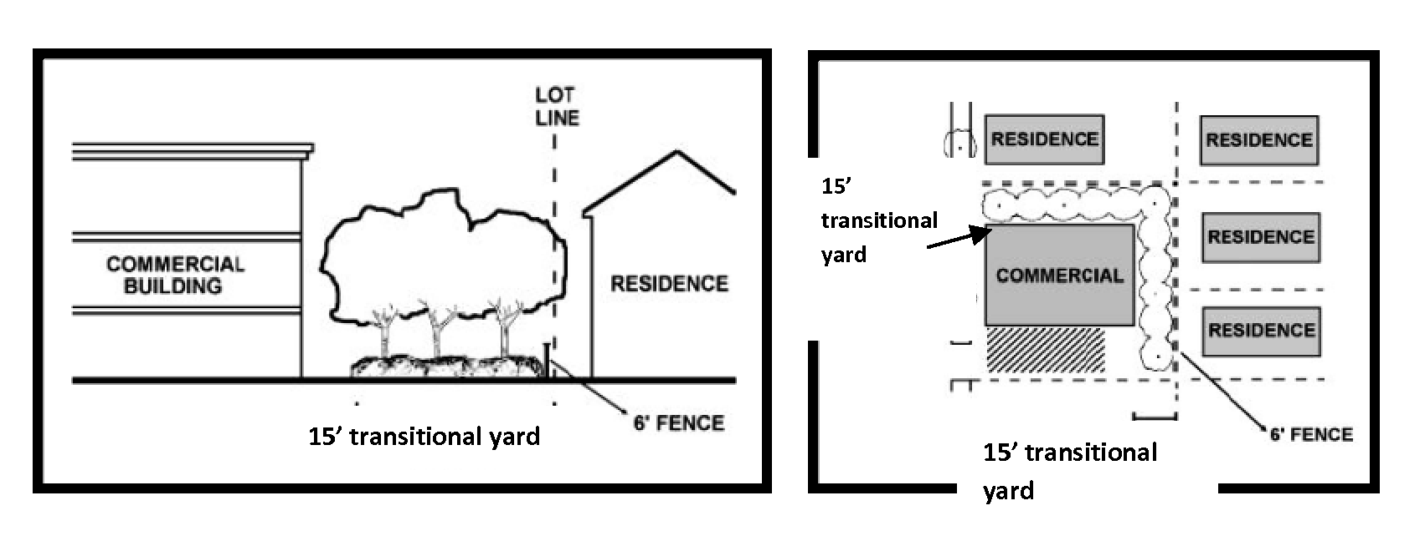
Lot size: Minimum 8,000 square foot lot.
Height regulations: Maximum height of two stories within 150 feet from single-family residential zoned or used property and three stories between 150 and 300 feet from single-family residential zoned or used property.**
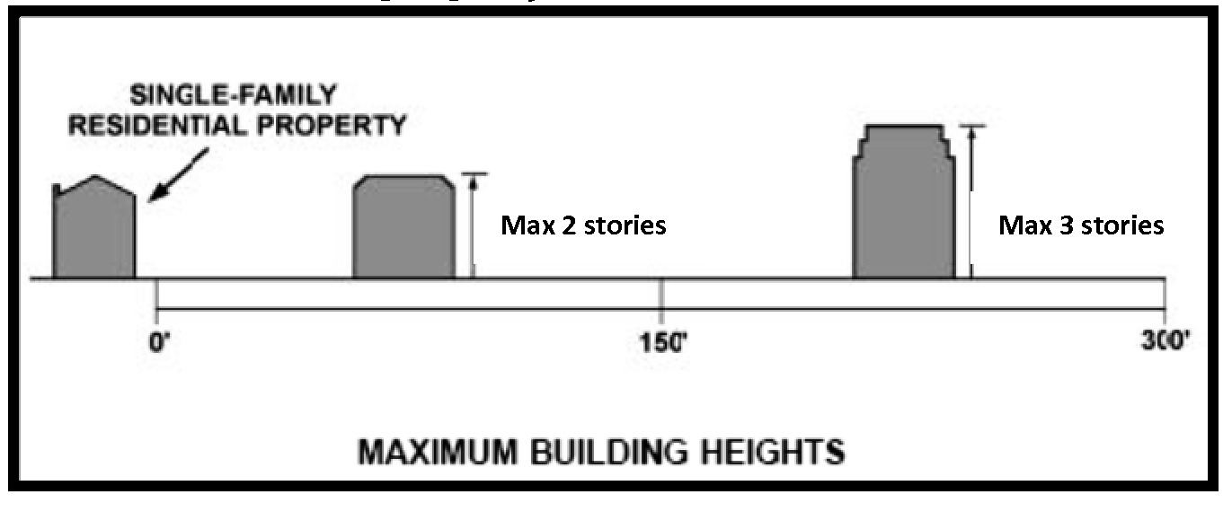
** Stories shall not exceed 14 feet in height from finished floor to finished ceiling. A single floor level exceeding 14 feet shall be counted as two stories.
(Ord. No. 700, § 2(Exh. A), 7-17-2012)
Sec. 53-670. - Design.
• Primary entrances shall face the public street.
• The exterior walls shall be constructed of 100 percent stone, brick, masonry, stucco, masonry veneer, or similar granular product excluding doorways and windows. All walls must include materials and design characteristics consistent with those on the front (wood and metal may be used as accent material).
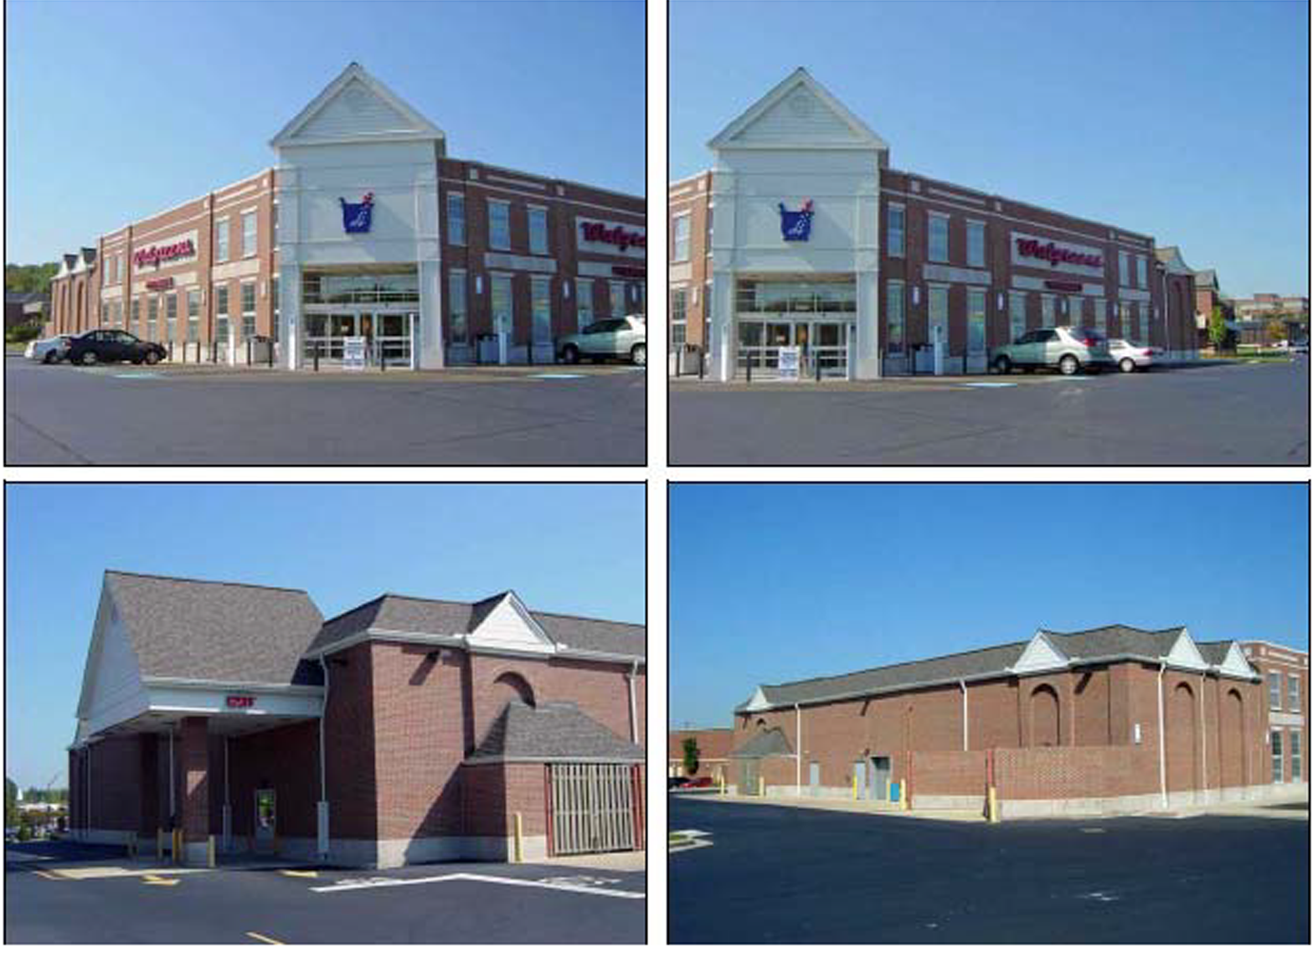
An example of four-sided design.

• Windows or doors of clear or lightly tinted glass (no high glare glass)shall comprise at least 50 percent of the frontage length measured between three feet and ten feet above grade, for retail buildings and shall comprise at least 30 percent of the frontage length for non-retail based buildings. Windows shall be distributed in a more or less even manner.
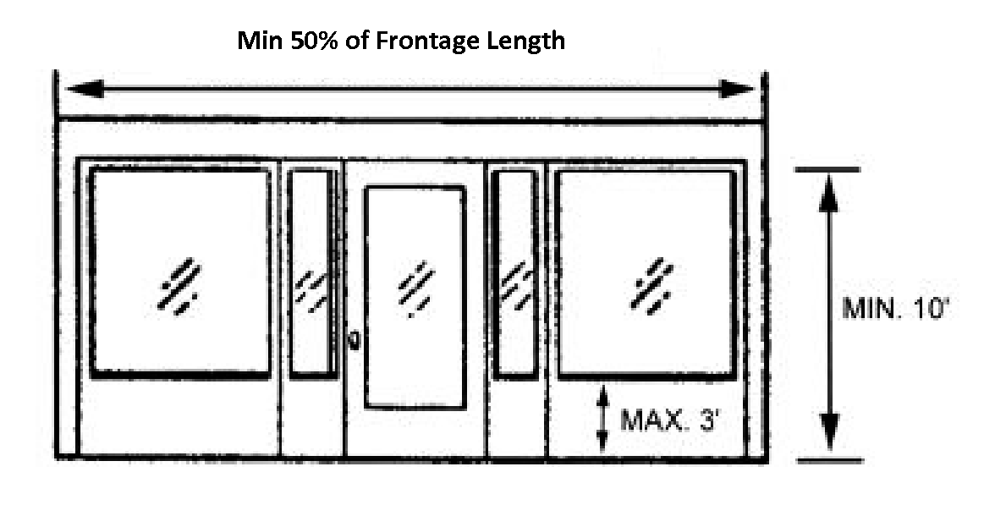
• For new non-residential development all buildings shall incorporate at least four of the following buildings elements:
• Awnings;
• Pillars;
• Canopies;
• Alcoves;
• Recessed entries;
• Ornamental cornices (other than colored stripes or bands alone);
• Pillar posts.
• Exterior walls cannot have a blank uninterrupted length greater than 30 feet, without including two or more features:
• Change in plane;
• Change in texture or masonry pattern;
• Windows;
• Other equivalent that subdivide the wall into a human scale.
(Ord. No. 700, § 2(Exh. A), 7-17-2012)
Sec. 53-671. - Site standards.
The site development regulations for uses in the CC district are as follows:
Landscaping
• Street trees shall be planted a minimum of 30 feet on center. A minimum of 25 percent of the lot area shall be devoted to landscaping (all landscaping shall consist of drought-tolerant plants). Fifty percent of the required landscaping shall be located in front of the primary building.
Sidewalks.
• Sidewalks, driveways and parking areas are required. The sidewalks and pedestrian walkways must be constructed of brick, pavers, or concrete with an exposed broom finish, and connect to the adjacent property having a common frontage.
Screening.
• Screening of loading, trash, recycling and storage facilities is required. All trash and recycling receptacles shall be stored behind the host building. The materials used for screening must be compatible with the materials used on the host building.
Parking.
• Seventy percent of all parking shall be setback behind the front of the building. Curb cuts for parking areas shall not exceed 25 feet in width.
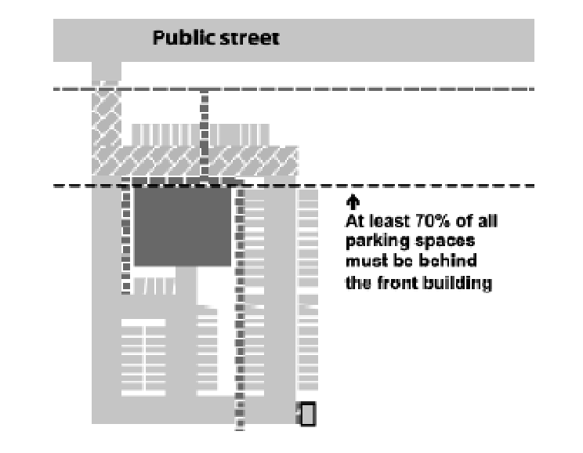
Detention Facilities.
• Detention and water quality ponds shall utilize earthen berms and be designed with a curvilinear contoured shape. Any structural stabilization shall be limited to the use of native stone (except for outlet structure), and shall be limited to not more than 30 percent of the perimeter of the pond and shall be seamlessly integrated with landscape.
Lighting.
• Site lighting shall shine downward and be shielded so that light sources are not visible from public thoroughfares or from adjacent residential zoned or used property. Lighting pole standards shall not exceed a height of 18 feet.
Fencing.
• Any fencing in front, or to the side on corner lots, shall not exceed a height of three feet and any solid fencing material shall not exceed a height of two feet. No chain link, sheet metal, plastic, vinyl, barbed wire or horizontal metal pipe larger than two inches in diameter shall be used.
(Ord. No. 700, § 2(Exh. A), 7-17-2012)
Sec. 53-672. - Use.
The neighborhood commercial zoning district shall allow professional offices and small businesses serving neighborhood community needs. The following uses shall be permitted:
• Multi-family on the second floor and above shall be permitted by right regardless of base zoning;
• Bed and breakfast up to five rooms;
• Retail;
• Restaurant;
• Religious assembly;
• Art gallery;
• Child care center (outdoor playground allowed);
• Fire/police station;
• Professional office;
• Funeral home;
• Barber/beauty shop;
• Convenience/grocery store;
• Fuel station*;
• Nursing/retirement homes;
• Veterinarian - without outdoor boarding;
• Health and fitness center;
• Restaurant with drive-thru*;
• Financial institution w/ drive-thru banking.
* See special standards.
(Ord. No. 700, § 2(Exh. A), 7-17-2012)
Sec. 53-673. - Special standards.
Size of building: First floors are limited to a maximum of 15,000 square feet.
Permanent outdoor storage shall not be allowed. Outdoor dining shall be allowed. Limited outdoor display shall be allowed with no more than ten percent of the lot area to be used for merchandise (merchandise shall not be left outside overnight). Outdoor displays shall not be allowed in any required off-street parking spaces.
Establishments located on property that are within 300 feet of any property zoned or used for a single-family residential use may not to be open to the general public before 6:00 a.m. and must be closed to the general public by 10:00 p.m. Businesses may utilize extended hours on Friday and Saturday if the following conditions exist:
• If a property is located 150 feet or more from a single-family zoned or used property the business shall be allowed a closing time of midnight, on Friday and Saturday, by right.
• Any property closer than 150 feet from a single-family residentially zoned or used property may apply for a conditional use permit to allow for extended business hours that would allow for a closing time of midnight, on Friday and Saturday.
Fuel stations must adhere to the following requirements:
• Fascias of the canopy shall be finished to match the building material and color. Striping and banding of canopies is prohibited.
• No more than eight fuel pumps shall be allowed within the community commercial zoning designation.
Drive-through facilities (speakers, menu boards, or drive-through windows) shall not be located within 75 feet of a residentially zoned property. Drive-through facilities shall not face a public ROW. Drive-through lanes and facilities shall be located to the side and rear of the primary building. A minimum of a ten-foot wide landscape area along the edge of a site where parking areas, drive lanes are adjacent to a public street shall be provided. The landscape area shall include trees, shrubs and/or low walls to screen cars from view while allowing eye level visibility into the site.
(Ord. No. 700, § 2(Exh. A), 7-17-2012)
Sec. 53-674. - Reserved.

